Table of Contents

# Introduction to the Control Strategy Tool (CoST)

This document is a user’s guide for the Control Strategy Tool (CoST) software. CoST was developed in cooperation between the [University of North Carolina Institute for the Environment](http://ie.unc.edu/research/environmental-modeling/) and by EPA’s Health and Environmental Impacts Division (HEID). CoST estimates the air pollution emission reductions and costs associated with future-year control scenarios, and generates emission inventories with the control scenarios applied [Misenheimer, 2007; Eyth, 2008](./ch7_references.md). CoST includes a database of information about emissions control measures, their costs, and the types of emissions sources to which they apply. The purpose of CoST is to support national- and regional-scale multi-pollutant analyses. CoST helps to develop control strategies that match control measures to emission sources using algorithms such as “Maximum Emissions Reduction” (for both single- and multiple-target pollutants), “Least Cost”, and “Apply Measures in Series”. CoST includes a graphical user interface (GUI) for configuring CoST simulations and viewing the results.

Results from a CoST control strategy run include the estimated cost and emissions (tons) reduction achieved for each control measure-source combination. CoST is an engineering cost estimation tool for creating controlled inventories and is not currently intended to model emissions trading strategies, nor is it an economic impact tool. Control strategy results can be exported to comma-separated-values (CSV) files, Google Earth-compatible (.kmz) files, or Shapefiles. The CoST results can be viewed in the GUI as graphical tables that support sorting, filtering, and plotting. The Strategy Detailed Results from a CoST strategy run can be input to the [Sparse Matrix Operator Kernel Emissions (SMOKE)](http://www.smoke-model.org) modeling system, which is used by EPA to prepare emissions inputs for air quality modeling.

CoST is a component of the [Emissions Modeling Framework (EMF)](https://github.com/USEPA-OAQPS/emf), which is currently being used by EPA to solve many of the long-standing complexities of emissions modeling [Houyoux, 2008](./ch7_references.md). Emissions modeling is the process by which emissions inventories and other related information are converted to hourly, gridded, chemically speciated emissions estimates suitable for input to a regional air quality model such as the [Community Multiscale Air Quality (CMAQ) model](http://www.epa.gov/cmaq). The EMF supports the management and quality assurance of emissions inventories and emissions modeling-related data, and also the running of SMOKE to develop CMAQ inputs. Providing CoST as a tool integrated within the EMF facilitates a level of collaboration between control strategy development and emissions inventory modeling that was not previously possible. The concepts that have been added to the EMF for CoST are “**control measures**” and “**control strategies**”. Control measures store information about available control technologies and practices that reduce emissions, the source categories to which they apply, the expected control efficiencies, and their estimated costs. A control strategy is a set of control measures applied to emissions inventory sources (in addition to any controls that are already in place) to accomplish an emissions reduction goal. These concepts are discussed in more detail later in this document.

CoST is designed for multipollutant analyses and data transparency. It provides a wide array of options for developing emissions control strategies through the Control Measures Database (CMDB). The CoST GUI provides an graphical interface for accessing the CMDB, designing control strategies, and viewing the results from control strategy runs. CoST has been applied to develop strategies for criteria and hazardous air pollutants (HAPs). CoST has been used in some very limited analyses for greenhouse gases (GHGs). The main limiting factors in performing GHG analyses is the availability of (1) GHG emissions inventories with enough detail to support the application of control measures to individual sources or source groups, and (2) GHG control measures, with the associated technology implementation and maintenance costs.

The CoST algorithms for developing control strategies include:

* “Annotate Inventory”
* “Maximum Emissions Reduction”
* “Multi-Pollutant Maximum Emissions Reduction”
* “Least Cost”
* “Least Cost Curve”
* “Apply Measures in Series”

The first five algorithms are typically used for point and area sources; the last one is usually used for mobile sources, for which most control techniques are independent of one another.

This document provides information on how to use CoST to view and edit control measures and how to develop control strategies. This includes how to specify the input parameters to control strategies, how to run the strategies, and how to analyze the outputs from the strategies. For additional information on other aspects of CoST, please see the following independent documents:

* [Control Strategy Tool (CoST) Development Document](https://www3.epa.gov/ttn/ecas/docs/CoST_DevelopmentDoc_02-23-2016.pdf): describes the algorithms implemented in the software
* [Control Strategy Tool (CoST) Control Measures Database Documentation](https://www3.epa.gov/ttn/ecas/models/CoST_CMDB_Document_2010-06-09.pdf): describes the contents of the Control Measures Database
* [Control Strategy Tool (CoST) Cost Equations Documentation](https://www3.epa.gov/ttn/ecas/docs/CoST_Equations_Document_2016_03_15.pdf): describes how CoST uses control measure engineering cost equations

These documents, and additional information about CoST, can be found at the US EPA website on [Cost Analysis Models/Tools for Air Pollution Regulations](https://www.epa.gov/economic-and-cost-analysis-air-pollution-regulations/cost-analysis-modelstools-air-pollution).

# Installing the CoST Software and Data

## Background on the CoST Client-Server System

Because CoST is fully integrated within the EMF, installing CoST is the same as installing the EMF. There are two parts of the CoST/EMF system: a client and a server. For this guide, it is assumed that you need to install both the client and the server.

In the CoST client-server system, client software that runs on a desktop computer is used to connect to a server running the CoST algorithms and database. The CoST/EMF client is a Java program that accesses Java and [PostgreSQL](http://www.postgresql.org) software running on the CoST/EMF server. CoST/EMF requires that a recent version of Java be installed on each user’s computer. The EMF database server stores information related to emissions modeling, including emissions inventory datasets and a database of emissions control measures. When a control strategy is developed, new datasets and summaries of them are created within CoST, and controlled emissions inventories can optionally be generated. These emissions inventories can be exported from CoST and then used as inputs to the SMOKE modeling system, which prepares emissions data for use in the CMAQ model. A schematic of the CoST/EMF client-server system is shown in Figure2-1.

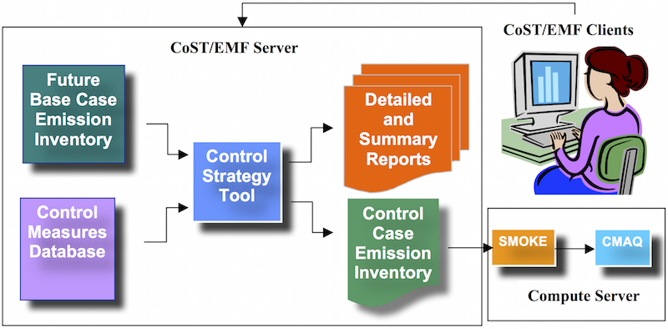

Figure 2-1: EMF Client-Server System

## Download the Software Installation Package

The software installation package is a ZIP file (~300MB) that contains all the relevant supporting applications and software required to run the CoST system on a Windows-based machine. The installation package also contains the most recent version of the Control Measures Database (CMDB) available at the time of the software release. Instructions for optionally updating the CMDB are provided at the end of this section.

The CoST server requires [Java Runtime Environment 7 or 8](http://www.oracle.com/technetwork/java/javase/overview/index.html) (also known as JRE 1.7 or 1.8), [Tomcat](https://tomcat.apache.org/index.html) and [PostgreSQL](https://www.postgresql.org). All of these components are in the CoST/EMF installation package.

The total space required for the software is 5GB. Around 1.2GB of space can be freed at the end of the installation process. Make sure you have enough storage space (~40-50 GB) available to allow for future usage with your own custom inventories and control measures in the CoST system.

The CoST/EMF software package can be downloaded via the [Community Modeling and Analysis System (CMAS)](http://www.cmascenter.org).

A. Download the CoST Windows Installation zip file from the CMAS software download site: <http://www.cmascenter.org/download/software.cfm>

B. Unzip the downloaded file into a known folder location on a Windows machine.

Figure2-2 lists the batch file and the folders that are located in the install zip file; these are described below the figure.

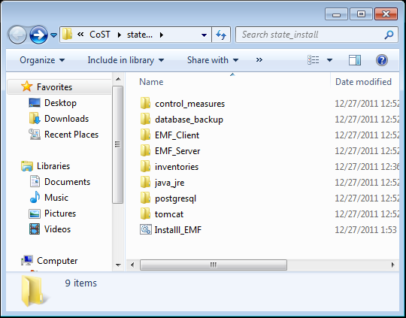

Figure 2-2: Installation Package Zip File Folder and File Structure

* Install_EMF.bat - bat file to install the EMF Client and Server
* control_measures - contains measures in the database (note: These are already installed)
* database_backup - contains a backup of the database
* EMF_Client - includes client installation package (all the Java libraries etc.)
* EMF_Server - includes the emf.war file that will be pushed to the tomcat server
* inventories - contains inventories
* java_jre - includes the Java JRE installation package
* postgresql - includes the PostgreSQL installation package and postgresql jdbc driver
* tomcat - includes the Tomcat installation package

## Install Java

Go to the java_jre directory and double click the executable file, jre-8u51-windows-i586.exe.

Follow the installation steps as illustrated in the following figures.

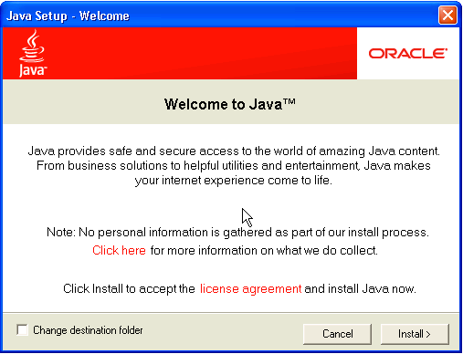

Figure 2-3: Java Setup Welcome

Click Install to accept the license agreement and start the installation process.

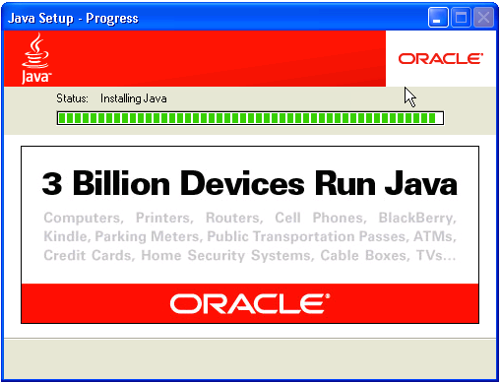

Figure 2-4: Java Setup Progress



Figure 2-5: Java Setup Welcome

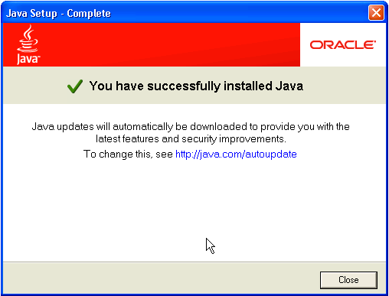

Figure 2-6: Java Setup Complete

Click Close to finalize the installation process.

## Install the PostgreSQL Database

Go to the postgresql directory and double click the executable file, postgresql-9.3.9-3-windows.exe.

During the installation process, you’ll be prompted to enter a database superuser password. Set a password, e.g., postgres, and take note of it for a later step of the installation process.

Follow the installation steps as illustrated in the following figures.

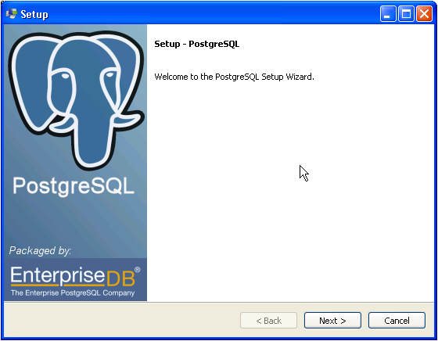

Figure 2-7: Postgres Welcome

Click Next to begin the installation process.

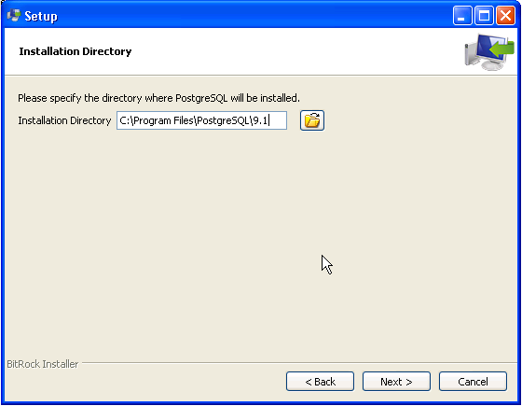

Figure 2-8: Postgres Installation Directory

The default directory location is sufficient, click Next to continue to the next step. Remember this directory for later use in the installation process.

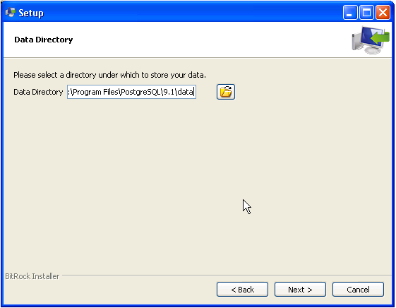

Figure 2-9: Postgres Data Directory

The default location is sufficient, click Next to continue to the next step.

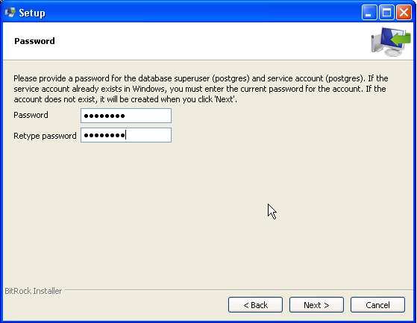

Figure 2-10: Postgres Password

For this step, make sure you use the password that you set earlier in the installation, e.g., postgres. This password is also expected during a later step when installing the CoST database.

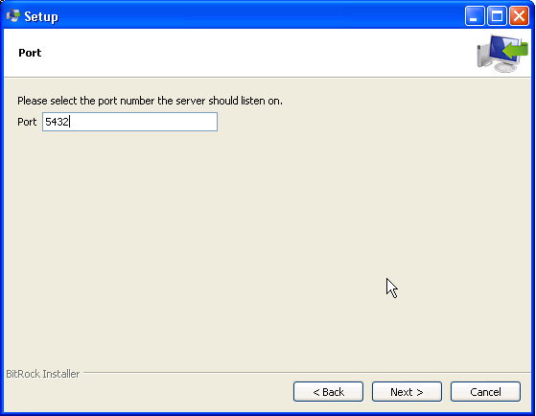

Figure 2-11: Postgres Port

The default Port is sufficient, click Next to continue to the next step.

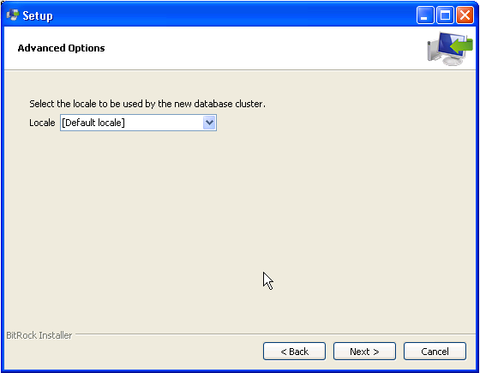

Figure 2-12: Postgres Locale

The default Locale is sufficient, click Next to continue to the next step.

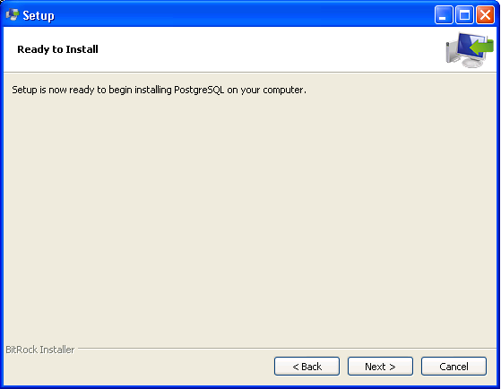

Figure 2-13: Postgres Ready to Install

Click Next to install the PostgreSQL database server.

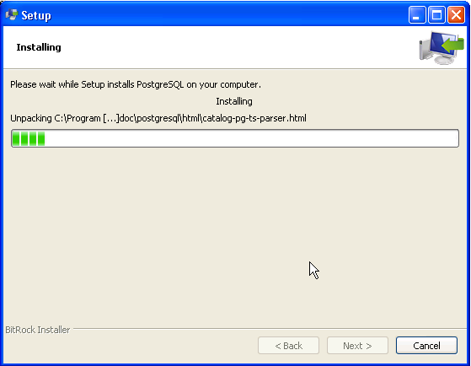

Figure 2-14: Postgres Installing

Click Next to finalize the PostgreSQL installation.

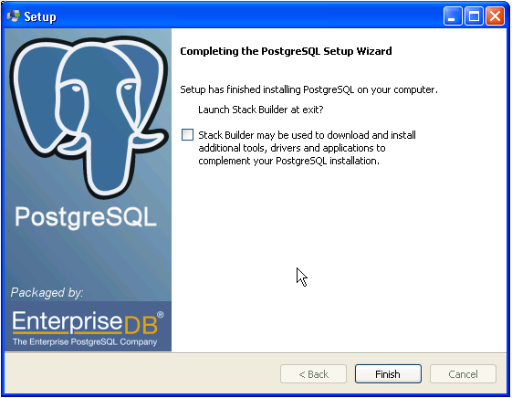

Figure 2-15: Postgres Complete

When you reach the end, uncheck the Launch Stack Builder option and click Finish.

The PostgreSQL database is now installed and ready for the CoST system database. This database will be installed in a later step.

## Install the Tomcat Web/Application Server

Go to the tomcat directory and find the executable file, apache-tomcat-7.0.63.exe. Double click the file to install Tomcat. Follow the installation steps as illustrated in the following figures.

Figure 2-16: Tomcat Welcome

Figure 2-16: Tomcat Welcome

Click Next to begin the installation process.

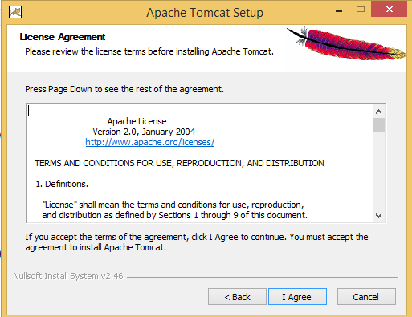

Figure 2-17: Tomcat License

Click I Agree to continue to the next step.

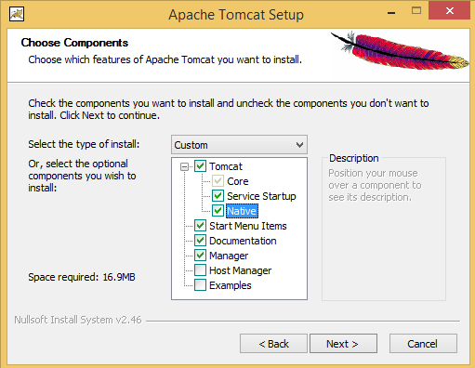

Figure 2-18: Tomcat Components

Expand the Tomcat option and check the Service Startup and Native components and then click Next. Note that the required Service Startup option ensures that the application server is available on startup when the machine is rebooted.

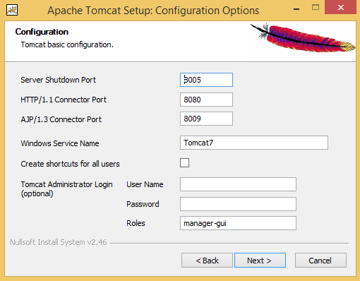

Figure 2-19: Tomcat Options

The default settings are sufficient, click Next to continue to the next step.

[][tomcat_jvm]

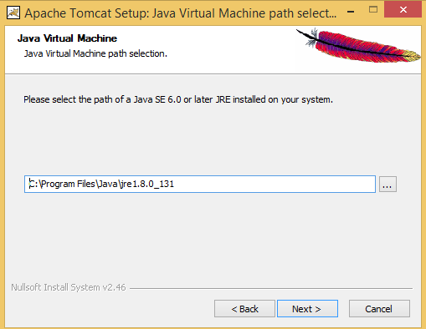

Figure 2-20: Tomcat JVM

The default location is sufficient, click Next to continue to the next step.

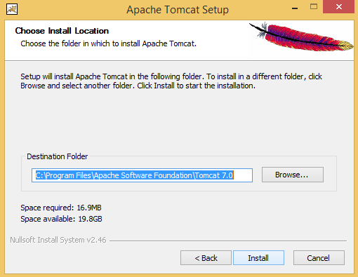

Figure 2-21: Tomcat Install Location

The default location is sufficient, click Install to install the Tomcat web server. Remember this folder for use in a later step of the installation process.

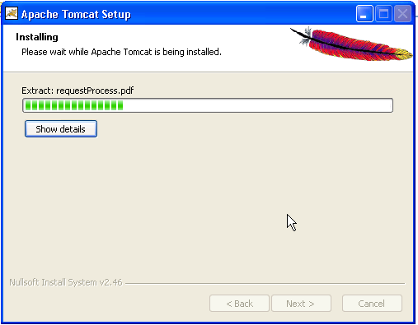

Figure 2-22: Tomcat Installing

Once the program files have been installed click Next to finalize installation process.

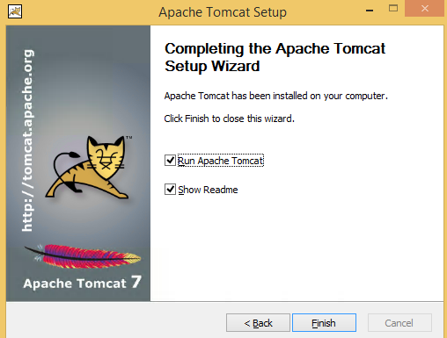

Figure 2-23: Tomcat Complete

When you reach the end, click Finish. The Tomcat application server is now installed and ready for the CoST system application. This CoST application will be installed in the next step.

## Installing CoST

Go to the root installation directory where the CoST/EMF zip file was installed and find the Install_EMF.bat executable file. Edit the bat file and change the following variables to match your computer’s settings:

SET EMF_CLIENT_DIRECTORY=C:\Users\Public\EMF  
SET EMF_DATA_DIRECTORY=C:\Users\Public\EMF_Data  
SET POSTGRESDIR=C:\Program Files\PostgreSQL\9.3  
SET TOMCAT_DIR=C:\Program Files\Apache Software Foundation\Tomcat 7.0

* EMF_CLIENT_DIRECTORY sets the location where the EMF client application will be installed. This is the location where you will find the CoST executable.
* EMF_DATA_DIRECTORY sets the location where the EMF data files (e.g., inventories and control measure import files) will be installed.
* POSTGRESDIR sets the location where the PostgreSQL application is installed.
* TOMCAT_DIR sets the location where the Tomcat application is installed.

Save, exit and double-click the file Install_EMF.bat to start the CoST/EMF server installation.

*Note: This installation process can take around 30-40 minutes to finish.* During the installation process, you will be prompted once (see Figure below) to enter the PostgreSQL superuser password, e.g., postgres.

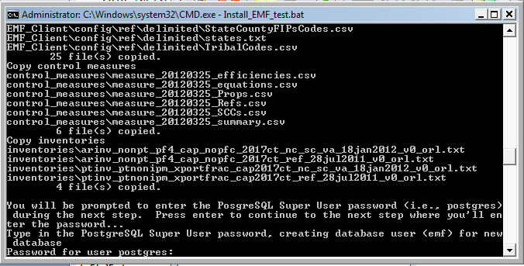

Figure 2-24: CoST Installation

After the server installer completes, go to the directory containing the EMF client application; this was specified in the Install_EMF.bat file via the EMF_CLIENT_DIRECTORY variable. Edit the EMFClient.bat batch file to match your computer’s settings:

set EMF_HOME=C:\Users\Public\EMF  
set JAVA_EXE=C:\Program Files\Java\jre1.8.0\_51\bin\java

* EMF_HOME sets the location of EMF client application (set to be the same as EMF_CLIENT_DIRECTORY from the server installer above)
* JAVA_EXE sets the location of Java runtime application (note that the directory is C:\Program Files\Java\jre1.8.0_51\bin and java is the Java runtime application)

Save and exit from the file EMFClient.bat.

## Running CoST and Logging into the EMF Server

The CoST application can now be run by going to the EMF client directory and locating the EMFClient.bat file. Double click this file, and you will then be prompted to log in to the system. If the configuration was specified properly and the server is running, you should the following window.

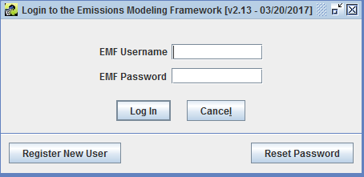

Figure 2-25: Login to the Emissions Modeling Framework Window

If you have never used the EMF before, click the **Register New User** button. You will then see the following window

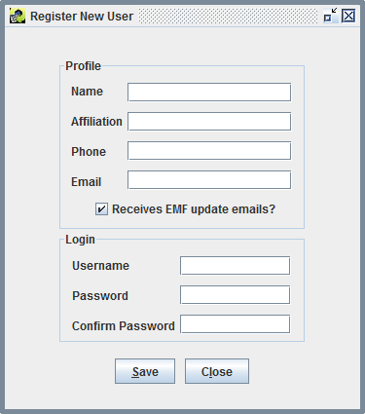

Figure 2-26: Register New User Window

In the Register New User window, fill in your full name, affiliation, phone number, and email address. You may then select a username with at least three characters and enter a password with at least 8 characters and at least one digit and then click OK. Once your account has been created, the EMF main window should appear (see below).

If have logged into the EMF previously, enter your EMF username and password in the Login to the Emissions Modeling Framework window and click Log In. The following EMF main window will appear on your screen

*Note: The administrator EMF login name is admin, with a password admin12345*.

After successfully logging into CoST the main EMF window shown below will display.

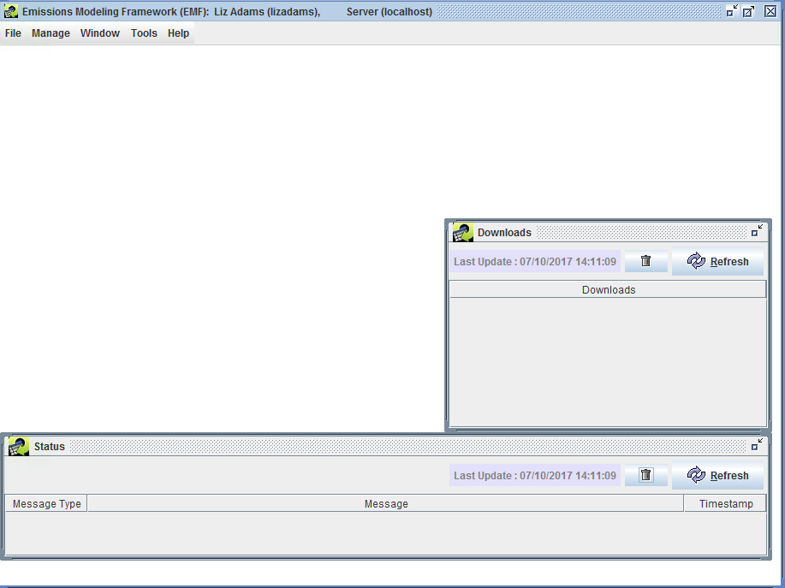

Figure 2-27: EMF Main Window

## (Optional) Upgrade the Control Measures Database (CMDB)

The Control Measures Database includes all of the emissions control technology information, emissions reductions, and associated costs used by U.S. EPA for developing emissions control strategies for stationary sources. The latests CMDB is available from [EPA CoST Website](https://www.epa.gov/economic-and-cost-analysis-air-pollution-regulations/cost-analysis-modelstools-air-pollution).

The CoST/EMF installation package includes the latest version of the CMDB. The instructions here are provided to guide the upgrade of an existing EMF installation with a new version of the CMDB.

To install the CMDB in the EMF, first download the latest CMDB CSV file from the EPA website. You must login to the EMF Client as Administrator to add to the CMDB to the CoST PostgreSQL database. After logging in as administrator select Control Measures from the Manage drop down menu at the top of the EMF Client window:

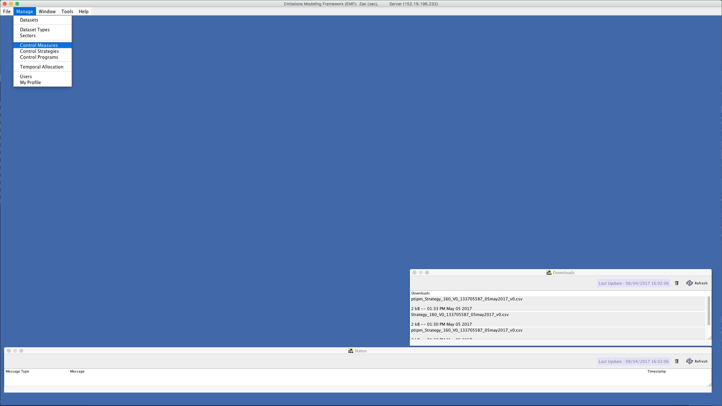

Figure 2-28: Manage Control Measures

Click the Import button to see the Import Control Measures screen:

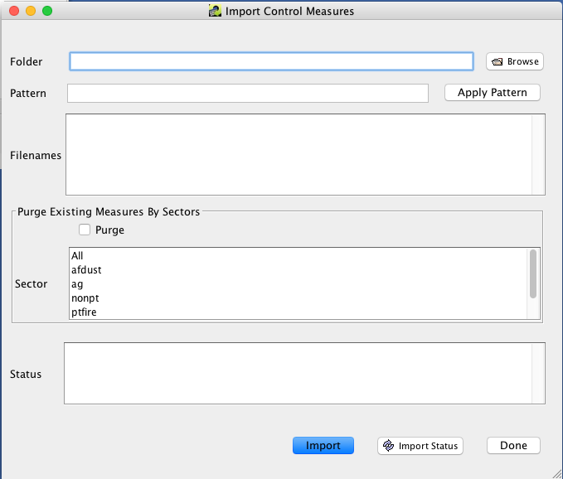

Figure 2-29: Import Control Measures

Use the Browse button to find the CMDB CSV file downloaded from the EPA website. Select the file and click OK.

Click Import to add the EPA CMDB to the CoST/EMF database.

## (Optional) Removing CoST Installation Package

To remove the CoST installation package, go to the root directory where the EMF/CoST Installer zip file was installed and manually remove all files and sub folders from this directory. The original zip package contains a compressed version of the installation package and can be kept for reference purposes. Removing these files and directories will free up around 1.2GB of space.

# Control Measure Manager

## Introduction

This chapter demonstrates the features of the CoST Control Measure Manager. The initial CoST installation includes area- and stationary-source control measures. The pre-loaded measures can be used directly for CoST control strategy runs, the measures are editable through the CoST/EMF client, and new measures may be imported through the client. **Control measures store information about control technologies and practices that are available to reduce emissions, the source categories to which they apply, the expected control efficiencies, and their estimated costs.**

The Control Measure Manager allows control measure data to be entered, viewed, and edited. The data that are accessible through the Control Measure Manager are stored in the [CoST Control Measures Database (CMDB)](https://www3.epa.gov/ttn/ecas/models/CoST_CMDB_Document_2010-06-09.pdf). The CMDB is stored as a set of tables within the EMF database. Control measures can also be imported from files that are provided in a specific CSV format and exported to that same format. In CoST, the control measures are stored separately from the emission inventory data and are matched with the emission sources using a list of Source Classification Codes (SCCs) that are specified for each control measure.

The Control Measure Manager has the following major features:

* Facilitates storing and maintaining control measure data
* Shows minimum, maximum, and average control efficiency, cost per ton (based on year 2013 values), and average rule effectiveness and rule penetration
* Displays other control measure attributes (e.g., abbreviation, major pollutant, source group, equipment life, sectors, class)
* Allows import of control measure information into the system from CSV files
* Enables export of control measure to CSV files

In this chapter, you will learn how to:

* View, sort, and filter a list of control measures from the Control Measure Manager window
* Find control measure that apply to selected SCCs
* View the detailed data available for a control measure, including control efficiencies, SCCs, cost equations, and properties
* Copy control measures
* Edit data for control measures
* Create new control measures
* Filter and display cost and control efficiency information for major and co-benefit pollutants of the measures
* See cost per ton information for different cost years
* Export control measures data

***This chapter is presented as a series of steps in a tutorial format.***

### Introduction to the Control Measure Manager

Begin by opening the Control Measure Manager and exploring the buttons and menus in the upper portion of the window.

**Step 1-1: Open Control Measure Manager.** To open the Control Measure Manager, choose Control Measures from the Manage drop down menu on the EMF main window (Figure 3-1). The Control Measure Manager window will appear (Figure 3-2). When the window first appears, it will be empty. Notice that the window appears within the EMF main window.

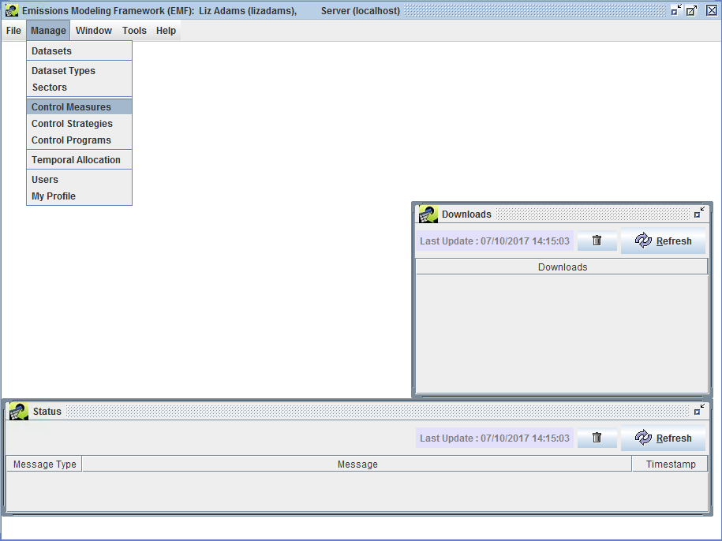

Manage Menu of EMF Main Window

**Figure 3-1. EMF Manage Menu**

Notice the different parts of the Control Measure Manager window. There is a Pollutant Filter drop down menu at the top, a Show Details checkbox, a Refresh button, and a Name or Abbr contains dialog box. Below those buttons is a toolbar with buttons that operate on the data shown in the table below the toolbar, which by default is empty. There is another set of buttons and pull-down menus below the table. The functions of all of these buttons will be discussed below.

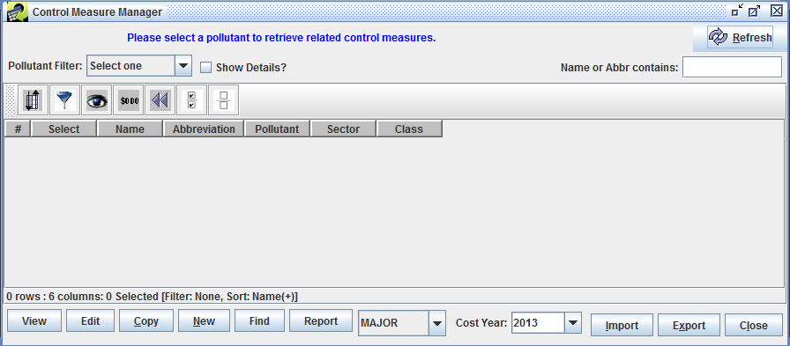

Control Measure Manager before Control Measures are Loaded

**Figure 3-2. Control Measure Manager Initial Window**

**Step 1-2: Display Control Measures.** To display control measures from the CMDB in the Control Measure Manager window, select a pollutant from the Pollutant Filter pull-down menu at the upper left corner of the Control Measure Manager. For this example, use the scroll bar to find and select PM10. Information about any control measures that control the selected pollutant will appear in the Control Measure Manager window (Figure 3-3). The control measure **Name**, **Abbreviation**, **Pollutant**, **Sector**, and **Class** are shown in the window. Note that name of each control measure must be unique within the database, and that the control measures appear in a table in which the data can be sorted by clicking on the row headers.

The control measure abbreviation is a set of characters that is a *short-hand* for the control measure. Typically, the abbreviation should express the name of the control measure in an abbreviated form such that if someone is familiar with the abbreviation conventions, the person might be able to infer the name of the measure. Typically the first character of the measure denotes the major pollutant (e.g., ‘P’ for PM controls, ‘N’ for NOx controls, ‘S’ for SO2 controls). The next few characters usually denote the control technology (e.g., ‘ESP’ for Electrostatic Precipitator, ‘FFM’ for fabric filter mechanical shaker). Abbreviations must be unique within the database (i.e., no two control measures can use the same abbreviation).

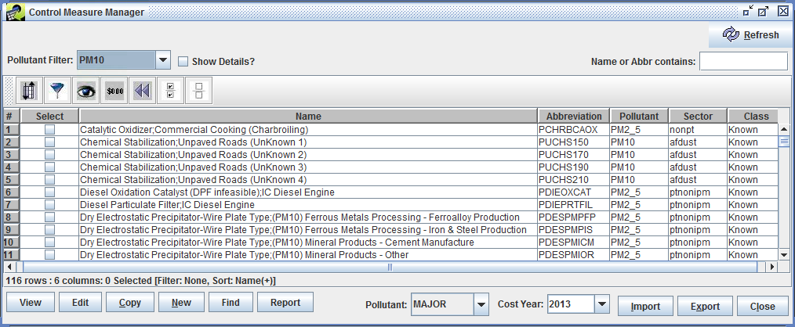

Control Measure Manager with Control Measures

**Figure 3-3. PM10 Control Measures List**

**Step 1-3: Show Details of Control Measures.** To see more information about the measures, check the Show Details checkbox - additional columns will appear on the right of the table. An example is shown in Figure 3-4.

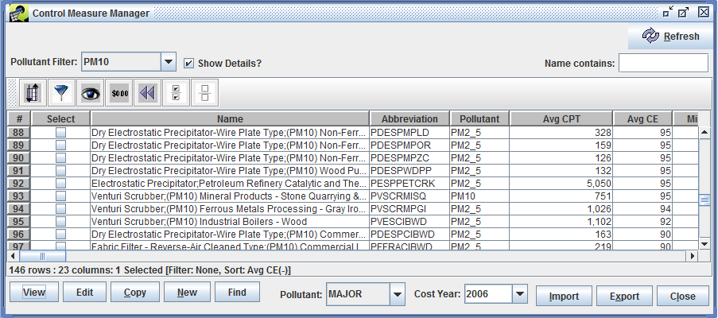

Control Measure Manager showing Control Measure Details

**Figure 3-4. PM10 Control Measures Expanded List with Details**

**Step 1-4: Configure the Control Measure Window.** To better see the additional columns, you can make the Name column narrower by positioning your mouse on the line between **Name** and **Abbreviation** on the table header; this will cause a special mouse pointer with arrows to appear and you can then use the mouse to drag the column edge to resize the column width.

**Step 1-5: Examine Control Measure Details.** Scroll to the right to examine the detail columns that are available in the Control Measure Manager. *Note that you may move the columns around by grabbing the column’s header with your mouse and dragging them. You may also change their widths as desired.* You can also resize the Control Measure Manager window within the EMF Main Window as desired, such as to make the entire window wider so that you can see more columns.

**Step 1-6: View Measure Name.** After you scroll to the right in the window, if you hover your mouse over one of the columns other than Name, you will see that the name of the measure corresponding to the row you are on will appear briefly as a “tooltip”. This is so that you can tell what the name of the measure is even if has scrolled off the window.

The columns shown on the Control Measure Manager with brief descriptions are shown in Table 3-1. The control measures table supporting sorting and filtering the data. Tables of this same type are used many places throughout CoST and the EMF.

**Table 3-1. Control Measure Manager Columns.**

|  |  |
| --- | --- |
| Column Name | Description |
| Select | This column will allow the user to view, edit, or copy the measure by clicking the corresponding button at the bottom of the manager window. These features will be discussed later in the training. |
| Name | A unique name for the measure. |
| Abbreviation | A unique abbreviation for the measure. |
| Pollutant | A pollutant (e.g., NOx, PM~10) that the measure might control. Note that any pollutant-specific information in the row is for this pollutant. |
| Max, Min, and Avg CE | Maximum, minimum, and average control efficiencies for the specified pollutant, aggregated across all locales, effective dates, and source sizes. |
| Max, Min, and Avg CPT | Maximum, minimum, and average cost per ton for the specified pollutant aggregated across all locales, effective dates, and source sizes. |
| Avg Rule Eff. | Average rule effectiveness aggregated across all efficiency records for the specified pollutant. |
| Avg Rule Pen. | Average rule penetration aggregated across all efficiency records for the specified pollutant. |
| Control Technology | The control technology that is used for the measure (e.g., Low NO~x burner, Onroad Retrofit). |
| Source Group | The group of sources to which the measure applies (e.g., Fabricated Metal Products - Welding). |
| Equipment Life | Expected lifetime (in years) of the equipment used for the measure. |
| Sectors | An emission sector or set of EPA’s emission sectors to which the measure applies (e.g., ptipm, afdust, nonpoint). A sector represents a broad group of similar emissions sources. |
| Class | The class of the measure. Options are Known (i.e., already in use), Emerging (i.e., realistic, but in an experimental phase), Hypothetical (i.e., the specified data are hypothetical), and Obsolete (i.e., no longer in use). |
| Eq Type | The type of COST equation to use |
| Last Modified Time | The date and time on which the information about the measure was last modified in the editor or imported from a file. |
| Last Modified By | The last user to modify the measure. |
| Date Reviewed | The date on which the data for the measure were last reviewed. |
| Creator | The user that created the measure (either from the import process or by adding it via the “New” button). |
| Data Source | A description of the sources or references from which the values were derived. Temporarily, this is a list of numbers that correspond to references listed in the References Sheet from when the control measures were imported. |
| Description | A textual description of the applicability of the measure and any other relevant information. |

**Step 1-7: Sort Control Measures.** To sort based on data in one of the columns, click on the column header. For example, to sort based on the average control efficiency of the measure click on the column header for the “Avg CE” column. The table will now be sorted by the values of “Avg CE” in descending order. *Notice that information about the currently specified sort is reflected in the line just below the table.*

**Step 1-8: Reverse Sort.** Click on the header of the “Avg CE” column a second time, the sort order will be reversed.

**Step 1-9: Multi-Column Sort.** To perform a multicolumn sort, click the sort button and then click Add to add an additional column to sort by (e.g., Name). Notice that you can control whether the sort is **Ascending** and whether it is **Case Sensitive**. Click OK once you have made your selection. The data should now be sorted according to the column(s) you specified.

**Step 1-10: Apply Filters to Control Measure Table.** To use a filter to limit the measures shown, click the button on the toolbar that looks like a filter: . When you do this the “Filter Rows” dialog appears (Figure 3-5).

* Enter a criterion for the filter by clicking Add Criteria.
* Click in the cell under “Column Name” to make a pull-down menu appear, from which you may choose a column to filter on (e.g., **Name**).
* Click in the cell under Operation to see the available operations and, if desired, select an operation (**contains** is the default).
* Enter a value in the Value cell (e.g., **Scrubber**). Note that the filter values are case-sensitive (e.g., Measure names containing “scrubber” will not match a filter value of “Scrubber”).

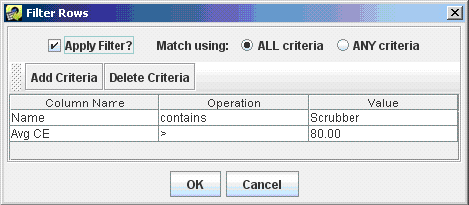

Filter Rows Dialog

**Figure 3-5. Filter Rows Dialog**

To add a second criterion click Add Criteria again on the **Filter Rows** dialog (e.g., enter **‘Avg CE > 80’**). Note that if Match using is set to **ALL criteria** then only rows that match all the specified criteria will be shown in the table after you click OK. If Match using is set to **ANY criteria**, then rows will be shown in the table if they meet any of the criteria that are listed.

Click OK to close the **Filter Rows** dialog and to apply the selected filter. Figure 3-6 shows the table that results from the selections shown in Figure 3-5. *Notice that the currently applied filter is reflected in the line under the horizontal scrollbar of the table.*

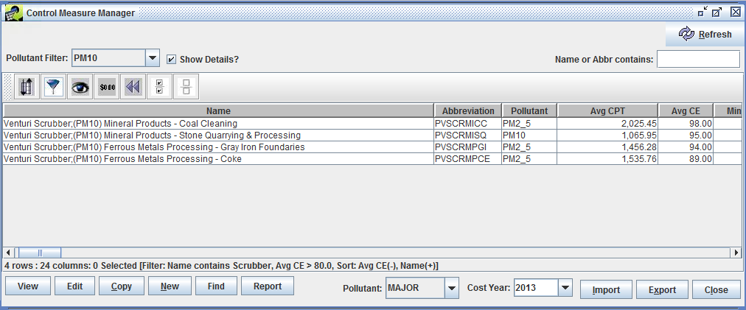

Control Measure Manager with Filter Applied

**Figure 3-6. Control Measure Manager with Filter**

Open the filter dialog again by clicking the Filter rows button. Set Match using to **ANY criteria** and then click OK to see what effect it has on the measures shown. Hint: you should see more measures displayed than when Match using is set to **ALL criteria**.

**Step 1-11: Remove Filters from the Control Measures Table.** Open the filter dialog again by clicking the Filter rows button. Remove one of criteria by clicking somewhere in one of the rows shown on the Filter Dialog and then clicking Delete Criteria. Now click OK to have the less stringent filter take effect.

**Step 1-12: Select and Unselect Control Measures.** To select all of the control measures that meet your filter criteria, click the Select All button on the toolbar: . You will see that the checkboxes in the Select column are now all filled with checks. You may select or deselect individual measures by clicking their checkboxes in the Select column. In the next subsection, we will discuss operations that can be performed on selected measures, such as viewing them and exporting their data.

To unselect all of the measures, click the Clear all the selections button: and you will see that all of the checks in the Select column are now removed.

**Step 1-13: Show/Hide Columns.** To hide some of the columns that are shown in the table, click the Show/Hide columns button: . On the Show/Hide Columns dialog that appears (similar to the one shown in Figure 3-7), uncheck some of the checkboxes in the Show? column and then click OK. The columns you unchecked will no longer display in the control measures table.

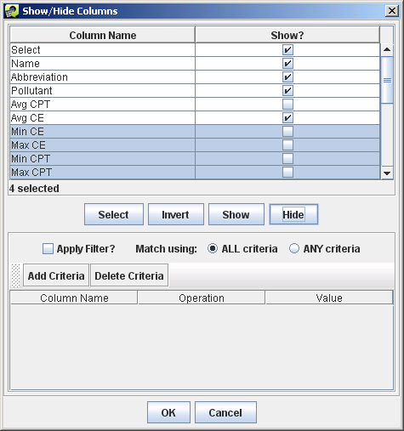

Show/Hide Columns Dialog

**Figure 3-7: Show/Hide Columns Dialog**

Click the Show/Hide columns button again and scroll down through the list of columns at the top of the dialog to see others that are farther down the list. To select multiple columns to show or hide, click on the first column name of interest, hold down the shift key, then click a second column name to select the intervening columns, and then click the Show button or the Hide button to either show or hide those columns.

To select columns that are not next to each other, hold down the control key and click on the columns that you want to select; when you are finished selecting click Showor Hide. The remaining buttons on the dialog are not used frequently: (a) Invert will invert the selection of highlighted columns. (b) The Add Criteria/Delete Criteria Filter section at the bottom can be used to locate columns when there are hundreds of column names, but there are no tables that large used in CoST.

**Step 1-14: Format Columns.** Click the Format Columns button, , to open the Format Columns dialog and examine the options for controlling how data in the table are shown. For example, check the checkboxes in the Format? column for one or more of the column names **“Avg CE”**, **“Min CE”**, and **“Max CE”** (note that you may first need to unhide the columns if you hid them in the previous step). Because these columns are all numeric, some controls used to format numbers will appear in the lower right corner.

Change the Font to **Arial**, the Style to **Bold**, the Size to **14**, the Horizontal Alignment to **Left**, the Text Color to **blue**, the Column Width to **6**, the number of Decimal Places to **0**, and select Significant Digits. Once these selections have been made, the dialog should look similar to the one in Figure 3-8. Click OK after making these selections to apply the formatting to the Control Measures table. The columns selected for formatting will have the attributes specified on the Format Columns dialog. In practice, this dialog is not used very often, but it can be particularly helpful to format numeric data by changing the number of decimal places or the number of significant digits shown.

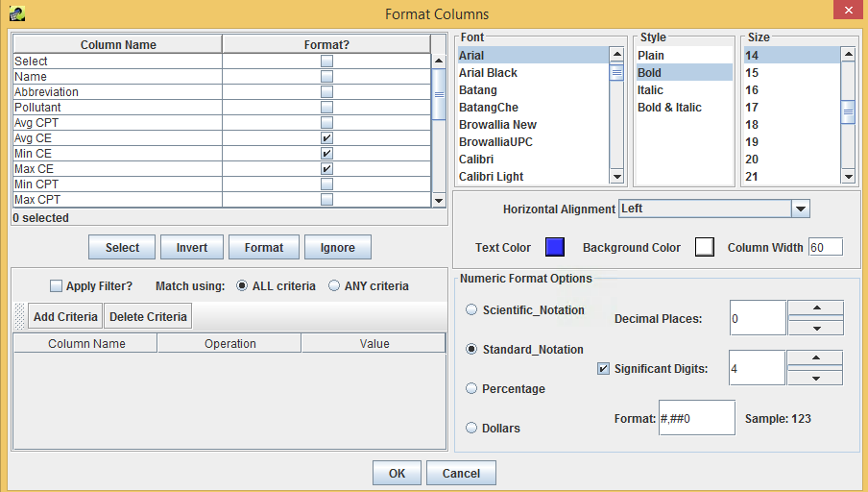

Format Columns Dialog

**Figure 3-8. Format Columns Dialog**

**Step 1-15: Reset Control Measures Table.** To remove sort criteria, row and column filters, and formatting, click the Reset button: in the Control Measure Manager window.

**Step 1-16: Mouse Hover Tooltip.** If you are unsure of what a button does when using CoST, place your cursor over the button and wait; in many cases, a small piece of text called a **“tooltip”** will appear. For example, place your cursor over one of the buttons on the Control Measure Manager window and hold it still. You will see a tooltip describing what the button does. Many of the buttons and fields used in CoST have tooltips to clarify what they do or what type of data should be entered.

**Step 1-17: Update Control Measures List.** If you wish to retrieve an updated set of control measures data from the CoST server, click the Refresh button: at the upper right portion of the Control Measure Manager. Note that this will also reset any special formatting that you have specified, but any sort and filter settings will be preserved.

## Viewing Data for an Existing Control Measure

In this section you will learn about viewing the detailed data for a control measure.

**Step 2-1: Select a Control Measure.** Select the control measure for which to view the underlying data. For example, in the Control Measure Manager, set the Pollutant Filter to **PM10**, and then in the table locate the Control Measure with the Name **“Dry Electrostatic Precipitator-Wire Plate Type;(PM10) Municipal Waste Incineration”** (Abbreviation = **PDESPMUWI**).

*Hint: Typing the abbreviation into the Name or Abbr contains box will display the measure directly.*

**Step 2-2: View Control Measure Data.** Click the checkbox in the **Select** column next to the measure and click View. The View Control Measure window will appear (Figure 3-9). There are several tabs available on the window; the Summary tab will be shown by default.

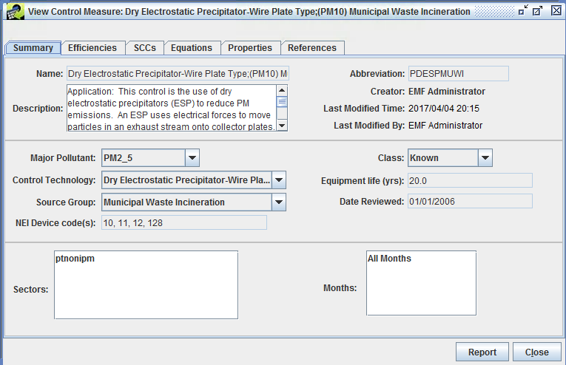

Summary Tab of View Control Measure Window

**Figure 3-9. View Control Measure Window**

### Control Measure Summary

**Step 2-3: Examine Control Measure Summary.** The Summary tab of the View Control Measure window contains high-level summary information about the measure. Table 3-2 shows brief descriptions of the fields on this tab.

**Table 3-2. Control Measure Summary Tab Contents.**

|  |  |
| --- | --- |
| Component | Description |
| Name | A unique name that typically includes both the control technology used and the group of sources to which the measure applies. |
| Description | A description of the applicability of the measure and any other relevant information. |
| Abbreviation | A 10-character unique abbreviation that is used to assign the control measure to sources in the inventory. Ideally, the abbreviation should be somewhat readable so that the user has some idea of what type of measure it is from reading the abbreviation (e.g., the DESP in PDESPIBCL is short for ‘Dry Electrostatic Precipitator, the IB is short for ’Industrial Boiler’, and the CL is short for ‘Coal’). |
| Creator | The name of the user who imported or created the measure. |
| Last Modified Time | The date and time on which the information about the measure was last modified in the editor or imported from a file. |
| Last Modified By | The last user to modify the measure. |
| Major Pollutant | The pollutant most controlled by the measure. This is used to group the measures only, and has no impact on how the measure is assigned to sources. |
| Control Technology | The control technology that is used for the measure (e.g., Low NO~x burner). You can type a new entry into this field and then choose it from the pull-down menu in the future. |
| Source Group | The group of sources to which the measure applies (e.g., Fabricated Metal Products - Welding). You can type a new entry into this field and then choose it from the pull-down menu in the future. |
| NEI Device Code | The numeric code used in the NEI to indicate that the measure has been applied to a source. A cross-reference table to match the control measure abbreviations and NEI Device Codes to one another may be created. |
| Class | The class of the measure. Options are Known (i.e., already in use), Emerging (i.e., realistic, but in an experimental phase), Hypothetical (i.e., the specified data are hypothetical), Obsolete (i.e., no longer in use), and Temporary (i.e., the specified data are temporary and should be used only for testing purposes). |
| Equipment Life | The expected life of the control measure equipment, in years. |
| Date Reviewed | The date on which the data for the measure were last reviewed. |
| Sectors | An emissions modeling sector or set of emissions modeling sectors to which the measure applies. A sector represents a broad group of similar emissions sources. |
| Months | The month(s) of the year to which the control measure is applicable. This is either “All Months” or a list of individual months (e.g., March, April, and May for measures applicable only in spring months). |

When viewing a control measure (as opposed to editing a control measure), you cannot make changes to any of the selections. However, you can review the available selections for some fields. Use the pull-down menus next to the fields Major Pollutant, Control Technology, Source Group, and Class to see the available options for each of these fields. Note that if you make a selection that differs from the original value on one of these menus, the new value will not be saved when you close the window because you are only viewing the measure data.

### Control Measure Efficiencies

**Step 2-4: Examine Control Measure Efficiencies.** Click on the Efficiencies tab in the View Control Measure Window to see the data that are available from this tab. You will see a table with many columns. Each row in the table corresponds to a different “efficiency record” in the database. An efficiency record contains cost and control efficiency information about the control measure. In the example shown in Figure 3-10, notice that the **Control Efficiency** and **cost data (CPT)** vary by pollutant. Scroll to the right in the table to see some of the other columns that are not immediately visible.

If the cost or control efficiency varies over region or time, it is possible to specify different records in the table for each Locale (i.e., state or county) or for each Effective Date if the measure will be “phased in” over time. Different efficiency records can also be entered to account for different source sizes using the Min Emis and Max Emis columns.

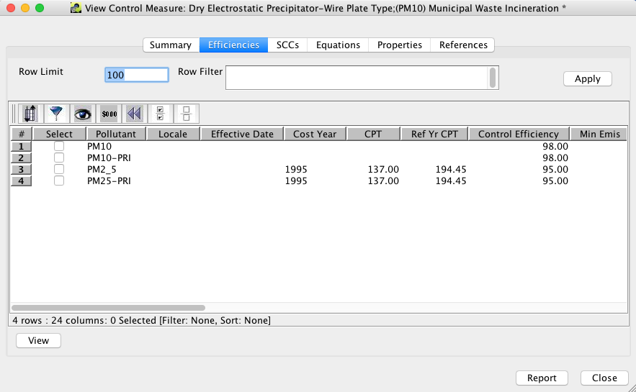

Efficiencies Tab of View Control Measure Window

**Figure 3-10. Control Measure Efficiencies Tab**

The Row Limit and Row Filter fields are helpful when there are hundreds or thousands of efficiency records (e.g., some data may be county specific and available for multiple pollutants). The Row Limit is the maximum number of records that will be displayed on the page. For example, if there were thousands of records, it could take a long time to transfer all of those data from the server, so by default only 100 records will be transferred if the Row Limit is set to 100.

**Step 2-5: Apply a Row Filter to Control Measure Efficiencies.** To apply a Row Filter to the control efficiencies, enter Pollutant='PM10' into the text field and then click Apply to display only the record for PM10. The Row Filter follows the syntax of a Structured Query Language (SQL) ‘WHERE’ clause. Note that the filter may not seem necessary in this particular example that only has a few records, but if this measure had entries for every county and pollutant, as do some mobile measures, then the filter is useful for limiting the number records displayed. If desired, you may try some other filters with this measure, such as:

Pollutant like 'PM%'  
Pollutant='PM10'  
Control Efficiency > 95

Here are some examples of other types of filters that illustrate other aspects of the syntax, although they may not all be applicable to this particular measure:

Pollutant <> 'PM10'  
Locale LIKE '37%'  
Pollutant IN ('EXH__CO', 'EXH__VOC', 'EXH__PM10')

**Step 2-6: View an Efficiency Record in a Separate Window.** To see the data for an efficiency record in a separate window, check the checkbox in the **Select** row for the PM2_5 efficiency record, and click View. A View Efficiency Record window will appear (Figure 3-11). The fields of the efficiency record are shown in Table 3-3.

Notice that most of the fields in Figure 3-11 are set using text fields. The Ref Yr Cost Per Ton Reduced is shown with a label because this value is automatically computed for the reference year (currently 2013) according to the cost year and the specified Cost Per Ton Reduced. Note that the cost per ton reduced should take into account the specified rule effectiveness and rule penetration, which ‘dilute’ the effectiveness of the control measure, but are not taken into account when the Ref Yr Cost Per Ton Reduced is computed. Other fields that are labels are Last Modified By and Last Modified Time. These fields are automatically updated and tracked by CoST when someone edits the efficiency record, although editing is done from the Edit Efficiency Record window instead of the View Efficiency Record window.

*Note: The efficiency records must be unique according to the contents of the following fields:* Pollutant, Locale, Effective Date, Minimum Emissions, Maximum Emissions, and Existing Measure Abbreviation. This means that two records cannot have the same values for all of these fields.

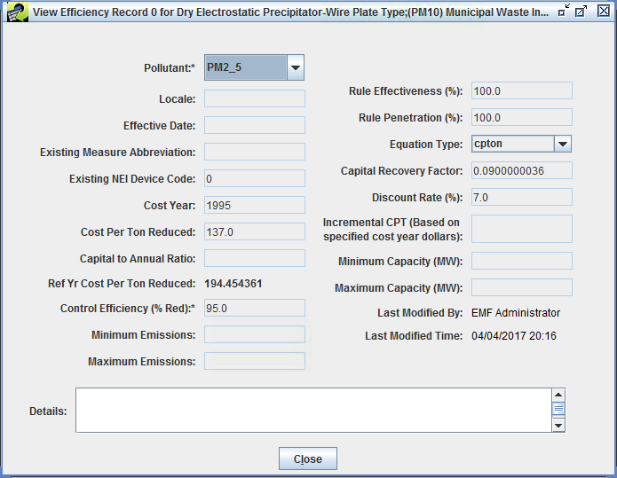

View Efficiency Record Window

**Figure 3-11. Efficiencies Record Window**

**Table 3-3. Efficiencies Record Window Contents.**

|  |  |
| --- | --- |
| Component | Description |
| Pollutant | The pollutant for which this record applies (emissions are either decreased or increased). An asterisk appears beside this field because a value for it must be specified. |
| Locale | A two-digit FIPS state code, or a five-digit FIPS county code, to denote that the information on the row is relevant only for a particular state or county. If left blank, it is assumed to apply to all states and counties. |
| Effective Date | The month, day, and year on which the record becomes effective. The system will find the record with the closest effective date that is less than or equal to the date of the analysis. If this is left blank, the record is assumed to apply to any date. |
| Existing Measure Abbreviation | This field should be populated when the data on the row are provided, assuming that a control measure has already been applied to the source. The contents of the field should be the control measure abbreviation that corresponds to the existing measure. The reason for this field is that the efficiency of and cost of applying the measure may vary when there is already a control measure installed on a source. |
| Existing NEI Device Code | This is used in conjunction with Existing Measure and should specify the device code used in the NEI that corresponds to the currently installed device. |
| Cost Year | The year for which the cost data are provided. |
| Cost per Ton Reduced | The cost to reduce each ton of the specified pollutant. |
| Capital to Annual Ratio | The ratio of capital costs to annual costs. *Applicable only for equation-based annualized costs.* |
| Ref Yr Cost per Ton Reduced | The cost per ton to reduce the pollutant in 2013 dollars. |
| Control Efficiency | The [median] control efficiency (in units of percent reduction) that is achieved when the measure is applied to the source, exclusive of rule effectiveness and rule penetration. An asterisk is shown next to the field because a value for the field is required, whereas other fields are optional. Eventually, statistical distributions for percent reduction may be provided to facilitate uncertainty analysis. *Note that there are sometimes disbenefits for certain pollutants as a result of the control device, so control efficiency can be negative to indicate that the amount of a pollutant actually increased.* |
| Minimum Emissions | The lower limit of emissions from the inventory required for the control measure to be applied. |
| Maximum Emissions | The upper limit of emissions from the inventory for the control measure to be applied. |
| Rule Effectiveness | The ability of a regulatory program to achieve all the emissions reductions that could have been achieved by full compliance with the applicable regulations at all sources at all times. A rule effectiveness of 100% means that all sources are fully complying at all times. Rule effectiveness can sometimes vary by locale. |
| Rule Penetration | The percent of sources that are required to implement the control measure. Rule penetration might vary over time as a new rule is “phased in” gradually, and can sometimes vary by locale. |
| Equation Type | The type of cost equation to use. |
| Capital Recovery Factor | The capital recovery factor to use. *Applicable only for equation-based annualized costs.* |
| Discount Rate | The discount rate used to compute the capital recovery factor. *Applicable only for equation-based annualized costs.* |
| Incremental CPT(Based on specified cost year dollars) | The cost to reduce a ton of the specified pollutant, when applied on top of an existing measure at an emissions source. |
| Minimum Capacity (MW) | The minimum capacity for the control measure (megawatts). |
| Maximum Capacity (MW) | The maximum capacity for the control measure (megawatts). |
| Last Modified By | The last user to modify the efficiency record. |
| Last Modified Time | The last date and time a user modified the efficiency record. |
| Details | Text that specifies information about the source of data for this row or reason they were changed. |

When you are done examining the information on the View Efficiency Record Window, click Close.

### Control Measure SCCs

**Step 2-7: View the Control Measure SCCs.** The inventory sources to which a control measure could be applied are listed in the SCCs tab for the control measure.

*Note that while multiple SCCs can be specified for a measure, if the control efficiency or cost data differs for any of the SCCs, then a separate measure must be created to contain that data.*

Click on the SCCs tab in the View Control Measure window to see the SCCs associated with the measure. An example of this tab is shown in Figure 3-12. The selected control measure is applicable only to SCCs listed on this tab.

*Note that CoST currently does not support wildcards in the SCC list for a control measure. There is no expanding of SCC codes ending in zeros; therefore each applicable SCC must be explicitly listed on this tab.* You may sort and filter the SCCs in the table to get a better idea of what SCCs are associated with the measure.

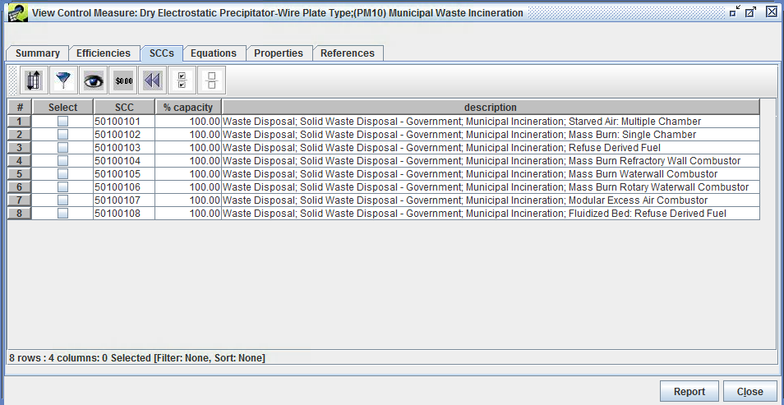

SCCs Tab of View Control Measure Window

**Figure 3-12. Control Measure SCCs Tab**

Do not click Close after examining the SCC list as this will close the View Control Measure window, which we will use for the next step.

### Control Measure Equations

As an alternative to using a simple ‘cost per ton of pollutant reduced’ value to compute the cost of a control measure, an engineering cost equation can be specified. The cost equation will then be used to associate emissions control costs with a particular pollutant. The equation must be selected from a list of pre-specified equation types. The equation will be computed using the form of the equation specified on the equations tab, source-independent variables listed in the equations tab, and source-dependent variables from the emissions inventory (e.g., stack flow rate). Currently, only a single equation can be specified for any given measure.

**Step 2-7: View the Control Measure Equations.** Click on the Equations tab on the View Control Measure window to see information associated with the cost equations for the selected measure. An example of this tab is shown in Figure 3-13. If the measure does not use a cost equation, this tab will be blank. The table at the bottom of the Equations tab shows the **Equation Type** (the same type is repeated in every row), in addition to the **Variable Name** and **Value** for that variable. The fields of the Equations tab are shown in Table 3-4.

Each type of equation uses a different set of variables. CoST supports eleven different types of cost equations. Additional types of equations may be added in the future. For more information on the Equations and their input variables, see the [Documentation of Cost Equations in EPA’s Control Strategy Tool (CoST)](https://www.epa.gov/economic-and-cost-analysis-air-pollution-regulations/cost-analysis-modelstools-air-pollution). The appropriate form of the equation will be used in conjunction with the specified values to compute the total cost of applying the measure to the source for the specified pollutant and cost year.

Do not click Close after examining the Equations as this will close the View Control Measure window, which we will use for the next step.

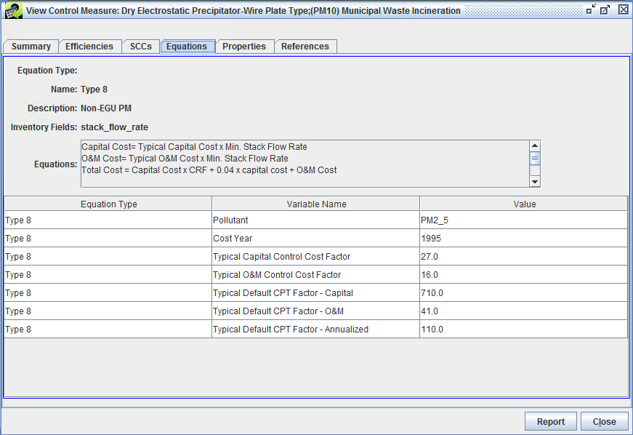

Equations Tab of View Control Measure Window

**Figure 3-13. Control Measure Equations Tab**

**Table 3-4. Efficiencies Record Window Contents.**

|  |  |
| --- | --- |
| Component | Description |
| Name | The name of the engineering cost equation type (e.g., Type 8). |
| Description | The description of the engineering cost equation type (e.g., Non-EGU PM Cost Equation). |
| Inventory Fields | The input parameters to the cost equations found in the inventory (e.g., stack velocity and temperature or design capacity). |
| Equations | The cost equation definitions. |

### Control Measure Properties

**Step 2-8: View the Control Measure Properties.** Click on the Properties tab on the View Control Measure window to see the data that are available from this tab. Each row in the Properties table corresponds to a different “property record” in the database. A property record allows for generic information to be stored about the control measures (e.g., metadata). The control measures example in Figure 3-14 shows property information that happened to be archived from the AirControlNET software when the measures were transferred into the CMDB.

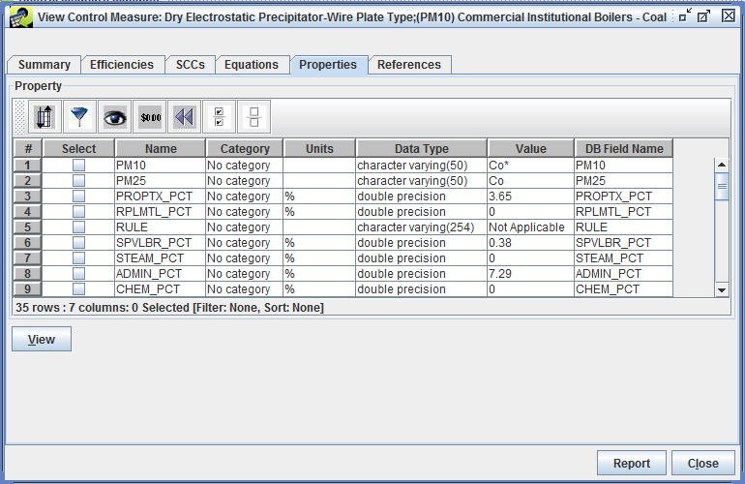

Properties Tab of View Control Measure Window

**Figure 3-14. Control Measure Properties Tab**

**Step 2-9: View a Properties Record in a Separate Window.** To see the data for a property record in a separate window, check a checkbox in the **Select** column and click View. For example, select the STEAM_PCT property record and click View. Figure 3-15 shows the View Property Record window that will appear. The fields of the property record are shown in Table 3-5.

Notice that most of the fields in Figure 3-15 are set using text fields. The Category is a free-form drop down, where an existing category could be used or a new one could be used by typing in the new category. When you are done examining the information on the View Property Record Window, click Close.

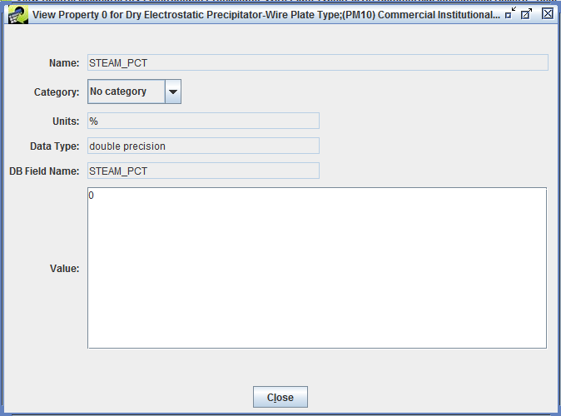

View Property Record Window

**Figure 3-15. Control Measure Property Record Window**

**Table 3-5. Property Record Window Contents.**

|  |  |
| --- | --- |
| Component | Description |
| Name | The name of the property. |
| Category | The category for the property (e.g., AirControlNET Properties, Cost Properties, or Control Efficiency Properties). |
| Units | The units for the property (e.g., % for percentage). |
| Data Type | If applicable, this defines the data type of the property (e.g., double precision/float for numeric values, or a varchar/string for textual information). |
| DB Field Name | If specified, this is a placeholder to help identify the database field name from the particular data source reference that supplied the property information (e.g., an ancillary dataset has a steam percentage stored in the STEAM_PCT table field/column). |
| Value | The value of the property. |

### Control Measure References

**Step 2-10: View the Control Measure References.** Click on the References tab of the View Control Measure window to see the report and literature citations associated with a control measure (Figure 3-16). Each row in the table corresponds to a different “reference record” in the database. A reference record stores source and reference information of the primary information used to create a control measure.

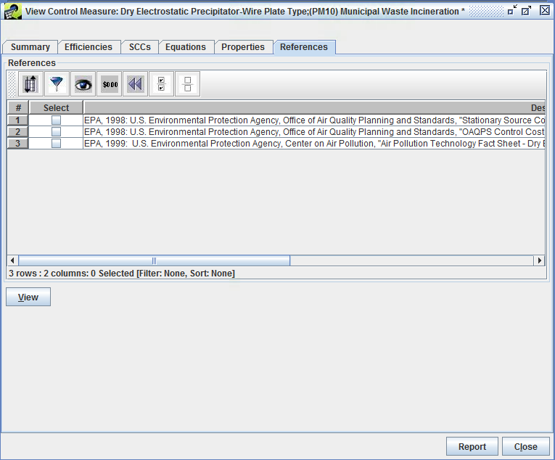

References Tab of View Control Measure Window

**Figure 3-16. Control Measure References**

**Step 2-9: View a References Record in a Separate Window.** To see the data for a reference record in a separate window, check a checkbox in the **Select** column and click View. For example, check the checkbox for the first reference record and click View. A View Reference Record window will appear (Figure 3-16) with an editable source/reference description text field.

When you are done examining the information on the View Reference Record Window, click Close.

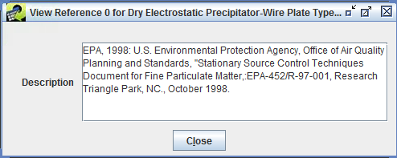

View Reference Record Window

**Figure 3-16. Control Measure Reference Record Window**

This concludes the exercises on examining existing control measures. Click Close to close the View Control Measure window.

## Copying a Control Measure

One way to create a new control measure in CoST is to copy an existing control measure and then edit its data.

**Step 3-1: Copy a Control Measure.** To copy a control measure, first find a measure to copy. Start by clicking the Reset button on the toolbar of the Control Measure Manager to remove any previously specified filters.

Next, uncheck the Show Details button at the top of the Control Measure Manager (to speed the data transfer) and set the Pollutant Filter at the top of the Control Measure Manager to the pollutant of interest. For this example select **NOx** and find the measure named **“Selective Non-Catalytic Reduction; ICI Boilers - Natural Gas”** (Abbreviation = **NSNCRIBNG**). *Hint: You may want to apply a filter to the manager to make it easier to find this specific measure.*

Once you have found the measure to copy, check the corresponding checkbox in the **Select** column and then click the Copy button. CoST will create a new control measure called **“Copy of *the starting measure name your name unique #“**. A unique abbreviation will also be automatically generated for the measure.

**Step 3-2: View the Copied Control Measure.** To see the new control measure in the Control Measure Manager, **Scroll** to the top of the window. If you do not see the measure, click the Refresh button at the top right of the Manager window to obtain updated data from the CoST server.

*Note: If the measure named ‘Copy of Selective Non-Catalytic Reduction; ICI Boilers…’ still does not appear, a filter may be active that is preventing the measure from showing up.* Remove any filters to see the newly copied measure.

View the contents of the copied measure by selecting the checkbox next to the measure and clicking the View button. The new measure will be edited in the next section.

## Editing Control Measure Data

Only control measures created by the current CoST user can be edited through the Control Measure Manager. Only CoST Administrators can edit all of the measures in the CMDB.

**Step 4-1: Find a Control Measure to Edit.** First, click the Clear all the selections button to unselect any previously selected measures: . For this exercise, find the measure created using the copy button (Section 3) in the Control Measure Manager and check the corresponding select box in the **Select** column. Click Edit to edit the data for the control measure. The Edit Control Measure window will appear (Figure 3-17).

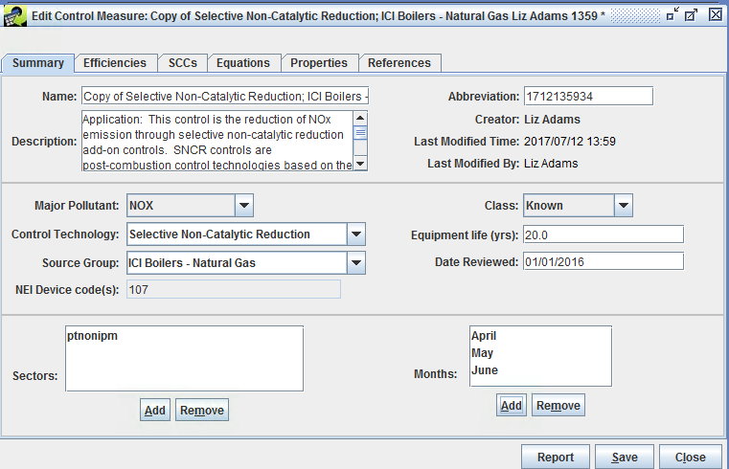

Summary Tab of Edit Control Measure Window

**Figure 3-17. Edit Control Measure Window**

### Editing a Control Measure Summary

Like the View Control Measure window, the Edit Control Measure window has six tabs, and the Summary tab is shown by default. The main difference between the View and Edit windows is that the control measure contents can be changed in the Edit window, rather than just viewing the information.

Notice that most of the fields have white backgrounds, which usually indicates that the field is editable; fields that are not contained within boxes are set by the software and cannot be changed by the user. In addition, there are Add and Remove buttons for the lists of Sectors and Months.

**Step 4-2: Change a Control Measure Name.** The name of a control measure can be changed on the Summary tab of Edit Control Measure window. For example, you may change the part of the measure name that deals with the affected sources, such as **Selective Non-Catalytic Reduction; ICI Boilers - Natural Gas and Oil**. Recall that measure names must be unique.

When the measure was copied, the abbreviation was set to a number that was known to be unique so that it could be saved in the database. Replace the automatically generated Abbreviation for the new measure with something else (e.g., **NSNCRIBNGO**). Try to follow a similar naming convention as the other measures, but your new abbreviation must be unique in the database.

**Step 4-3: Edit Other Fields in the Control Measure Summary.** Edit the other **Summary** fields of the measure as desired. For this exercise, change the Equipment Life to **10**,the Date Reviewed to **today’s date**, set Class to **Emerging**, and make any other changes you wish, such as entering a more detailed Description.

Click the Add button under the Sectors list to add another sector for the measure. For example, from the Select Sectors dialog, choose **ptipm** (i.e., point sources handled by the Integrated Planning Model) and click OK. You will then see the new sector added to the list of applicable sectors. *Note that the sectors listed here are informational only; they do not affect the use of the measure in control strategies in any way.*

**Step 4-4: Remove a Control Measure Sector.** To remove a sector from a Control Measure, click on the sector in the list and click Remove and it will no longer appear on the list.

**Step 4-5: Setting Months for a Control Measure.** Adding and removing Months to which a control measure applies works similarly to adding and removing sectors. For this exercise, specify some specific months to which the measure should apply (e.g., **March**, **April**, and **May**).

*Note: the feature of setting specific months for which a measure applies is effective only when applying measures to monthly emission inventories. Specifying months in this way is not effective when applying measures to annual emission inventories.*

To set the months back to All Months, select all of the months in the Months list by clicking on the first month, scrolling to the last month in the list, and using **shift-click** with your mouse to select all of the months in the list. Click Remove to remove specific months and to set the measure to be applicable to all months.

**Step 4-6: Discard Changes.** Now that you have changed information for the measure, notice that an asterisk (*) appears after the measure name in the title for the window. This means that CoST is aware that you have made changes. If you try to Close a window on which you have made changes to the data without saving it, CoST will ask you “Would you like to discard the changes and close the current window?” If you want to discard (i.e., undo) ALL of the changes made since you started editing the measure, click Yes. If you prefer to not to close the window so that your changes stay in-tact, click No. For this exercise, click No to preserve the changes that you made.

### Editing Control Measure Efficiencies

**Step 4-7: Edit Control Measure Efficiencies.** Go to the Efficiencies tab of the Edit Control Measure Window (Figure 3-18). The buttons on the Efficiencies tab of the Edit window are different from those on the View window. The available buttons are Add, Edit, and Remove. Notice the efficiency record for the measure shown in Figure 3-18 is for only one pollutant, and that this record can be applied only to sources emitting at least 25 tons/yr as specified in the **Min Emis** field.

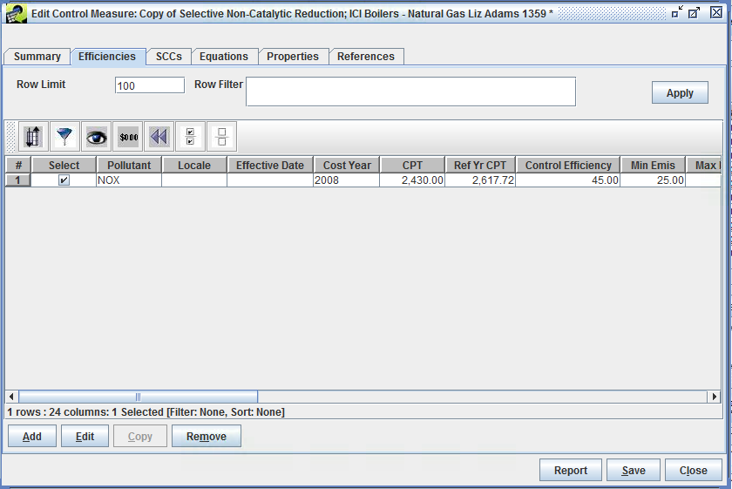

Efficiencies Tab of Edit Control Measure Window

**Figure 3-18. Edit Control Measure Efficiencies**

Scroll to the right to examine additional efficiencies fields. Note that more of the fields are filled in for NOx than for the PM measure that you examined in Section 2. The additional data allows CoST to compute the capital and operating and maintenance (O&M) costs in addition to overall annualized costs when this measure is used in a control strategy.

To edit an efficiency record, check the checkbox in the **Select** column for the pollutant to edit and then click Edit. The Edit Efficiency Record window will appear (Figure 3-19).

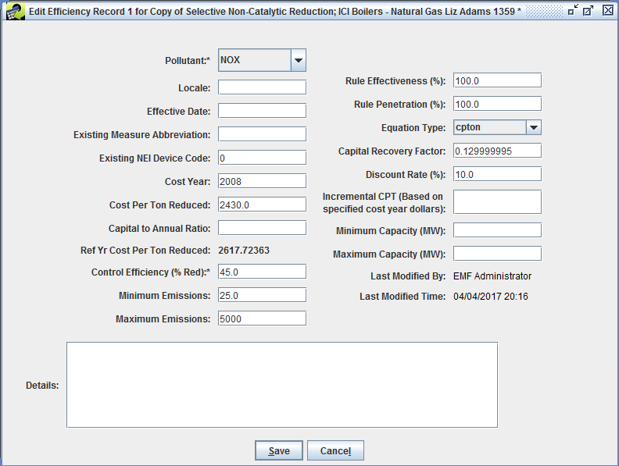

Edit Efficiency Record Window

**Figure 3-18. Edit Control Measure Efficiencies Window**

Edit the values for the efficiency record to configure the new control measure. For this exercise, set Maximum Emissions to **5000** and click Save. The value for this field is now updated in the table in the Edit Control Measure window. The measure will apply only to sources that emit between 25 and 5000 tons of NOx annually.

**Step 4-8: Add a Control Measure Efficiency Record.** To add a new efficiency record, click Add in the Edit Control Measure Efficiencies tab. Fill in the fields in the Add Efficiency Record window to create the new Efficiencies record. For this exercise, select **CO2** as the Pollutant, set Locale to **06**, set Effective Date to **01/01/2015**, and set Control Efficiency (% Red) to **10**. Click Save to save the new record. A new row will appear in the table on the Efficiencies tab in the Edit Control Measure window. The effect of this new record will be to include a 10% reduction to CO2 emissions for sources in California (FIPS=06) starting on 01/01/2015 when this control measure is applied.

**Step 4-9: Remove a Control Measure Efficiency Record.** To remove one or more efficiency records, click the corresponding checkboxes next to the record and then click Remove to remove those records. For this exercise, click the checkbox in the **Select** column for the CO2 record that you just added and click Remove to remove that record. When asked to confirm removal of the selected record, click Yes. The record will disappear from the Efficiencies table.

**Additive impact of multiple efficiency records.** If cost per ton (CPT) values are specified for multiple efficiency records, they are additive when they are used in a control strategy. For example, if a CPT is specified for both NOx and VOC for a measure, the total cost of applying the measure is the sum of (1) the CPT for NOx times the NOx emissions reduced and (2) the CPT for VOC times the VOC emissions reduced.

### Editing Control Measure SCCs

**Step 4-10: Edit Control Measure SCCs.** Click on the SCCs tab on the Edit Control Measure window to show the SCCs for inventory sources to which the edited measure can be applied. SCCs may be added or removed for a measure from this window. An example of this tab is shown in Figure 3-19.

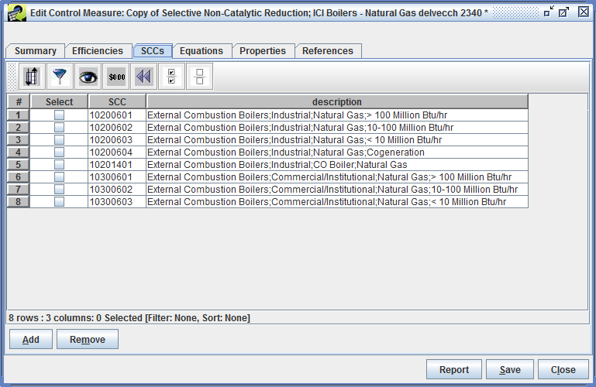

SCCs Tab of Edit Control Measure Window

**Figure 3-19. Edit Control Measure SCCs**

To add new SCCs, click the Add button to display the Select SCCs window (Figure 3-20). Note that there are over 11,900 possible SCCs to use for developing control measures. The number of available SCCs can be found in the lower left hand corner of the Select SCCs dialog.

To filter the SCCs for the new measure on the Select SCCs window, click the Filter Rows button on the toolbar. For this exercise, when the Filter Rows dialog that appears, click Add Criteria three times, enter the following criteria, then click OK:

* Description contains Natural Gas
* Description contains Boiler
* SCC starts with 1

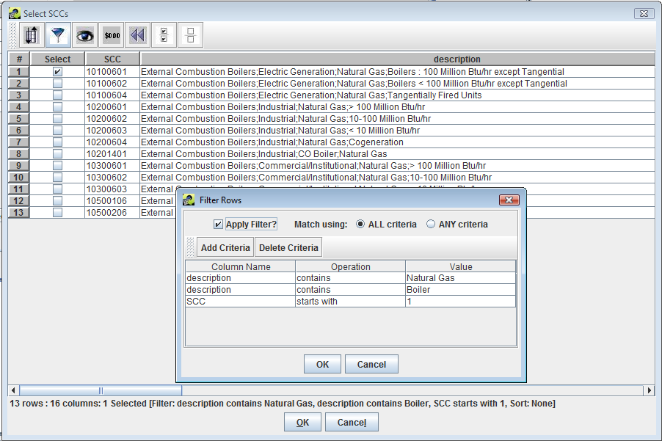

Select SCCs and Filter Rows Dialogs

**Figure 3-20. Select SCCs and Filter Rows Dialog Box**

The Select SCCs window will show only the SCCs that met the above criteria, such as the 13 SCCs shown in Figure 3-20. While many of these SCCs are already associated with the measure (i.e., they are already shown on the SCCs tab of the Edit Control Measure window in Figure 3-19), a few additional SCCs (i.e., the ones starting with 101 and 105) are also relevant for this measure.

**Step 4-11: Add SCCs to a Control Measure.** Click the checkbox in the **Select** column for the SCCs to add to the measure. For this exercise, select **10100601** and then click OK. The SCC will now appear in the list of applicable SCCs for the measure in the Edit Control Measure window. *Note: If you select an SCC to add that was already on the SCCs tab, it will not cause any problems and it will not add the SCC for a second time.*

*Tip for adding multiple of SCCs:* If you need to add several SCCs and are able to specify a filter on the Select SCCs dialog that results in only the SCCs that are appropriate for the control measure being shown, click the Select All button on the toolbar to select all of the SCCs at once. Then, when you click OK, all of the SCCs will be added to the SCCs tab for the measure. This avoids requiring you to click all of the individual Select checkboxes. Alternatively, if most but not all of the SCCs were appropriate, you could select all of them and then click on a few checkboxes to deselect the ones that were not needed and then click OK to add only the ones that remained selected.

### Editing Control Measure Equations

**Step 4-12: Edit Control Measure Equations.** Go to the Equations tab of the Edit Control Measure window (Figure 3-21). Double click your mouse in the **Value** column next to the variable named **Cost Year**. For this exercise, change the value to **1995** and then press the Enter key on your keyboard. You will see that the new cost year is set to 1995. Note that the values for other fields could be changed in a similar way.

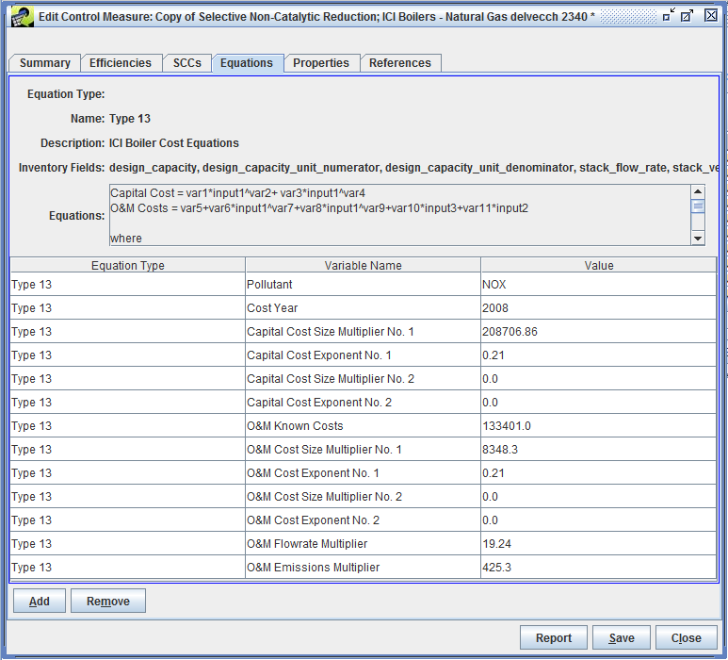

Equations Tab of Edit Control Measure Window

**Figure 3-21. Edit Control Measure Equation Window**

**Step 4-13: Remove Control Measure Equation Data.** To remove all of the equation information, click the Remove button. You will see a dialog that says “Are you sure you want to remove the equation information”? To demonstrate how removing and resetting equation information works, click Yes to remove the equation information. All of the equation information will be removed from the Equations tab.

**Step 4-14: Add Control Measure Equation Data.** To add equation information to a measure, click the Add button on the Equations tab. You will see a Select Equation Type dialog. Click the pull-down menu to see the available types of equations and select the desired equation type. For this exercise, select **Type 1 - EGU** and click OK. You will see that there are eight variables for this equation type. Note that the variables differ somewhat from the variables for the Type 13 equation shown in Figure 3-21, and that the Type 1 equation is for NOx controls.

Details on the types of cost equations and their variables are given in the [Documentation of Cost Equations in EPA’s Control Strategy Tool (CoST)](https://www3.epa.gov/ttn/ecas/docs/CoST_Equations_Document_2016_03_15.pdf).

For this exercise, click the Remove button again Yes to confirm removal of the equation information. Click the Add button on the Equations tab and select **Type 13 - ICI Boiler Cost Equations**. Next, fill in the values for the variables as they are shown in Figure 3-21 by double clicking on the field corresponding to each value and then entering the appropriate information.

*Note: You can enter cost equations in terms of only one pollutant, even if the measure reduces emissions for multiple pollutants.*

Click Save at the bottom of the Edit Control Measure window to save the changes you made to the control measure and to close the window. To see the revised name and abbreviation for the new measure, click the Refresh button at the upper right of the Control Measure Manager to load the updated data from the server.

### Editing Control Measure Properties

**Step 4-15: Edit Control Measure Properties.** Go to the Properties tab of the Edit Control Measure Window (Figure 3-22). The buttons on the Properties tab of the Edit window are different from those on the View window. The available buttons are Add, Edit, and Remove. The property record allows for freeform property metadata/information to be associated with the measure. The property can be assigned a category grouping (e.g., Steam Factors), units (e.g., MW/hr), and a data type (e.g., numeric).

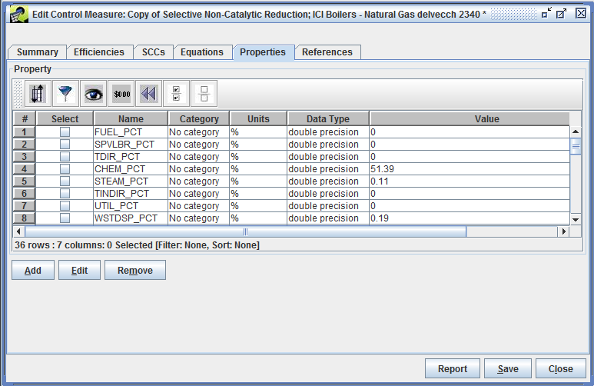

Properties Tab of Edit Control Measure Window

**Figure 3-22. Edit Control Measure Properties Window**

To edit a property record, scroll down to the **COST_BASIS** property, and check the corresponding checkbox in the **Select** column for the **COST_BASIS** property and then click Edit. The Edit Property Record window will appear (Figure 3-23). The data type is text, which means the property will contain textual information about the measure. Note also how the value field contains detailed information about the methodologies used for costing this control measure.

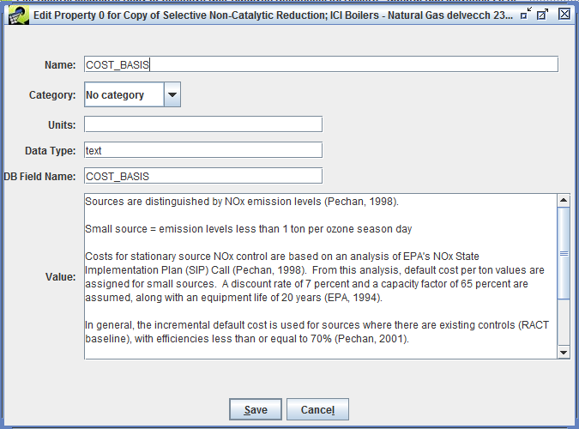

Edit Property Record Window

**Figure 3-23. Edit Property Record Window**

Edit the value for the property record as needed to reflect the new control measure. For this exercise, add some additional text to the Value, then click Save.

**Step 4-16: Add a New Control Measure Property.** To add a new property record, click Add in the Propertiestab. Fill in the appropriate values in the Add Property Record window that appears. For this exercise, set the Name to “POWER_LOSS”, select **No category** as the Category, **MW/hr** for the Units, **numeric** for the Data Type, **POWER_LOSS** for the DB Field Name, and **5** as the Value. Click Save once this information is entered and a new row will appear in the table in the Edit Control Measure window.

**Step 4-17: Remove a New Control Measure Property.** To remove one or more property records, click the corresponding checkboxes and then click Remove. For this exercise, click the checkbox in the **Select** column for **POWER_LOSS** and then click Remove and confirm with Yes to remove that record. The **POWER_LOSS** record will disappear from the table.

### Editing Control Measure References

**Step 4-18: Edit Control Measure References.** Go to the References tab of the Edit Control Measure Window (Figure 3-24). The available edit buttons in this window are Add, Edit, and Remove.

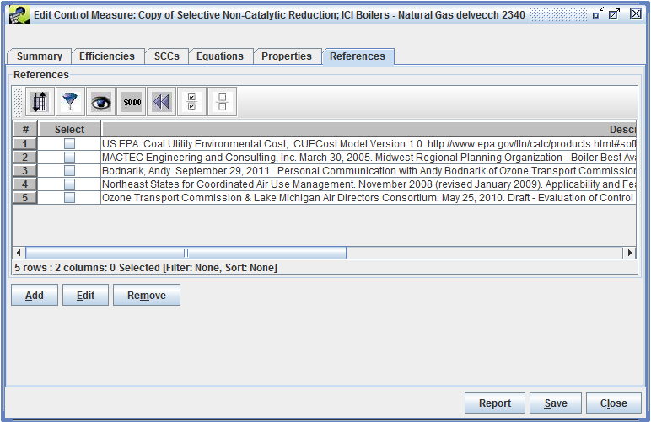

References Tab of Edit Control Measure Window

**Figure 3-24. Edit Control Measure References Window**

To edit an existing reference record, check the corresponding checkbox in the **Select** column and click Edit. For example, click the box next to the **“MACTEC Engineering and Consulting…”** reference entry and then click Edit. The Edit Reference Record window will appear (Figure 3-25).

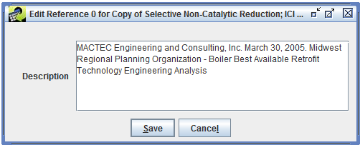

Edit Reference Record Window

**Figure 3-25. Edit Reference Record Window**

Edit the value for the reference record as needed to reflect information for the new control measure. For this example, add some additional text to the Description box, then click Save.

**Step 4-19: Adding Control Measure References.** To add a new reference for a control measure, click Add in the References tab, and the **Add Reference Record** window will appear (Figure 3-26). Either choose a reference that already exists in the database, or add a new reference.

To choose an existing reference, click on theUse existing reference option and then search for the reference by filling in the Text contains field, then click Search. When you have located the correct reference, select the item in the References box and click Save to add the reference to the control measure.

To create a new reference, click on the Create new reference option and then type the reference in the Description field, then click Save to add the reference to the control measure. For this exercise, click on Create new reference and then add **“sample technical reference”** to the Description field. Click Save and a new row will appear in the References table in the References tab of the Edit Control Measure window.

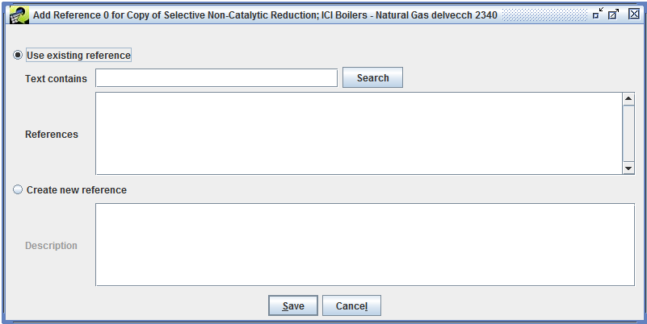

Add Reference Record Window

**Figure 3-26. Add Reference Record Window**

**Step 4-20: Remove Control Measure References.** To remove one or more reference records in the References tab, click the checkbox(es) next to the reference(s) to remove and then click Remove. For this exercise, click the checkbox in the **Select** column for the record for “sample technical reference” that you just added and click Remove and Yes to confirm to remove that record. The record will disappear from the references table.

Click **Save** at the bottom of the Edit Control Measure window to save the changes you made to the control measure and to close the window.

## Creating a New Control Measure

This section describes how to create new CoST control measures through the Control Measure Manager.

**Step 5-1: Add a New Control Measure.** To create a new control measure, click New on the Control Measure Manager to display the New Control Measure window as shown in Figure 3-17, except with none of the control measure information filled in.

**Step 5-2: Adding a New Control Measure: Summary.** Enter a unique name (e.g., New PM10 Control Measure) in the Name field and a unique abbreviation (e.g., PNCM) in the Abbreviation field for the control measure. You must also set the Major Pollutant (e.g., PM10) and Class (e.g., Hypothetical) and the Date Reviewed for the measure before the measure can be saved into the CMDB. For more information on the fields in the Summary tab, see Section 2 and Section 4 above.

**Step 5-3: Adding a New Control Measure: Efficiencies.** Go to the Efficiencies tab of the New Control Measure window and add at least one efficiency record for the measure; otherwise it will have no effect on any emissions sources. The efficiencies tab for the new measure will look similar to Figure 3-18, except initially there will be no efficiency records. For more information on the data needed for efficiency records, see Section 2 and Section 4. Add as many efficiency records as needed to describe the control efficiency and cost of the measure.

**Step 5-4: Adding a New Control Measure: SCCs.** Go to the SCCs tab of the New Control Measure window and add at least one SCC record for the measure; otherwise it will have no effect on any emissions sources. The SCC tab for the new measure will look similar to Figure 3-19, except initially there will be no SCCs records. Note that the same control efficiency and cost information must apply to all sources with SCCs listed on this tab, otherwise the information must be stored in a separate measure for the other SCCs. For more information on the data needed for SCCs, see Section 2 and Section 4.

**Step 5-5: Adding a New Control Measure: Equations.** To associate a cost equation with the new measure, go to the Equations tab and add an equation. The tab should look similar to the one shown in Figure 3-21. Cost equations are optional. If you do not have a cost equation, cost per ton information from one or more of the efficiency records will be used to estimate the cost of applying the measure.

**Step 5-6: Adding a New Control Measure: Properties and References.** To associate a property with the measure, go to the Properties tab and add a property. The tab should look similar to the one shown in Figure 3-22. Properties are optional.

To associate a reference with the measure, go to the References tab and add a reference. The tab should look similar to the one shown in Figure 3-24. References are optional.

After all of the relevant information for the measure has been entered, click Save at the bottom of the New Control Measure window.

**Step 5-7: View the New Control Measure.** Set the Pollutant Filter in the Control Measure Manager to a pollutant specified for one of the new measure’s efficiency records (e.g. PM10), and you will see the new measure listed Manager window. If you do not see it, try clicking the Refresh button to reload the measures from the server.

## Finding Available Control Measures for Specific SCCs

If the SCCs are known for a source, the Find button on the Control Measure Manager (e.g., see Figure 3-4) can be used to display which control measures are available for sources with those SCCs.

**Step 6-1: Find Control Measures for SCCs.** Before using the Find feature, set the Pollutant Filter (in the top left corner of the Control Measure Manager) to **Select one**, and click the Reset button on the toolbar, so that no pollutant or other filters will be applied prior to performing the next step. Click the Find button. You will see the Select SCCs window, similar to the one shown in Figure 3-20, except that all 11,900+ SCCs will be shown.

Use the Filter Rows button on the toolbar of the Select SCCs window to enter a filter that will help identify SCCs for which you would like to see available control measures. For this example, click Add Criteria twice and add the filters **SCC starts with 103** and **SCC starts with 305006**, select Match using **ANY criteria**, and click OK. You should see 83 SCCs that meet this criterion.

Click the checkbox in the **Select** column for a few of the SCCs (e.g., select at least **10300101** and **30500606**) and then click OK. If there are measures available for the selected SCC(s), they will be shown in the table. If you selected an SCC for which there are no measures available, none will be shown.

Click Find again and enter a filter on the Select SCCs window based on the SCC description instead of the SCC itself. For example, use the Filter Rows button on the Select SCCs window toolbar to enter the filter **description contains Cement**, then click on the checkbox in the **Select** column for a few of these SCCs (e.g., 30500606) and click OK. If there are measures in the database for the selected SCCs, they will be shown in the Control Measure Manager table. Note that there may be some SCCs for which there are no measures available in the database. In that case, no measures would be shown in the table after applying the SCC filter. For the measures that are returned, notice whether they all have the same value for Pollutant (e.g., measures for SCC 30500606 target NOx, PM2_5, and SO2).

## The Pollutant Menu

The Pollutant pull-down menu near the bottom of the Control Measure Manager selects the pollutant for which the **CPT**, **Control Efficiency (CE)**, **Rule Effectiveness**, and **Rule Penetration** data are shown in the Control Measure Manager. Note that to view these fields Show Details must be checked and you may need to scroll right or widen the window. Recall that each control measure can have efficiency records for multiple pollutants. By setting the Pollutant Filter at the top of the window, any measures that controls the selected pollutant will be shown in the table. The Pollutant pull-down menu displays the specific setting for the selected pollutant.

**Step 7-1: Use the Pollutant Menu.** To see the effect of the Pollutant pull-down menu, click the Reset button on the Control Measure Manager toolbar to remove any previously specified filters. Set the Pollutant Filter to **PM2_5** and make sure that Show Details? is checked. Set the Pollutant menu at the bottom of the window to **MAJOR**.

Examine the values in the **Avg CPT**, **Min CPT**, **Max CPT**, **Avg CE**, **Min CE**, and **Max CE** columns for some of the measures. Notice that for some of the measures, PM2_5 is not the pollutant listed in the **Pollutant** column (e.g., sort on the Pollutant column by clicking on it once or twice to find other pollutants). These measures are shown in the manager because they all apply to PM2_5, even if PM2_5 is not the major pollutant for the measure. In this case, the CPT and CE values are shown for the major pollutant specified for the measure, not necessarily for PM2_5.

Change the value of the Pollutant menu to something other than **MAJOR** (e.g., **PM10**). All entries in the **Pollutant** column are now set to the pollutant specified in the Pollutant menu, and the cost per ton (CPT) and control efficiency (CE) values are specific to the selected pollutant instead of being for the major pollutant specified for the measure. Note that CPT values may not be filled in for some measures. For PM measures, the cost information is typically associated with PM10, as opposed to PM2_5. Therefore, if the **Pollutant** menu is set to PM2_5, fewer CPT values will be shown than when Pollutant is set to PM10.

## The Cost Year Menu

The Cost Year pull-down menu near the bottom of the Control Measure Manager controls the year for which the cost data are shown in the Manager. The default cost year is 2013. The cost data are converted between cost years using the Gross Domestic Product (GDP): Implicit Price Deflator (IPD), issued by the U.S. Department of Commerce, Bureau of Economic Analysis. Details of the computation used are given in the “Control Strategy Tool (CoST) Development Document”.

**Step 8-1: Change the Cost Year.** Change the cost year in the Cost Year menu from 2013 to an earlier year (e.g., 2010). Note how the CPT values decrease. If the cost year is changed to a later year, the CPT values increase.

*Note that due to the method used to convert the costs between years, it is not possible to show costs for a future year (e.g., 2025); costs can be shown only for years prior to the current year.* As there is a 1- to 2-year lag between the current year and the latest available cost year data, the Cost Year cannot be set to the current year.

If an equation is specified for a measure, and there are no default CPT data available for that measure, the CPT will not be shown in the Control Measure Manager because it must be applied to an emissions source for the cost to be computed.

## Importing and Exporting Control Measure Data

Control measure data can be exported from the Control Measure Manager to a set of CSV files. First identify a set of control measures for which to export data. Measures may be exported based on specifically selected control measures via the Control Measure Manager, or an entire set of measures associated to a certain sector may be exported.

### Exporting Control Measures

**Step 9-1: Export PM10 Control Measures.** To export measures that control PM10, set the Pollutant Filter on the Control Measure Manager to **PM10**. Next, use the Filter Rows button the toolbar to enter the following criterion: **Name contains Fabric Filter**. The Manager will display 44 measures.

Click the Select all button on the Control Measure Manager toolbar, and then click the Export button. The Exporting Control Measures window (Figure 3-27) will appear.

To export by selected measures, select the Export By Measure option . The list of measures displayed for export are the same measures that were chosen from the Control Measure Manager. Note it’s not necessary to click the “Select” checkboxes for these measures, all measures shown in the list will be exported regardless if they are checked or not. To export by inventory sector, select the Export By Sector option, then choose the various sectors for which to export control measures.

For this exercise, select Export By Measure to export the preselected measures from the Control Measure Manager. To specify the output folder (i.e., directory) into which the CSV files will be written, type the folder name into the Server Export Folder text field or use the Browse button to bring up a file and directory browser to select the output folder. To specify an export file name prefix for naming the new exported files, type the prefix string into the File Name Prefix text field.

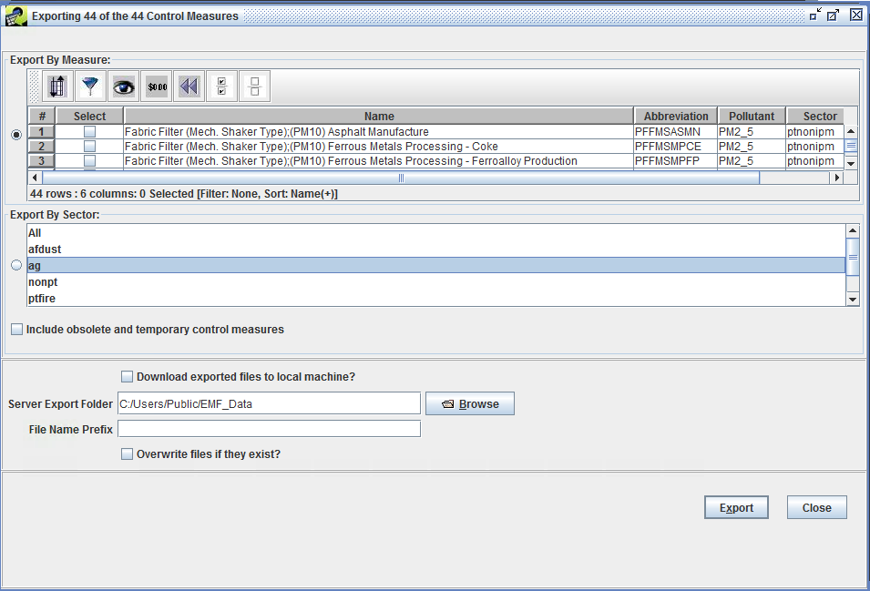

Exporting Control Measures Dialog

**Figure 3-27. Export Control Measures Window**

Type an export file prefix string (e.g., fabric_filter) into the File Name Prefix field of the Exporting Control Measures window. This string will be included at the beginning of the names of the exported CSV files to help identify the types of measures that are included in the files.

After setting the desired output folder and the file name prefix on the Exporting Control Measures window, click the Export button. The message at the top of the Export window will state that the export has started and to monitor the **Status** window to track the export request.

The **Status** window is near the bottom of the EMF main window. It will show a message when the export starts and another when it is finished. Monitor the status on demand by clicking the Refresh button at the top of the **Status** window.

**Step 9-2: View the Exported Control Measures.** After the export is finished, close the Exporting Control Measures window by clicking Close. Use your computer’s file browser to view the contents of the folder that you selected for the export. In the example shown above, the files created in the selected folder are: **fabric_filter_summary.csv**, **fabric_filter_efficiencies.csv**, **fabric_filter_SCCs.csv**, **fabric_filter_equations.csv**, **fabric_filter_Props.csv**, and **fabric_filter_Refs.csv**. These files may be opened with standard spreadsheet software. For a complete description of the fields in the files, see “Control Strategy Tool (CoST) Control Measures Database (CMDB) Documentation”.

### Importing Control Measures

Files in the exported format can also be imported into the CMDB. Control measures can only be imported to CoST/EMF by an Administrator.

**Step 9-3: Import Control Measures.** If logged in as Administrator, click the **Import** button on the Control Measure Manager to start importing measures. In the **Import Control Measures** window that appears (Figure 3-28), type or paste the name of the import Folder. You may also use the Browse button to browse to a folder containing the files to be imported and select the files directly from the browser. Alternatively, enter the folder name and then type in a **pattern** to specify the files, then click Apply Pattern. When using a pattern, an asterisk (*) will be expanded to the available file names.

After selecting the files to import, click the Import button. Information about the status of the import will be shown in the **Status** section of the window. To see updates to the status of the import, click the Refresh Import Status button. Once the imports are complete, click the Done button. If the measures already existed in the database, the new data will replace the existing data.

*Note that as there will be no warning before the CMDB data are replaced, use the import feature with caution.*

It is possible to purge existing measures from the CMDB by sector. This feature will remove all measures associated with the sectors chosen in the Purge Existing Measures By Sectors list. The user must also click the Purge checkbox to allow the measures to be purged. The measures will be purged when the Import button is clicked.

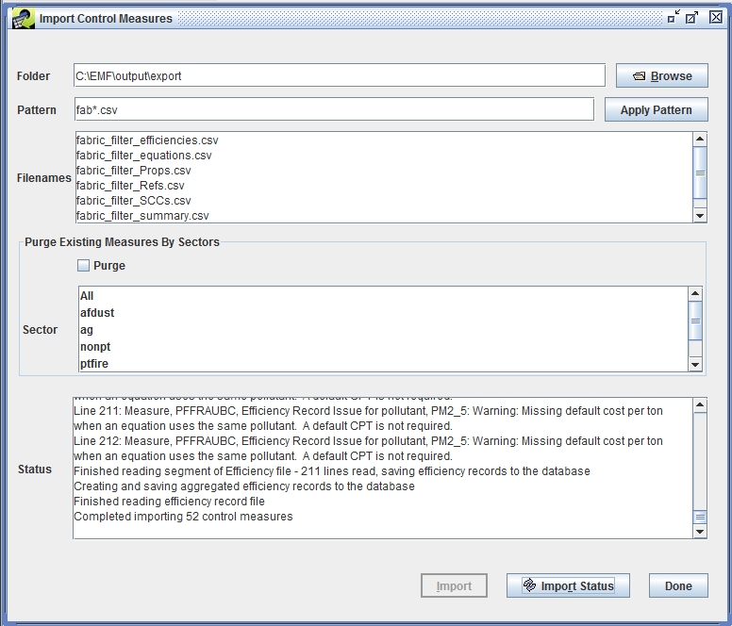

Import Control Measures Dialog

**Figure 3-28. Import Control Measures Window**

# Control Strategy Manager

## Introduction

This chapter demonstrates the features of the Control Strategy Manager. The Control Strategy Manager allows control strategies to be created, edited, copied, and removed. **A control strategy is a set of control measures applied to emissions inventory sources (in addition to any controls that are already in place) to accomplish an emissions reduction goal.** Such goals are usually set to improve air quality and/or to reduce risks to human health. In this chapter, you will learn how to:

* View, sort, and filter a list of control strategies from the *Control Strategy Manager* window
* Create control strategies
* Edit control strategies to specify their inputs and parameters
* Run control strategies
* Copy control strategies
* Remove control strategies
* Analyze and summarize outputs from control strategies

This chapter is presented as a series of steps so that it may be used as part of a training class or as a tutorial on how to use CoST. The numbered steps are the ones you are expected to perform, while other material is provided for documentation purposes.

### Introduction to Control Strategies

CoST automates the key steps for preparing control strategies. The purpose of developing control strategies is to answer questions about which sources can be controlled and how much the application of those controls might cost. For example, if the goal is to reduce NOx emissions for the Southeast U.S. in 2030 by 100,000 tons per year, CoST can help answer questions related to this goal, such as:

* What is the **maximum emissions reduction** achievable for NOx (i.e., is my reduction goal less than the maximum possible reduction?), and what set of controls will achieve this reduction?
* What set of controls can achieve the goal at the **least cost**?
* What does the **cost curve** look like for other levels of reduction?
* What **emissions reductions** for the target pollutant would be achieved?
* What are the emission reductions or increases for **other pollutants** of interest?
* What are the **engineering costs** of applying the controls for a specific strategy?
* What **control measures** are available for specific source categories and pollutants, how much reduction does each one provide, and for what cost?

A future goal for CoST is to be able to answer this question: What is the optimum method for achieving simultaneous targeted reductions for **multiple pollutants**?

CoST can help answer the above questions when users set up and run one or more control strategies. A diagram of the basic steps for running a control strategy is shown in Figure 4-1. As illustrated in that figure, the inputs to a control strategy consist of:

* a set of parameters that control how the strategy is run
* one or more emissions inventory datasets (that have already been loaded into the EMF)
* filters to limit the sources included from those datasets
* filters to limit which control measures are to be included in the strategy analysis
* constraints that limit the application of measures to specific sources based on the resulting costs or emissions reduction achieved

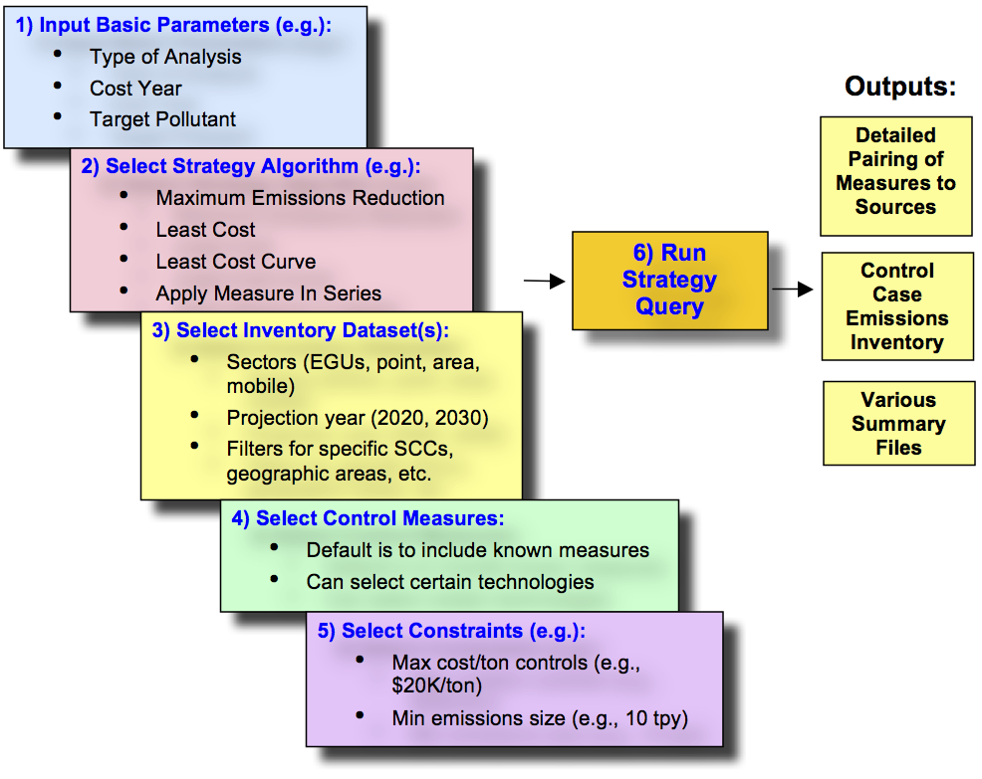

Basic Steps for Running a Control Strategy

**Figure 4-1. Control Strategy Diagram.**

After a control strategy run is complete, several outputs are associated with the strategy. The main CoST output for each control strategy is a table called the “**Strategy Detailed Result**”. This table consists of emission source-control measure pairings, each of which contains information about the cost and emission reduction that would be achieved if the measure were to be applied to the source. If multiple inventories were processed by the strategy, then there will be one Strategy Result for *each* input inventory, unless the inventories were merged for a least cost run (as indicated in the ‘Multiple Inventories’ column Table 4-1). Also, there will be at least one Strategy Detailed Result for each of the least cost iterations performed as part of a Least Cost Curve run. In addition to the Strategy Detailed Result, two other outputs are produced for each strategy run: the Strategy County Summary (which includes uncontrolled and controlled emissions), and the Strategy Measure Summary (which summarizes how control measures were applied for each sector-county-SCC-Pollutant combination). These three outputs are referred to in Table 4-1 as the ‘Standard’ outputs.

The Strategy Detailed Result table itself can be summarized on-demand in many ways using predefined summary queries (e.g., by state, by county, by control technology). Users familiar with SQL can also define their own custom queries. The Strategy Detailed Result table can also be merged with the original input inventory, in an automated manner, to produce a *controlled emissions inventory* that reflects implementation of the strategy. The controlled emissions inventory includes information about the measures that have been applied to the controlled sources and can be directly input to the SMOKE modeling system to prepare air quality model-ready emissions data. Comments are placed at the top of the inventory file to indicate the strategy that produced it and the settings of the high-level parameters that were used to run the strategy.

Detailed information on the types of control strategy algorithms is provided in Section 2. Section 3 describes how to set up and manage control strategies. Section 4 details the inputs to control strategies, including adding inventories, control measures, and constraints to a strategy. Running a strategy and accessing its outputs are discussed in Section 5. Documentation for the various types of strategy outputs is given in Section 6 and information about summaries of strategy inputs and outputs is given in Section 7.

## CoST Control Strategy Algorithms

Once the inputs have been defined, the strategy can be run on the EMF server. The method by which the measures are associated with the strategies depends on the algorithm that has been selected for the strategy. At this time, six algorithms are available to determine how measures are assigned to sources:

* **Annotate Inventory**: assigns control measures to the inventory based on the control efficiency specified for each source, and can be used to fill in control measure information for inventory sources that are missing these details but have a control efficiency assigned.
* **Apply Measures in Series**: assigns all control measures that can be used for a source in the specified order; this is often used for mobile sources, for which the control measures are typically independent of one another.
* **Least Cost**: each source can be assigned only a single measure to achieve a specified percent or absolute reduction for the sources included in the strategy run, with the minimum possible annualized cost.
* **Least Cost Curve**: performs least-cost runs iteratively at multiple percent reductions so that a cost curve can be developed that shows how the annualized cost increases as the level of desired reduction increases.
* **Maximum Emissions Reduction**: assigns to each source the single measure (if a measure is available for the source) that provides the maximum reduction to the target pollutant, regardless of cost.
* **Multi-Pollutant Maximum Emissions Reduction**: assigns all control measures that can be used for a source based on a specific target pollutant order (e.g., NOx first, PM10 second, VOC third, and SO2 last). Each source target pollutant can be assigned only a single measure, and it must be the one that provides the maximum reduction, regardless of cost. If a source’s target pollutant was already controlled via a co-impact from a measure applied during a previous target pollutant iteration, then no additional control will be chosen for that specific source’s target pollutant (e.g., if a NOx measure also controlled VOC as a co-impact, during the VOC iteration no measure would be attempted for this source, since it was already controlled via the co-impact).

Some of the key aspects of each of the strategy types are summarized in Table 4-1, and some additional information on each strategy type is provided in the following subsections.

**Table 4-1. Control Strategy Algorithms**

|  |  |  |  |  |
| --- | --- | --- | --- | --- |
| Strategy Type | Multiple Inventories | Typical Sectors | Measure Assignment | Outputs |
| Annotate Inventory | Processed independently | Area, nonpoint | One per source | Standard |
| Apply Measures in Series | Processed independently | Mobile: Onroad, nonroad | Multiple per source | Standard |
| Least Cost | Will be merged | Area, nonpoint | One per source | Standard, Least Cost Control Measure Worksheet |
| Least Cost Curve | Will be merged | Area, nonpoint | One per source | Standard, Least Cost Control Measure Worksheet, Least Cost Curve Summary |
| Maximum Emissions Reduction | Processed independently | Area, nonpoint | One per source, to achieve maximum reduction of target pollutant | Standard |
| Multi-Pollutant Maximum Emissions Reduction | Processed independently | Area, nonpoint | One per source target pollutant; based on specified target pollutant order; could be multiple per source | Standard |

### Maximum Emissions Reduction Control Strategy

The Maximum Emissions Reduction control strategy is the simplest of the strategy algorithms. It assigns to each source the single control measure that provides the maximum reduction to the target pollutant, regardless of cost. The strategy produces the three standard types of strategy outputs, including a Strategy Detailed Result for each input inventory.

### Apply Measures in Series Control Strategy

The Apply Measures in Series control strategy applies all relevant controls to a source, as opposed to the Maximum Emission Reduction strategy, where only the most relevant measure (with the best possible reduction for lowest cost) is applied to the source. The Apply Measures in Series strategy is typically used for mobile sources, for which the input inventories are often average day inventories specific to a given month, and for which there are often multiple independent controls available for each source. Therefore, the measures are applied to the source in series, one after the other. The order of application is based on the user-specified “apply order,” but the system also considers the lowest cost and greatest control efficiency. Thus, the cost factor in terms of dollars per ton of pollutant reduced is used to calculate the annualized cost of the control measure when applied to a specific source.

The three standard types of outputs are generated after a successful strategy run: a Strategy Detailed Result ***for each input inventory***, a single Strategy Measure Summary, and a single Strategy County Summary. Note that when input inventories contain average-day emissions data for a month, the corresponding Strategy Detailed Result datasets will specify total monthly emissions as opposed to average day emissions for each source; otherwise they will specify annual emissions. The total monthly emissions are calculated by multiplying the average day emissions by the number of days in the month. Regarding the two types of summary outputs, if the input datasets have data for each of the 12 months, the summaries will provide annual emissions.

### Least Cost Control Strategy

The Least Cost strategy type assigns measures to emissions sources to achieve a specified percent reduction or absolute reduction of a target pollutant for sources in a specified geographic region while incurring the minimum possible annualized cost. This algorithm is similar to the maximum emissions reduction strategy in that only a single measure is applied to each source. For example, one measure might be selected for a source when trying to reduce the target pollutant by 20%. However, if you were trying to obtain a 40% reduction of the target pollutant, another more expensive measure that achieves a higher level of control might be selected for the same source to meet the targeted level of reduction. If multiple inventories are specified as inputs to a Least Cost strategy, they are automatically merged into one EMF dataset as an ORL Merged dataset type. This allows the multiple inventory sectors to be considered simultaneously during a single Least Cost run. Note that the merged inventory dataset will be truncated and repopulated at the start of each strategy run, to ensure that the most up to date inventory data is included in the run.

The Least Cost strategy automatically creates the same three standard output datasets, but it also creates an additional output dataset called the Least Cost Control Measure Worksheet. This output is a table of all possible emission source-control measure pairings (for sources and measures that meet the respective filters specified for the strategy), each of which contains information about the cost and emission reduction achieved if the measure was to be applied to the source. Examples of these tables are given in Section 6. This dataset will be used to help generate ***a single*** Strategy Detailed Result (no matter how many input inventories were processed) once the optimization process has been performed to achieve the desired reduction. This dataset has the all of the same columns as the Strategy Detailed Result (see Table 4-9), in addition to the following columns:

* **marginal**: This column stores the marginal cost (dollars are given based on the specified cost year) for the source-measure record. This is calculated according to the following equation:

marginal cost = annual cost (for specified cost year) / emission reduction (tons)

Note that cost equations are used to compute the annual cost, when applicable and all required input data is available. For target pollutant source-control pair records, the annual cost will be the total of the annual costs for the target pollutant and any costs associated with co-benefit pollutants.

* **status**: This column contains a flag that helps determine which source-control records should be actively considered during the strategy run.
* **cum_annual_cost**: This column contains the cumulative annual cost for the source and all preceding sources that have been included in the strategy (i.e., for which status is null). This is only specified for target pollutant sources, but it also includes costs associated with co-benefit pollutants.
* **cum_emis_reduction**: This column contains the cumulative emission reduction for the source and all preceding sources that have been included in the strategy (i.e., for which status is null). This is only calculated for target pollutant sources. The emission reduction is cumulated by following the apply_order in an ascending order.

If multiple input inventories are used for the least cost strategy run and the user requests to create controlled inventories, there will be one controlled inventory created for each of the input inventories.

### Least Cost Curve Control Strategy

The purpose of the Least Cost Curve strategy type is to iteratively run Least Cost strategies so that a cost curve of can be generated. Typically, a cost curve has the total cost of emissions reduction and the cost per ton of emissions reduction increases as the desired level of reduction increases. The input inventories are treated in the same way as the least cost run in that the data from the inventories will be put together into an ORL Merged inventory prior to performing any of the runs. The inventory filters and measure filters work in the same way as they do for the other strategy types, as do the constraints that apply to all strategy types. The main difference between the Least Cost and Least Cost Curve strategy types is in the specification of constraints. Instead of specifying a single percent reduction or absolute emissions reduction, three new constraints are used to control the run:

* **Domain-wide Percent Reduction Start (%)**: Specifies a percent reduction to be used for the first Least Cost strategy to be run.
* **Domain-wide Percent Reduction End (%)**: Specifies a percent reduction to be used for the last Least Cost strategy to be run.
* **Domain-wide Percent Reduction Increment (%)**: Specifies an increment on percentages to use between the first and last runs (e.g., if 25% is specified, runs will be performed for 25, 50, 75, and 100% reduction).

Additional runs can be added to a least cost curve strategy if you do not delete the previous results when you rerun the strategy. Suppose that you generate a coarse cost curve (default increment is 25%) and you find an area of interest that bears further examination. You can then go back and specify different start, end, and increment to obtain more information (e.g., start=80%, end=90%, increment=2%) about that portion of the curve.

The types of outputs for a Least Cost Curve strategy are the following:

* **Strategy Detailed Result** datasets for each targeted percent reduction. Note that several results could have the same actual percent reduction if the targeted reduction exceeds the maximum available reduction. As with a Least Cost strategy, the actual percent reduction may not exactly match the targeted reduction due to the discrete nature of applying specific controls to specific sources. CoST will ensure that each actual reduction is equal to or greater than the corresponding targeted reduction.
* **Least Cost Control Measure Worksheet**: this output is the same as the worksheet produced for a regular Least Cost strategy run. Note that the same worksheet is used for all targeted percent reductions and only the status column is updated to specify when measure-source combinations are included in the current strategy.
* **Least Cost Curve Summary**: this output dataset contains a row with cost and emissions reduction information for each of the runs that was performed for the strategy. Rows are added to this output if additional strategy runs are performed (e.g., to examine different sections of the curve). The columns of this summary are: Poll, Uncontroll_Emis (tons), Total_Emis_Reduction (tons), Target_Percent_Reduction, Actual_Percent_Reduction, Total_Annual_Cost, Average_Ann_Cost_per_Ton, Total_Annual_Oper_Maint_Cost, Total_Annualized_Capital_Cost, Total_Capital_Cost. Here, the Uncontroll_Emis column contains the emissions from the original input inventory with all existing controls backed out so that it represents the uncontrolled emissions. The columns starting with Total are computed by summing all of the values of the corresponding column in the Strategy Detailed Result for the pollutant specified in the Poll column. Examples of Least Cost Curve Summaries are given in (Figure 4-27) and Table 19 (TODO: fix).
* **Controlled Inventories**: these output datasets may optionally be created based on any of the Strategy Detailed Results that are available for the strategy. Thus, results corresponding to any of the targeted reductions may be processed by SMOKE and the resulting data used as an input to an air quality model. Note that for each targeted reduction, individual controlled inventories will be created for each of the input inventories.

### Annotate Inventory Control Strategy

The purpose of the Annotate Inventory strategy type is to specify what measures are likely to have been used to achieve specified percent reductions in input inventories. The input inventories are treated in the same way as the Maximum Emissions Reduction runs in that each inventory is processed separately and separate results are created for each one. The inventory filters and measure filters work in the same way as they do for the other strategy types. Note that the selected target pollutant is important because only records for that pollutant will be annotated, but CoST may be changed in the future to consider all inventory pollutants. Constraints are applicable in that if the controlled source does not satisfy the specified constraints, it will not be included in the result and another measure that does satisfy the constraints will be sought.

The outputs from the Annotate Inventory strategy type are an Annotated Inventory for each of the input inventories. The annotated inventories have the same dataset types as the input inventories. All of the source records for the specified target pollutant with nonzero control efficiencies in the input inventory will appear in the annotated inventory and the control measures column will be filled in for sources for which a matching measure has been found. Note that the originally specified control efficiency fields and the emissions in the inventory are not changed, even if the inventory efficiency differed from the efficiency specified for the control measure. Once an annotated inventory has been created, a controlled inventory can be created from the annotated inventory. Unlike the annotated inventory, the controlled inventory will have all records found in the input inventory and can therefore be used as an input to SMOKE.

One of the goals for CoST that has not yet been met is for the tool to be able to intelligently make use of control measures that can be applied in addition to other controls (also known as ‘add-on’ controls). In order for the software to meet this goal, it is important for it to first be able to determine whether there are any existing control measures on the emissions source and the type of control device(s) used by the existing measures. Currently, a data gap exists in this area for both the base year emissions inventories and the future year emission inventories which may be used as inputs to a control strategy run. The NEI contains data fields to store this information, and there is a limited amount of existing control efficiency and control device code data in the base year NEI. However, these fields are not very well populated in the base year inventory for sectors other than the EGU point sources, and the fields are even less well populated in the future year modeling inventories. Generally, the control efficiency field is much better populated than the control device fields. In addition, the control device codes that are stored in the NEI are a lot less specific than the control measure abbreviations that CoST uses. Therefore, even if the control device codes were well populated, these codes would need to be translated into the CoST control measure abbreviations for CoST to really have the information it needs to properly apply add-on controls.

To address the issue of unspecified control measures in inventories that can be input to CoST, several steps have been taken. First, when CoST creates a controlled inventory, in addition to filling in the information in the CEFF, REFF, and RPEN columns, CoST populates the Control Measures, Pct Reduction, Current Cost, and Total Cost columns in the FF10 or ORL inventory to specify information about measures that it has applied. In this way, the controlled inventories created by CoST always specify the relevant information about the measures that have been applied as a result of a CoST control strategy. The Annotate Inventory strategy type is a second step that has been taken to provide more information about existing control measures.

When an Annotate Inventory strategy is run, CoST looks at the percent reduction specified by the CEFF, REFF, and RPEN columns and uses the available control measures in the database to try to determine what control measure has the closest percent reduction to the one specified in the inventory. It then fills in the control measures column with the measure that was found. Note that the originally specified control efficiency fields and the emissions in the inventory are not changed, even if the inventory efficiency differed from the efficiency specified for the control measure. If no measure was found, it leaves the control measure field blank. Once the strategy has been run, a summary report can be generated with using the “Compare CoST to NEI measures” query that shows the sources with non-zero CEFF values and the difference between the inventory specified percent reduction and the percent reduction that the control measure that CoST “guessed” had been applied to the source. **It is important for the user to then examine the results of this report to find cases where the specified control efficiency matches were not even close and those for which no match was found.** Both of these situations can indicate that there is missing or incorrect data in the control measures database, or that the information in the inventory was erroneous. The eventual goal of the Annotate Inventory strategy is to develop a base year inventory with more complete existing control measure information.

### Multi-Pollutant Maximum Emissions Reduction Control Strategy

The Multi-Pollutant Maximum Emissions Reduction control strategy assigns to each source the single measure for each target pollutant that provides the maximum reduction, regardless of cost. This process is performed for each target pollutant in an order specified by the user (e.g., NOx first, PM10 second, VOC third, and SO2 last). If a measure would control a pollutant that was already controlled as a co-impact from a previous target pollutant analysis iteration, that measure will be excluded from consideration during the source-measure matching process. For example, if measure ABC controlled NOx (the first analyzed target pollutant) and VOC, and during the next pollutant iteration (for VOC) measure DEF also controls NOx and VOC, this measure will not be considered because VOC control was a co-impact from applying the ABC measure.

The inventory filter and county filter work differently for this control strategy than they do for the other strategy types. The inventory filter and county filter can be specified separately for each target pollutant, whereas for the other strategy types they are defined at the strategy level.

The Multi-Pollutant Maximum Emissions Reduction strategy produces the three standard types of strategy outputs, including a Strategy Detailed Result for each input inventory.

## Managing Control Strategies

The control strategies currently available within CoST are shown in the Control Strategy Manager. The Control Strategy Manager allows you to see information about control strategies, to create new control strategies, and also to edit, remove, and copy control strategies.

### Opening the Control Strategy Manager

**Step 3-1: Open Control Strategy Manager.** To open the Control Strategy Manager, choose Control Strategies from the Manage menu on the EMF main window (Figure 4-2) and the Control Strategy Manager will appear (Figure 4-3).

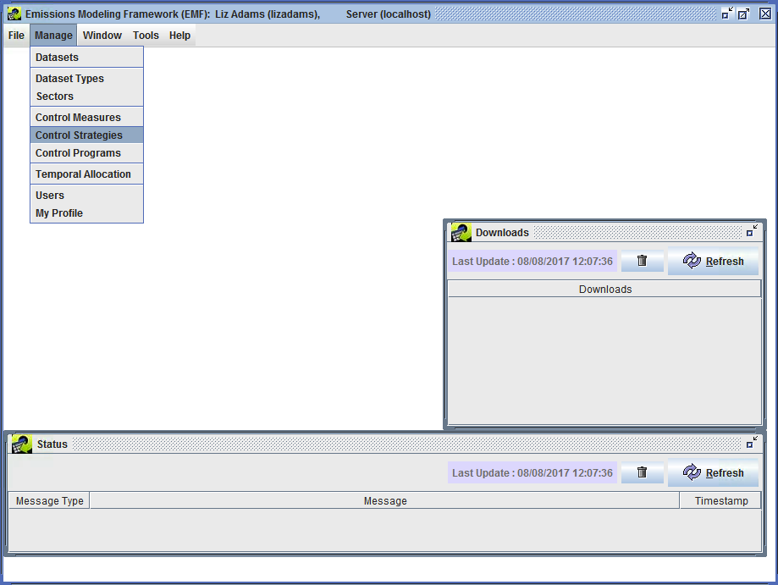

Manage Menu of EMF Main Window

**Figure 4-2. EMF Manage Menu.**

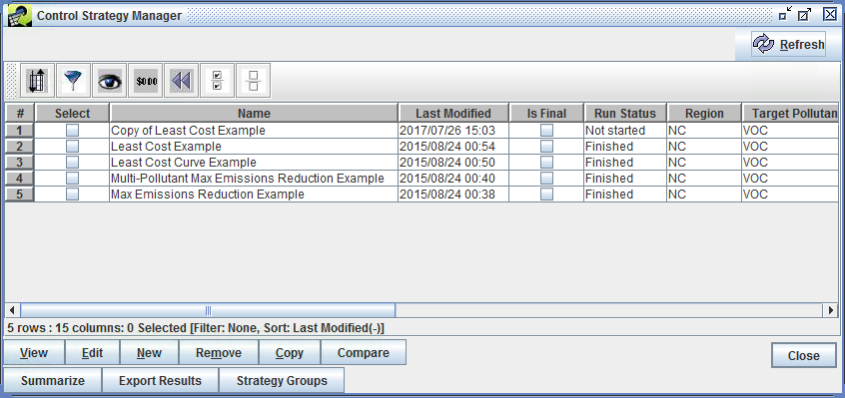

Control Strategy Manager Window

**Figure 4-3. Control Strategy Manager.**

The Control Strategy Manager shows all of the control strategies currently available within the CoST/EMF system in a sortable, filterable window. The columns shown in the window are Select, Name, Last Modified, Is Final, Run Status, Region, Target Pollutant, Total Cost, Reduction (tons), Average Cost Per Ton, Project, Strategy Type, Cost Year, Inventory Year, and Creator. Descriptions of some of the columns are given in Table 4-2. The remaining fields are described in detail in Section 4.

**Table 4-2. Control Strategy Manager Table**

|  |  |
| --- | --- |
| Column | Description |
| Name | shows the name of the control strategy. |
| Last Modified | shows the date and time on which the strategy was last changed. |
| Run Status | gives information about the strategy run. Possible options are:Not started - the strategy run has never been started;Waiting - a run has been requested, but it is waiting because other strategies are running;Running - the strategy is currently running;Finished - the strategy run completed successfully;Failed - the strategy run started, but failed due to a problem. |
| Inv Year | shows the year of the emissions inventory that the strategy will process. |

### Sorting and Filtering Control Strategies

By default, the strategies are shown using a descending sort on the last modified date and time, so that the most recently modified strategies appear at the top of the list.

**Step 3-2: Sort Control Strategies.** To sort the control strategies on the total cost of the strategy, click on the heading of the **Total Cost** column and the rows will re-sort so that the most expensive strategies will be shown at the top. Click on the **Total Cost** column header again to reverse the sort.

**Step 3-3: Filter Control Strategies.** To see only strategies that were run with a specific target pollutant, click the Filter button () on the Control Strategy Manager toolbar. When the **Filter Rows** window appears enter a criterion for the filter by clicking Add Criteria. Click in the cell under **Column Name** and choose **Target Pollutant**. Change the operation by clicking in the cell under **Operation**. For this example select **contains** as the desired **Operation**. Enter the pollutant of interest in the **Value** cell. Enter **PM2_5** in the **Value** cell for this example.

*Note that the filter values are case-sensitive* (e.g., “NOx” will not match a filter value of “NOX”). After applying the filter criterion above, the **Filter Rows** window will look like Figure 4-4.

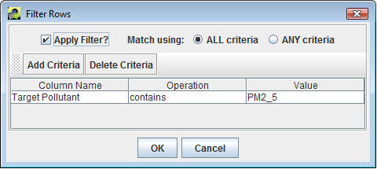

Filter Rows to Show Only Strategies Targeting NO~x

**Figure 4-4. Filter Rows Window.**

Click OK and the Control Strategy Manager will show only strategies that targeted PM2_5.

After reviewing the information available on the Control Strategy Manager for PM2_5 measures, click the Reset button () to remove the filter and sort criteria.

For more information on performing sorting, filtering, formatting, and other operations on the table that shows the control strategies used for the Control Strategy Manager, refer to the [Introduction to the Control Measure Manager](./ch3_control_measure_manager.md#Intro3).

### Copying Control Strategies

Existing strategies can be copied to create new control strategies, regardless of whether they have been run. If you copy a strategy and then edit the newly created strategy, you will not be changing any settings for the original strategy, so this is a safe way to start working with your own strategies. When a strategy is copied, it retains all of the settings from the original strategy except for the information on the Outputs tab, and the output summary information that is shown on the Summary tab.

**Step 3-4: Copy Control Strategies.** Click the **Select** checkbox next to one of the strategies (e.g., “Least Cost Example) and then click Copy. A new strategy will be added to the Control Strategy Manager with the name”Copy of *original strategy name*“.

Note that multiple strategies can be copied at once by selecting as many strategies as needed before clicking Copy.

### Removing Control Strategies

A control strategy creator and the EMF Administrator can remove control strategies from CoST. Strategies should be removed with caution, because there is no ‘undo’ for this operation.

**Step 3-5: Remove Control Strategies.** Click the **Select** checkbox next to one of the strategies and then click Remove. As an example, select the strategy you just copied in the previous subsection. When prompted to confirm removal of the control strategy, a pop-up menu will appear Figure 4-5 where the user can select whether to remove output datasets associated with the strategy that they would like to remove. The first check box is to remove the following output data: Strategy results, messages, and summaries assocated with the control strategy that is being deleted. The second check box is to remove the Controlled inventories associated with the control strategy that is being deleted. Check both check boxes, so that all datasets created by the control strategy are cleaned up when the strategy is deleted. The selected strategy and output datasets will be removed from the table of strategies in the Control Strategy Manager.

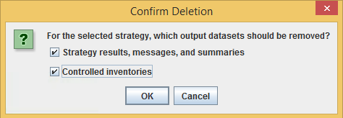

Confirm_Strategy_Deletion

**Figure 4-5. Confirm Strategy Deletion Window.**

*Note that if you select more than one control strategy before clicking Remove, all of the selected strategies will be removed.*

### Creating a New Control Strategy

**Step 3-6: Create New Control Strategies.** To create a new control strategy, click the New button in the Control Strategy Manager. The **Create New Control Strategy** window will appear with a text box to name the new strategy. Enter a name that is different from any of the existing control strategies (e.g., **Least Cost 2017 NOx Example**) and then click OK.

An **Edit Control Strategy** window for your newly created strategy will appear (Figure 4-6). The window has five tabs: Summary, Inventories, Measures, Constraints, and Outputs. This window and how to fill in the information on these tabs is discussed in more detail in Section.

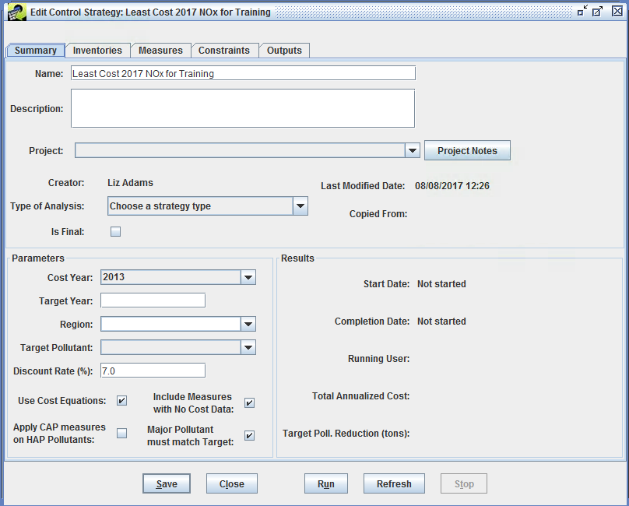

Edit Control Tab Summary Window

**Figure 4-6. Edit Control Strategy Window.**

For this example, edit the following fields in the **Edit Control Strategy** window:

* Set Target Year to **2017**
* Set Type of Analysis to **Least Cost**
* Set Target Pollutant to **NOX**

Click Save to save the new strategy and click Close to close the **Edit Control Strategy** window.

If the new strategy does not appear in the Control Strategy Manager, first click the Reset button on the toolbar to remove any filters that have been applied to the strategies. If the strategy still does not appear, click Refresh at the top right of the Control Strategy Manager to obtain new data from the server.

### Editing Control Strategies

**Step 3-7: Edit Control Strategies.** Click the **Select** checkbox next to the new strategy (i.e., the strategy created in Step 2-6) and then click Edit. If you have permission to edit the strategy (i.e., you are its creator or an Administrator), the **Edit Control Strategy** window will appear with the **Summary** tab visible (Figure 4-7). Note that if you had selected multiple control strategies before clicking Edit, they each would have opened in their own window. The tabs on the Edit Control Strategy window are listed in Table 4-3. The contents of these tabs are described in detail in Section 4.

**Table 4-3. Control Strategy Manager Summary Tab**

|  |  |
| --- | --- |
| Tab | Description |
| Summary | Shows you high-level information about the strategy, such as its Name and the Target Pollutant. |
| Inventories | From which you can specify the emission inventories to use as input to the strategy and filters for those inventories. |
| Measures | Allows you to specify the classes of measures to include in the strategy, or select specific measures to include. |
| Constraints | Allows you to specify constraints for the strategy, such as a maximum cost per ton. |
| Outputs | Shows the results from the strategy after it has been run. |

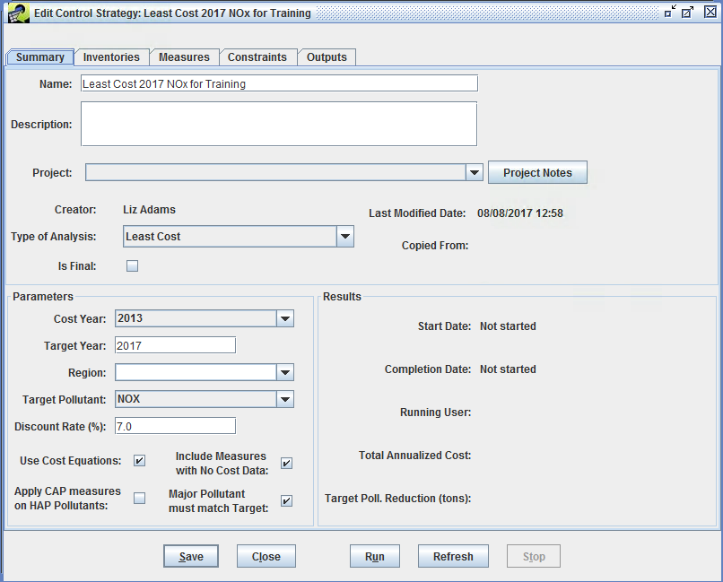

Summary Tab of Edit Control Strategy Window

**Figure 4-7. Edit Control Strategy Summary Tab.**

## Inputs to Control Strategies

Control strategies are defined by a series of fields that must be set prior to running the strategy. These fields are described in this section.

### Inputs on the Summary Tab

Along with the name and description of the strategy, the Control Strategy **Summary** tab defines the type of analysis to use for the strategy, spatial-temporal parameters, the target pollutant, and the discount rate. To set the fields for the strategy on the **Summary** tab (see Figure 4-5), follow the steps below. Note that the fields on the Summary tab missing from this list are automatically set by CoST, and are discussed in Fields Automatically Set by CoST Section. *Fields that are contained within boxes with either white backgrounds or that are pull-down menus are editable; fields that are not contained within boxes are set by the software and cannot be changed by the user.*

**Step 4-1: Set the Control Strategy Name and Description.** If one has not already been specified, enter a unique and descriptive Name for the control strategy. For this example set Name to **Least Cost 2017 NOx Example**. Enter a Description of the purpose for the control strategy, and any other information relevant and useful to describe the strategy.

Optionally, use the Project pull-down menu to select a project for which this strategy run was performed (e.g., Ozone NAAQS). Projects are set in the EMF and are used as a means of grouping related strategies that were performed in support of a common goal.

**Step 4-2: Set Strategy Type.** Use the Type of Analysis pull-down menu to set the type of algorithm used to match the control measures with sources (e.g., Maximum Emissions Reduction, Least Cost). For this example, select **Least Cost** as the analysis type.

Optionally specify whether the strategy Is Final to finalize and archive the strategy. Once marked as final, a strategy may not be rerun. For this exercise, do not check the Is Final checkbox.

**Step 4-3: Set the Cost Year.** Use the Cost Year pull-down menu to set the year to use for estimating the costs of a strategy. For this exercise, set Cost Year to **2013**. All cost data specified for the control measures will be converted to this year using the Gross Domestic Product (GDP): Implicit Price Deflator (IPD), issued by the U.S. Department of Commerce, Bureau of Economic Analysis. Details of the computation used are given in the [Control Strategy Tool (CoST) Development Document](Add%20link). As there is a 1- to 2-year lag between the current year and the latest available cost year data, the Cost Year cannot be set to the current year.

**Step 4-4: Set the Target Year.** The target year should correspond to the input inventory or inventories (e.g., 2020, 2030). For control measure efficiency records to be considered for a strategy, the specified effective date for the record must be equal to or earlier than the target year. Note that any control measure efficiency records that come into effect *after* the target year will not be considered for use in the strategy. For this example set Target Year to **2017**.

Optionally set the name of the geographic Region to which the strategy is to be applied. This setting is informational only and does not impact the strategy results. Region is different from the concept of “locale” used in the control measure efficiency records to indicate the state or county code to which the record applies. For this example, set Region to **NC**.

**Step 4-5: Set the Target Pollutant.** The target pollutant is the pollutant of primary interest for emissions reduction for the control strategy. The Least Cost and Maximum Emissions Reduction algorithms will apply reductions to the target pollutant. For the Multi-Pollutant Maximum Emissions Reduction strategy, one or more pollutants must be selected from the Target Pollutant pull-down menu.

Note that reductions of pollutants other than the selected target pollutant (e.g., PM10, PM2.5, elemental carbon [EC], organic carbon [OC]) will be included in strategy results if those pollutants both appear in the inventories input to the strategy and they are affected by measures applied as part of the strategy. These pollutants are sometimes referred to as “co-impact pollutants”, because the impact on the emissions could be either a reduction (i.e., a benefit) or an increase (i.e., a disbenefit).

If **Multi-Pollutant Maximum Emissions Reduction** is selected from the Type of Analysis pull-down menu, set the Target Pollutant using the Set button next to this field to select from a list of pollutants to use for the strategy. Select the pollutants to include in the strategy from the pollutant list using Control-Click.

For this Least Cost example, use the pull-down menu to set Target Pollutant to VOC.

**Step 4-6: Set the Discount Rate.** The Discount Rate** (i.e., interest rate) is used in the calculation of the annualized capital cost for control measures when appropriate data are available. For this example, set the Discount Rate to **7.0**. Note that the discount rate typically does not affect strategies for area or mobile sources.

**Step 4-7: Use Cost Equations.** When the Use Cost Equations checkbox is checked, cost equations will be included in the strategy run; otherwise only cost per ton (CPT) related cost estimates will be used. For this exercise, leave Use Cost Equations checked to use the Least Cost equations selected as the Type of Analysis in Step 2-9.

**Step 4-8: Apply CAP measures on HAP Pollutants.** When the Apply CAP measures on HAP Pollutants checkbox is checked, a CAP-to-HAP pollutant mapping is used to apply CAP reductions to the corresponding HAP pollutants at the same emission reduction percentage. For this exercise, leave Apply CAP measures on HAP Pollutants unchecked so that HAP pollutant controls will not be used.

**Step 4-9: Include Measures with No Cost Data.** When the Include Measures with No Cost Data checkbox is checked, measures with control efficiencies but without cost data are included in the strategy run; otherwise they are not included. These are typically measures with no cost data specified or measures that use a cost equation to compute cost, but for which there is not enough data for the source in the inventory to fill in the equations variables. For this exercise, leave Include Measures with No Cost Data checked.

**Step 4-10: Specify whether Major Pollutant must match Target.** When the checkbox is checked, then the major pollutant must be the same as the target. For this exercise, leave Major Pollutant must match Target checked.

### Fields Automatically Set by CoST

Some fields of a control strategy that appear on the **Summary** tab are set automatically by the CoST software and are not specified by the user. Note that some of these summarize the results of the strategy analysis, so information for them is not available until after the strategy has been run. The automatically set fields are described in Table 4-4.

**Table 4-4. Fields Automatically Set by CoST**

|  |  |
| --- | --- |
| Field | Description |
| Creator | The name of the person who created the strategy. |
| Last Modified Date | The date and time when the strategy was last modified. |
| Copied From | The name of the strategy that this strategy was copied from, if any. |
| Start Date | The date and time on which the strategy run was most recently started, or “Not started” if the strategy has never been run. |
| Completion Date | The date and time on which the strategy run was most recently completed. If the run has not completed, this field shows the run status of either “Not started”, “Running”, “Waiting”, “Completed”, or “Failed”. |
| Running User | The name of the user who most recently ran the strategy. |
| Total Annualized Cost | The total annualized cost of applying the strategy. |
| Target Poll. Reduction (tons) | The absolute emissions reduction achieved for the target pollutant, in tons. |

### Inputs on the Inventories Tab

This section describes how to set the inventory inputs for a Control Strategy on the Edit Control Strategy window **Inventories** tab (Figure 4-8). Click on the **Inventories** tab. The Inventories to Process table near the top of the tab lists the emissions inventories for which the control strategy will be run. A control strategy can have one or more emissions inventories as input. Before inventories can be selected for use in the strategy, they must already have been imported into the EMF using either the Import item on the File menu of the EMF Main Window or through the Dataset Manager. The CoST application comes preloaded with several example inventories for training purposes.

CoST/EMF supports both one-record-per-line (ORL) and flat file (FF10) inventory formats. Point inventories have information about emissions sources with specific locations, which are specified using latitude and longitude. Nonpoint, nonroad, and onroad inventories contain data aggregated to the county level. *Note that IDA inventories are not supported by CoST and need to be converted to ORL or FF10 prior to use with CoST.* The EMF database stores the data for the emissions inventories along with metadata about the inventories in its PostgreSQL (<http://www.postgresql.org>) database.

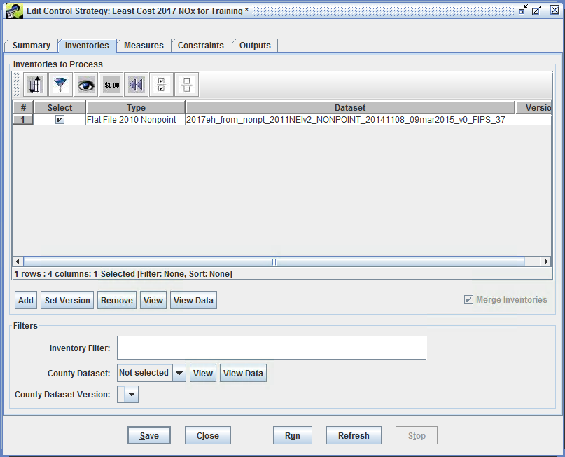

Inventories Tab of Edit Control Strategy Window

**Figure 4-8. Edit Control Strategy Inventories Tab.**

**Step 4-11: Add an Inventory to Control Strategy.** To add one or more inventories to the Inventories to Process table for the control strategy, click the Add button on the **Inventories** tab. From the **Select Datasets** window that appears, use the Choose a dataset type pull-down menu to select the type of inventory to add (e.g., Flat File 2010 Nonpoint). The file browser will display the inventories of the specified type (Figure 4-9). If there are many inventories in the list, narrow down the list (e.g., to find inventories for 2017) by entering a search string in the Dataset name contains field and pressing the Enter key on your keyboard.

To select an inventory to use for the strategy from the **Select Datasets** window, click on the name of the inventory in the table. For this exercise, after choosing **Flat File 2010 Nonpoint** from the Choose a dataset type pull-down menu, select **2017eh_from_nonpoint_2011NEIv2_NONPOINT_20141108_09mar2015_v0_FIPS_37** and then click OK. The inventory file will then be displyed in the Inventories to Process window of the **Inventories** tab.

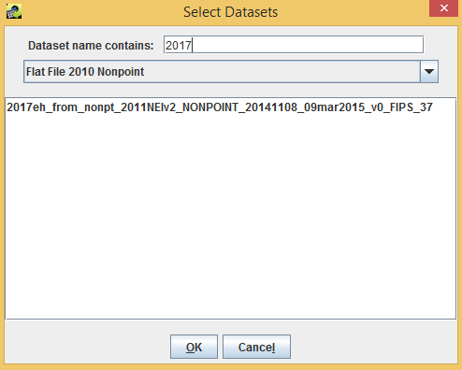

Selecting Inventory Datasets for a Control Strategy

**Figure 4-9. Selecting Inventories for a Control Strategy.**

**Step 4-12: Add a Second Inventory to Control Strategy.** Click the Add button to add a second inventory to the control strategy. Select **Flat File 2010 Point** from the Choose a dataset type pull-down menu and add **2017eh_from_ptnonipm_2011NEIv2_POINT_20140913_revised_20150115_10mar2015_v0_FIPS_37**.

*Note: To select multiple inventories, hold down the control key while clicking the additional inventories.*

**Step 4-13: Remove an Inventory from a Control Strategy.** To remove inventories from a control strategy, click the **Select** checkbox next to the inventory to remove and click the Remove button below the Inventories to Process table (Figure 4-8). Click Yes to confirm deletion of the selected inventories. There is no need to remove either of the inventories for this example strategy.

**Step 4-14: Set Dataset Versions.** Note that multiple versions of the inventories may be available within the EMF. The EMF supports dataset versioning to facilitate reproducibility of historical runs. To specify which version of an inventory to use, check the **Select** checkbox next to a single inventory file in the Inventories to Process table and then click the Set Version button. A window will appear with a pull-down menu that lists the versions available for the selected inventory. Choose the desired version from the menu and then click the OK button to set the version to use for the strategy. You will then see the version number in the **Version** column of the Inventories to Process table. Note that the initial version of a dataset is always version **0**. There is no need to change the inventory versions for the example exercises.

**Step 4-15: View Dataset Properties.** To see the properties (i.e., metadata) for an inventory dataset, click the checkbox in the **Select** column of the Inventories to Process table and then click View. The **Dataset Properties View** window will appear (Figure 4-10). The **Dataset Properties View** window provides information about the selected inventory dataset and has multiple tabs as described in Table 4-5.

**Table 4-5. Dataset Properties View Window Tabs**

|  |  |
| --- | --- |
| Tab | Description |
| Summary | Shows high-level properties of the dataset |
| Data | Provides access to the actual inventory data so that you can view the data that will be used in the control strategy |
| Keywords | Shows additional types of metadata not found on the Summary tab |
| Notes | Shows comments that users have made about the dataset and questions they may have |
| Revisions | Shows the revisions that have been made to the dataset |
| History | Shows how the dataset has been used in the past |
| Sources | Shows where the data came from and where it is stored in the database, if applicable |
| QA | Shows QA summaries that have been made of the dataset (e.g., state summaries, county summaries) |

In addition to the different tabs, there are buttons at the bottom of the Data Properties window. The Edit Properties button displays the **Dataset Properties Editor** for *changing* (as opposed to viewing) the properties of the Dataset. The Edit Data button displays the **Dataset Versions Editor** for editing the actual data of the dataset by adding new versions. The Refresh button updates the data on the **Dataset Properties View** window with the latest information available from the server. The Export button exports the dataset data to a file. The Close button closes the **Dataset Properties View** window.

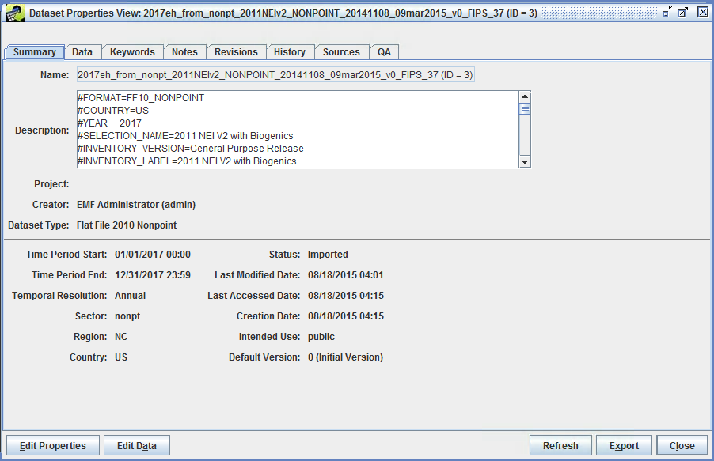

Dataset Properties View Window for an Emissions Inventory

**Figure 4-10. Dataset Properties View Window.**

Close the **Dataset Properties View** window by clicking Close.

**Step 4-16: View Inventory Data.** To view the inventory data itself (as opposed to just the metadata), check the **Select** checkbox next to an inventory file in the Inventories to Process table in the **Inventories** tab of the **Edit Control Strategy** window and click the View Data button. A Data Viewer window will appear that shows the actual data for the selected inventory (Figure 4-11). The data shown here are different from the metadata in the Dataset Properties View window. *Note that the View Data button is a shortcut. The Data Viewer can also be brought up from the Data tab of the Dataset Properties Viewer.*

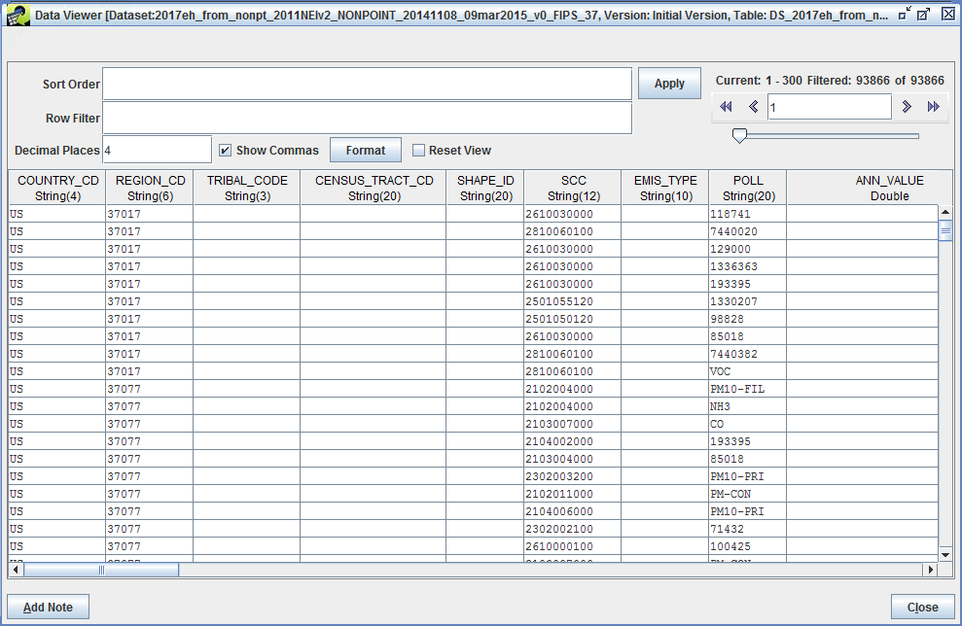

Data Viewer for an Emissions Inventory

**Figure 4-11. Data Viewer Display of an Emissions Inventory.**

As inventories can contain a lot of data, only the first 300 rows of an inventory are transfered from the server to the Data Viewer by default. The fields in the upper right corner of the window in the area labeled “**Current**” provide information about how many rows the inventory has, and which rows are currently visible. The **Data Viewer** works similarly to a web search engine that shows the results in pages, and the pagination arrows near the upper right corner of the window facilitate moving between pages of data. Use the pagination arrows in the upper right corner of the window to see how they work. Go to first record, go to previous page, give a specific record, go to next page, and go to last record.

The data sorting can be controlled by entering a comma-separated list of columns in the Sort Order field and then clicking Apply. Note that a descending sort order can be specified by following the column name with “desc” (e.g., “ANN_VALUE desc, REGION_CD” will sort by decreasing annual emissions and then by county).

If you enter a Row Filter, and then click Apply, the **Data Viewer** will find rows that meet the specified criteria. Examples of the syntax for row filters are given in Table 4-6. See [Chapter 6](./ch6_example_sql.md) for additional row filter examples.

**Table 4-6. Row Filter Examples**

|  |  |
| --- | --- |
| Filter Purpose | SQL Where Clause |
| Filter on a particular set of SCCs | scc like '246%' or scc like '261%' |
| Filter on a particular set of pollutants | poll in ('PM10', 'PM2\_5')*or*POLL = ‘PM10-PRI’ or POLL = ‘PM25-PRI’Filter sources only in NC (REGION\_CD = 37) ;<br/>note that REGION\_CD column format is State + County FIPS code (e.g., 37017)|substring(REGION_CD,1,2) in (‘37’)or REGION\_CD like '371' for only sources in NC with a county FIPS code that starts with 1. Filter sources only in NC (37) and include only NO~x and VOC pollutants|substring(REGION_CD,1,2) = ‘37’ and poll in (‘NOX’, ‘VOC’)<br/>*or*<br/>REGION_CD like ‘37%’ and (poll = ‘NOX’ or poll = ‘VOC’)` |

Click Close to close the **Data Viewer** window.

The next few paragraphs provide information on how the options at the lower portion of the **Inventories** tab work.

Some control strategy algorithms (e.g., Apply Measures in Series) are designed to process the inventories iteratively and produce results for each inventory. However, the “Least Cost” and “Least Cost Curve” strategy types can merge the input inventories from multiple sectors together prior to processing them, thereby facilitating cross-sector analyses. The Merge Inventories checkbox in the lower right corner of the Inventories to Process section of the **Inventories** tab controls whether multiple inventories will be merged together prior to applying the strategy algorithm, such as for Least Cost or Least Cost Curve runs. Otherwise, each inventory will be processed independently to create separate, independent results.

The fields in the Filters section of the **Inventories** tab of control whether the entire inventory is processed in the strategy or just a portion of it. The Inventory Filter field sets a general filter that can be entered using the same syntax as a Structured Query Language (SQL) “where clause”. Any of the columns in the inventory can be used in the expression. Examples include: “`SCC like ‘212%’`” to limit the analysis to apply only to inventory records for which the SCC code starts with 212, and “`FIPS like ‘06%’ or FIPS like ‘07%’`” to limit the strategy analysis to apply only to inventory records with Federal Information Processing Standards (FIPS) numeric state-county codes starting with 06 or 07. Additional examples of filters are shown in Table 4-6.

Note: for the Multi-Pollutant Max Emission Reduction strategy type the Inventory Filter has been moved from the **Inventories** tab to the **Constraints** tab. (you are currently viewing the Least Cost Curve Strategy at this point in the exercise, so the Inventory Filter is on the **Inventories** tab) For the Multi-Pollutant Max Emission Reduction strategy it is possible to specify the Inventory Filter differently for each target pollutant instead at the strategy level. Note that within the inventory filter, either upper or lower case may be used to refer to the column names and for the SQL keywords; the specified values within single quotes, however, are case sensitive (e.g., ‘NOx’ is different from ‘NOX’). Adding an inventory filter will not have an effect on the strategy until the strategy is run.

If an inventory filter includes only specific pollutants, then pollutants not specified by the filter will not be considered for the computation of co-impacts from a strategy. In addition, pollutants like EC and OC that are not traditionally included in input inventories will not be included in the results unless the inventory has been preprocessed to include EC and OC.

The County Dataset filter allows another way to filter the inventory. This field sets an EMF dataset with a list of counties to which control measures will apply during the strategy run. Control measures will be applied only to counties that are included in this list. The County Dataset pull-down menu will show the names of the available CSV datasets in the EMF that have the dataset type ‘List of Counties (CSV)’. Note that CSV files from which these county datasets are created must have at least two columns of data. Also, the first row of the file must be the column names, and one of the columns must have a name that starts with “FIPS”. CoST will assume that this column has the list of FIPS codes that should be controlled. Make sure that leading zeros are present for FIPS codes less than 10000. Note that for the Multi-Pollutant Max Emission Reduction strategy type the County Dataset filter has been moved from the **Inventories** tab to the **Constraints** tab. For the Multi-Pollutant Max Emission Reduction strategy it’s possible to specify different County Dataset filters for each target pollutant instead of at the strategy level.

*Note that only the records of the input inventories that pass both the inventory and county filters will be considered for control measure application.*

**Step 4-17: Set Inventory Filters.** For this exercise, set the following on the **Inventories** tab: Inventory Filter: **`REGION_CD in (‘37077’, ‘37017’, ‘37095’)`**. Note that specifying a list of counties using the Inventory Filter is an alternative to specifying a county dataset that has a list of counties to consider controlling in the strategy (as shown in the next bullet). To control only a few counties, it is straightforward to use the Inventory Filter; to control more than a few counties, the county dataset method is recommended. In addition, many types of Inventory Filters can be specified using other fields of the inventory depending on the specifications of the control strategy (e.g., SCC like '231%', or ANN_VALUE>5).

**Step 4-18: View a County Dataset.** Examine the available county datasets by pulling down the County Dataset menu and selecting one of the datasets. After selecting a county dataset, examine the dataset properties by clicking View. Display the the actual county dataset data by clicking View Data. Select a version of the dataset using the County Dataset Version field, which shows the available versions of the selected dataset. This selection is required because the EMF can store multiple versions of each dataset.

For this example, set the County Dataset pull-down menu to **Not selected** before proceeding.

### Inputs on the Measures Tab

The **Measures** tab appears on the Edit Control Strategy window for all types of strategies . The **Measures** tab sets the control measures to use in a strategy run. There are two mutually exclusive ways to select control measures for inclusion in the control strategy run. The default is to include measures according to their class (see the top half of Figure 4-12). Currently available classes are **Known** (i.e., already in use), **Emerging** (i.e., realistic, but in an experimental phase), **Hypothetical** (i.e., the specified data are hypothetical), **Obsolete** (i.e., no longer in use), and **Temporary** (controls that are used during the analysis only if the user was the creator of the control measure, therefore other users’ temporary measures won’t be considered during an analysis). By default, only **Known** measures will be included in the strategy run. The second way to specify measures for inclusion in a strategy run is to select a list of specific measures to consider using for the run. The use of these two methods is described in this section. To select additional classes of measures other than the default ‘Known’, **hold down the Ctrl key while clicking the desired classes of measures**. To start over with selecting classes, just click on a single class of measure without holding down the Ctrl key. Note that only the measures with the classes selected by the user will be included in the strategy run.

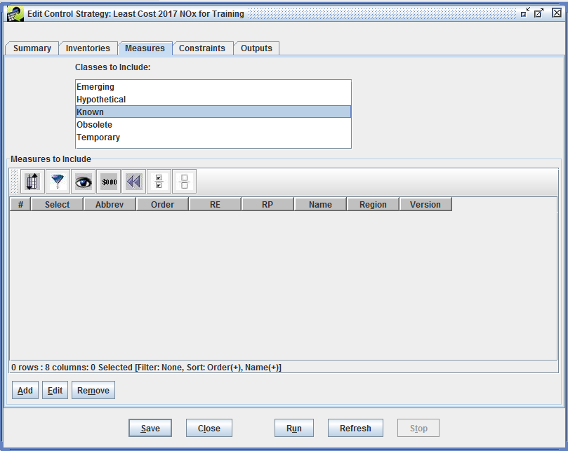

Measures Tab of Edit Control Strategy Window

**Figure 4-12. Edit Control Strategy Measures Tab.**

**Step 4-19: Select Control Measures by Class.** Click on one of the classes in the Classes to Include table and click Save to include all measures of a given class in a control strategy. To select multiple classes of measures, hold down the Ctrl key while clicking the desired classes of measures. To start over with selecting classes, just click on a single class of measure without holding down the Ctrl key. Note that only the measures with the classes selected by the user will be included in the strategy run.

**Step 4-20: Select Specific Control Measures.** To select specific measures for inclusion in the strategy, click the Add button under the Measures to Include table to show the **Select Control Measures** window (Figure 4-13). In this window, set a filter to find all measures with the same control technology. Use the checkboxes in the **Select** column to all of the measures to include in a control strategy. To select all of the measures shown in the **Select Control Measures** window, click the Select All button in the toolbar. Uncheck measures to exclude from a strategy. For this example, use the Filter to select all sources matching the following criteria: **Abbrev contains SNCR**.

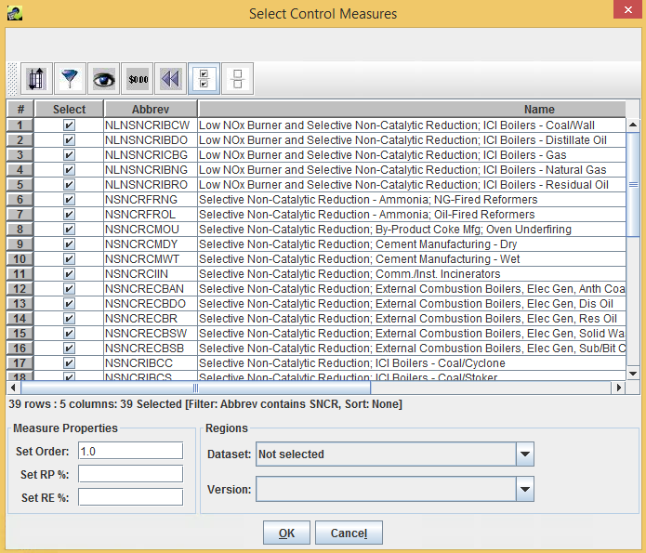

Dialog to Add Specific Control Measures to a Strategy

**Figure 4-13. Select Control Measures Window.**

* Specify an **Order** to control the order in which this group of measures is applied as compared to other groups of measures you have selected. This order of application is particularly relevant to the “Apply Measures in Series” strategy type. When running this type of strategy, since multiple measures can be applied to the sources, they will be applied in increasing numerical order (i.e., measures with order set to 1 will be applied before those with order set to 2).
* Set Order: Controls the order in which the current group of measures is applied as compared to other groups of measures selected for the control strategy. This order of application is particularly relevant to the “Apply Measures in Series” strategy type. When running this type of strategy, since multiple measures can be applied to the sources, they will be applied in increasing numerical order (i.e., measures with order set to 1 will be applied before those with order set to 2).
* Set RE%: Overrides the values of Rule Effectiveness specified in the measure efficiency records.
* Set RP%: Overrides the values of Rule Penetration specified in the measure efficiency records. These two settings are useful for assessing the level of emissions reductions achieved assuming different levels of effectiveness and penetration for the measures. For example, setting the rule penetration to 75% assumes that 75% of the sources are applying the measure and would therefore result in 75% of the emissions reductions it would if it was 100%.
* Regions: Sets a county dataset from the Dataset pull-down menu and a version of that dataset from the Version menu. By setting a Region the selected measures will only be applied to counties listed in the selected county dataset.

After selecting some the specific measures and overrides using the **Select Control Measures** window, click OK to add the measures to the control strategy. The selected measures will appear on the **Measures** tab. The tab will now look similar to that shown in Figure 4-14. Note that only the table of specific measures and their properties is shown, and the Classes to Include list is no longer shown. If desired, you may repeat the process of selecting specific measures to add new sets of measures to the list of measures to be used for the strategy. Each new group of measures selected can have different settings for the order, RE, RP, and Region.

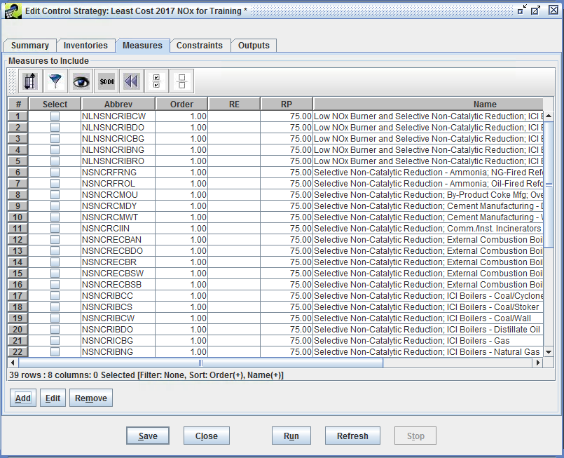

Measures Tab Showing Specific Measures to Include

**Figure 4-14. Measures Tab with Selected Control Measures.**

**Step 4-21: Editing Control Measures List.** Specific measures included in a control strategy can be changed by selecting the measure(s) to edit using the checkboxes in the **Select** column of the Measures to Include table in the **Measures** tab of the **Edit Control Strategy** window. Select the measures to change and click the Edit button. An **Editing Measures** window will appear that supports changes to the measure properties as they apply to the control strategy. Click OK to accept the edits or Cancel to reject the edits.

**Step 4-22: Removing Control Measures from a Strategy.** To remove specific measures from the list of measures to be included in a strategy run, check the corresponding **Select** checkboxes and then click Remove. Click Yes to confirm the removal of the selected measures from the control strategy.

For this example, remove all of the individually selected measures by clicking the Select All button on the **Measures** tab toolbar and then clicking Remove and Yes when prompted. Make sure that **Emerging** and **Known** are both selected in the Classes to Include list. The Measures tab will again look like Figure 4-12.

### Input on Constraints Tab

The **Constraints** tab (Figure 4-15) of the **Edit Control Strategy** window can be used to specify constraints for a control strategy to limit how control measures are assigned during the strategy run. For example, a strategy could be set up to not use any measures that cost more than $5,000 per ton (in 2013 dollars) for the target pollutant. Alternatively, a strategy could be defined to only use measures that reduce at least 1 ton of the target pollutant for the source. CoST evaluates the constraints while the source is being matched with the control measures. For example, the emission reduction achieved by applying a measure to a source is not known until the measure and its control efficiency have been selected. Thus, constraint calculations are dependent on both the inventory source and the measure being considered for application to the source. Note that the term “source” here refers to a single row of the emissions inventory, which for point sources is uniquely determined by FIPS, plant, point, stack, segment, and SCC, and for nonpoint sources is uniquely determined by FIPS and SCC. Sources should not be confused with “plants”, each of which can contain many sources.

Table 4-7 defines the constraints that are applicable to all strategy types. If the constraint values are not satisfied for a particular control measure and source combination, the measure under consideration will not be applied to the source, and CoST will look for another measure that satisfies all of the constraints.

**Table 4-7. Constraints Elements Applicable to All Strategy Types**

|  |  |
| --- | --- |
| Constraint Name | Constraint Description |
| Minimum Emissions Reduction (tons) | If specified, requires each control measure to reduce the target pollutant by at least the specified minimum tonnage for a particular source (down to the plant+point+stack+segment level of specification); if the minimum tonnage reduction is not attainable, the measure will not be applied. |
| Minimum Control Efficiency (%) | If specified, requires each control measure used in the strategy to have a control efficiency greater than or equal to the specified control efficiency for a particular source and target pollutant. |
| Maximum 2013 Cost per Ton ($/ton) | If specified, each control measure must have an annualized cost per ton less than or equal to the specified maximum annualized cost per ton for the target pollutant for each source. This cost is based on 2013 dollars. |
| Maximum 2013 Annualized Cost ($/yr) | If specified, each control measure must have an annualized cost less than or equal to the specified annualized cost for each source and target pollutant. This cost is based on 2013 dollars. |
| Minimum Percent Reduction Difference for Replacement Control (%) | If specified, each control measure must have a percent reduction in emissions with the new measure that is greater than or equal to the specified difference in order for the old control measure to be “replaced by” the new control measure. Incremental controls that add an additional device onto a previously controlled source are not yet supported by CoST except for the Apply Measures in Series strategy type, for which all controls are assumed to be independently applicable. In the event that a combination of two control devices is listed as a control measure (e.g., LNB+FGR) and the combined control efficiency provides an ample increase in the control efficiency over the original efficiency, that combination of the devices can still serve as a replacement control if the source already has a measure applied (e.g., LNB). In the future, instead of requiring an increase in the percent reduction, it may be more useful to specify a minimum additional percent reduction in remaining emissions (e.g., such as one might see when going from a 99% control measure to a 99.5% control measure). |

The constraints in Table 4-7 are available in the All Strategy Types section of the **Constraints** tab. The Least Cost section of the **Constraints** tab is used to specify constraints that are specific to the Least Cost strategy type. These constraints vary based on the type of algorithm selected. Figure 4-15 shows the constraints specific to the Least Cost strategy algorithm.

Details of algorithm-specific constraints for the Least Cost, Least Cost Curve, and Multi-Pollutant Maximum Emissions Reduction follow.

### Least Cost Algorithm Constraints

Constraints for the Least Cost algorithm, include *either* a Domain Wide Emissions Reduction for the target pollutant in tons or a Domain Wide Percent Reduction in emissions of the target pollutant. When the strategy is run, CoST will attempt to satisfy the specified reduction using controls selected with the minimum cost. Note that after the strategy run is complete, CoST will fill in the value for the least cost constraint that was not originally specified.

**Step 4-23: Set a Least Cost Constraint.** Enter a Domain Wide Percent Reduction(%) of **15.0** for the Least Cost Constraint. Click Save to save the changes made to the strategy. Do not close the Edit Control Strategy window yet.

Note that if you were to click Close without saving the changes, a prompt will ask if you wish to close the window without saving the changes.

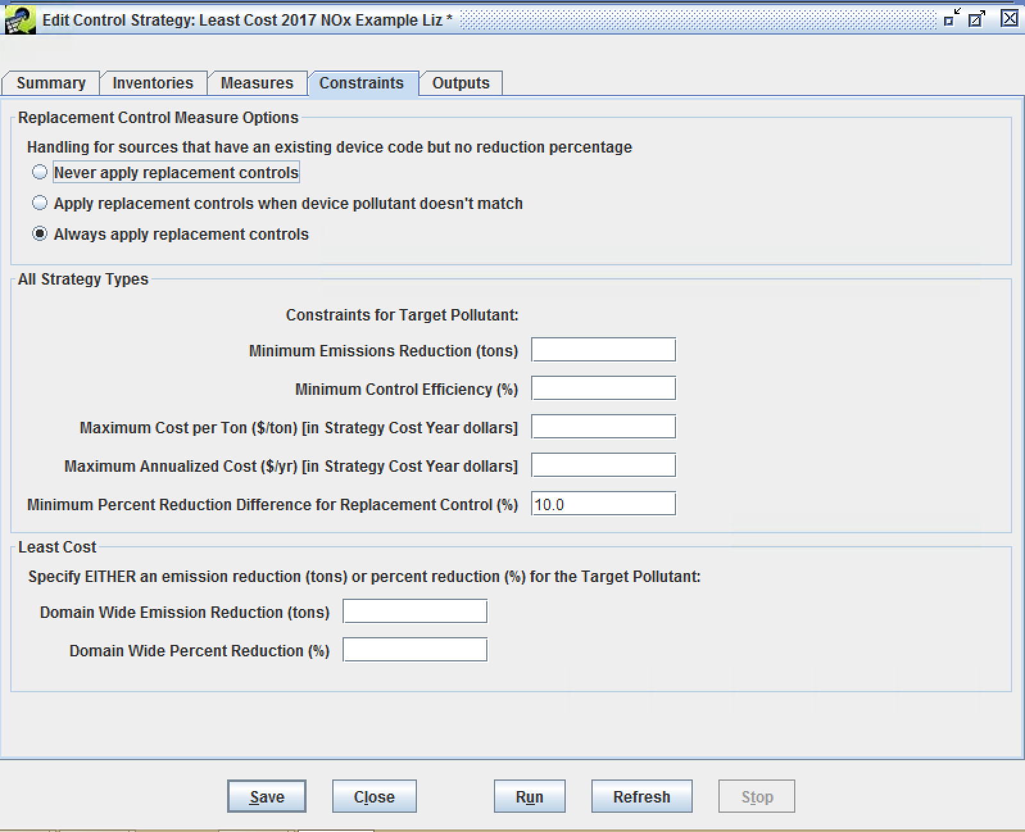

Constraints Tab of Edit Control Strategy Window

**Figure 4-15. Edit Control Strategy Constraints Tab.**

### Least Cost Curve Algorithm Constraints

When **Least Cost Curve** is selected from the Type of Analysis pull-down menu on the **Summary** tab three constraints settings are available in the Least Cost Curve section of the **Constraints** tab: * Domain-wide Percent Reduction Increment (%): increment for subsequent least cost runs to iterate on until the end percent reduction is reached. * Domain-wide Percent Reduction Start (%): target emissions reduction for the first least cost run. * Domain-wide Percent Reduction End (%): final emissions reduction target of the emissions reductions for the incremental least cost runs.

The Least Cost Curve strategy uses all three constraints in an iterative control run. First it will run the least cost strategy with the percent reduction specified as the value of **Domain-wide Percent Reduction Start (%)**, it will then add the **Domain-wide Percent Reduction Increment (%)** to the starting percent value and will run the least cost strategy at that value (i.e., starting value + increment). It will continue running strategies for each increment until it reaches the value of **Domain-wide Percent Reduction End**. Note that it may not be possible to achieve some of the selected percent reductions, in which case CoST will generate the same result for that increment as the Maximum Emissions Reduction would generate.

### Multi-Pollutant Maximum Emissions Reduction Algorithm Constraints

The Multi-Pollutant Maximum Emissions Reduction strategy type presents a different **Constraints** Tab than the other strategy types. Since this strategy type is running goals on numerous target pollutants (e.g. PM2.5, NOx, SO2), the constraints presented in Table 4-7 are combined with an inventory filtering capability (see the Section on the Inputs to the Inventory Tab) to allow for pollutant-specific constraints. The Multi-Pollutant strategy **Constraints** tab interface is shown in Figure 4-16.

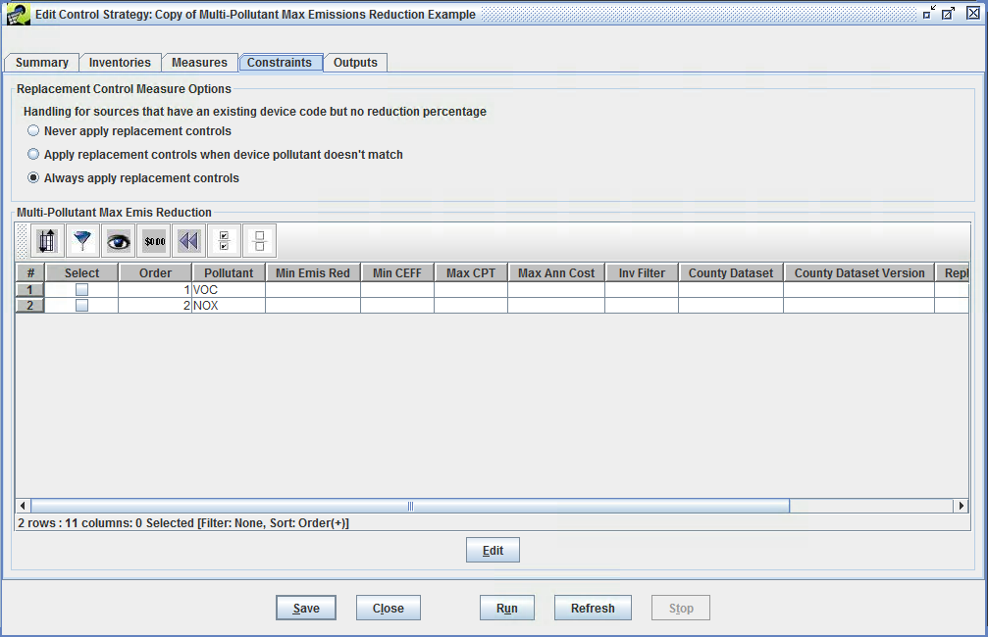

Constraints Tab (for Multi-Pollutant Maximum Emission Reduction strategy type) of Edit Control Strategy Window

**Figure 4-16. Multi-Pollutant Strategy Constraints Tab.**

The first step in configuring a Multi-Pollutant Maximum Emissions Reduction strategy is to select the target pollutants from the Target Pollutant list on the **Summary** tab. The pollutants selected from this list will appear in the table on the **Constraints** tab. Note that the order that the pollutants are added to the Target Pollutant list is important because it sets the order by which controls are applied in the multi-pollutant strategy.

To set the constraints and filters for each pollutant, click the checkbox in the **Select** column next to a pollutant on the **Constraints** tab and click Edit. The **Edit Control Strategy Target Pollutant** window will appear for setting the constraints and filters to use as the control strategy for the selected pollutant. Figure 4-17 shows an example **Edit Control Strategy Target Pollutant** window. The fields in the Edit Control Strategy Window include:

* Minimum Emissions Reduction(tons): sets the minimum emissions reduction tonnage for a particular source (down to the plant+point+stack+segment level of specification); only control measures that meet this threshold will be considered for the strategy
* Minimum Control Efficiency(%): requires that control measures used in the strategy have a control efficiency greater than or equal to the specified percentage for a particular source and target pollutant
* Maximum Cost per Ton($/ton): requires that control measures used in the strategy have an annualized cost per ton less than or equal to the specified maximum annualized cost per ton for the target pollutant for each source. This cost is based on 2013 dollars
* Maximum Annualized Cost($/yr): requires that control measures used in the strategy have an annualized cost less than or equal to the specified annualized cost for each source and target pollutant. This cost is based on 2013 dollars
* Minimum Percent Reduction Difference for Replacement Control(%): requires that control measures used in the strategy have a percent reduction of emissions that is greater than or equal to the specified difference in order for an old control measure to be “replaced by” the new control measure
* Inventory Filter: sets a general filter that can be entered using the same syntax as a Structured Query Language (SQL) “where clause”. Any of the columns in the inventory can be used in the expression. Examples include: “`SCC like ‘212%’`” to limit the analysis to apply only to inventory records for which the SCC code starts with 212, and “`FIPS like ‘06%’ or FIPS like ‘07%’`” to limit the strategy analysis to apply only to inventory records with Federal Information Processing Standards (FIPS) numeric state-county codes starting with 06 or 07.
* County Dataset/Version: sets an EMF dataset and version with a list of counties to which control measures will apply during the strategy run. Control measures will be applied only to counties that are included in this list. The County Dataset pull-down menu will show the names of the available CSV datasets in the EMF that have the dataset type ‘List of Counties (CSV)’

See [Table 4-7](constraints_common_to_multiple_control_strategy_types_table) for an additional description of how these fields are applied in a control strategy.

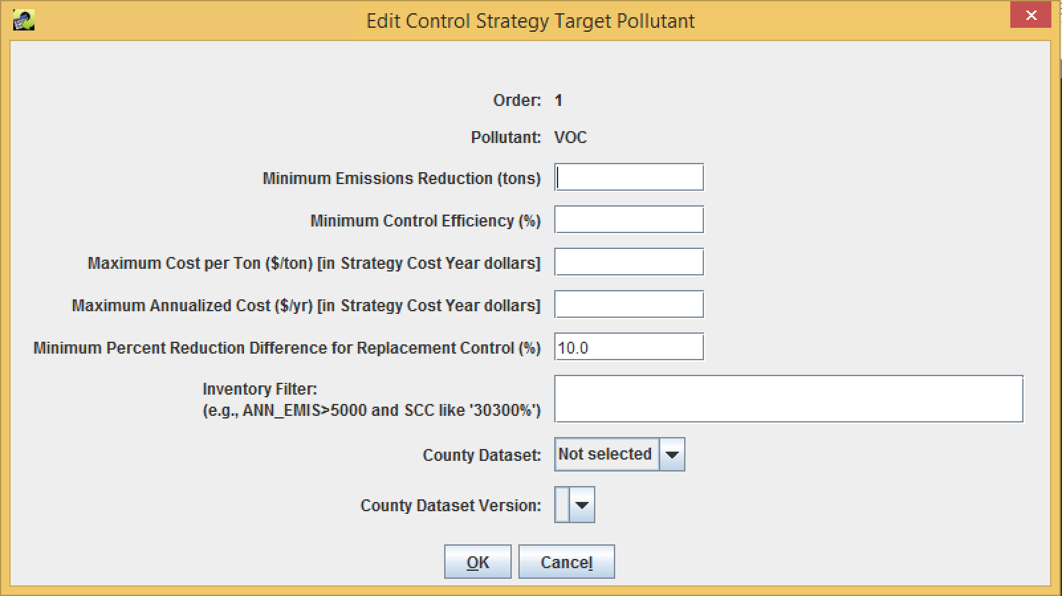

Edit Target Pollutant Dialog of Edit Control Strategy Window

**Figure 4-17. Multi-Pollutant Target Pollutant Window.**

## Running a Strategy and Accessing Its Outputs

### Running a Strategy

**Step 5-1: Run Least Cost Example Strategy.** After setting all of the example strategy inputs and constraints, as described in Section 4, click the Run button in the **Edit Control Strategy** window to start running the strategy. If the strategy was not saved before clicking Run, the changes will automatically be saved to the database. Note if the **Edit Control Strategy** window for the “Least Cost 2017 NOx Example” strategy is closed, it can be reopened by selecting the strategy from the list of strategies in the **Control Strategy Manager** and clicking the Edit button.

**Step 5-2: Monitor a Control Strategy Run Status.** After starting a control strategy run, check the **Status** window near the bottom of the EMF graphical user interface (GUI) to view messages about the run. If all inputs have been properly specified, the status message should show **“Started running control strategy: *your strategy name*”**. Click the Refresh button on the **Status** window to see immediate status updates; the **Status** window will autoupdate every 1-2 minutes.

If the strategy runs successfully, one message will be displayed for each inventory that completes, such as **“Completed processing control strategy input dataset: *dataset_name*”**. When the entire run has finished, the following message will be displayed: **“Completed running control strategy: *your strategy name*”** in the **Status** window. Otherwise, message will display stating that the strategy failed with information about why it failed.

### List Strategy Outputs

**Step 5-3: List Control Strategy Run Outputs.** Once the strategy run completes, click on the **Outputs** tab in the **Edit Control Strategy** window and then click Refresh at the bottom of the window to see the outputs from the run listed in the Output Datasets table (Figure 4-18 and Figure 4-19).

CoST automatically generates three main outputs for successful strategy runs: **Strategy Detailed Result**, **Strategy Measure Summary**, and **Strategy County Summary**. Some strategy types also generate a **Strategy Messages** output. Least Cost and Least Cost Curve strategies generate a **Least Cost Control Measure Worksheet** that lists all of the available control measure options for each source in the inventories.

For all types of strategies, CoST can generate a **Controlled Inventory** on-demand for any of the Strategy Detailed Result datasets. The types of outputs are discussed in more detail in Section 6. Note that the output datasets are given unique names that include a timestamp indicating when the strategy was run, including the year, month, day, hour, and minute of the run. A description of how to rename output datasets is provided below.

For additional details on the algorithms that are applied to assign measures to sources as part of a strategy run (other than the descriptions in Section 1), please see the [Control Strategy Tool (CoST) Equations Document](https://www3.epa.gov/ttn/ecas/docs/CoST_Equations_Document_2016_03_15.pdf).

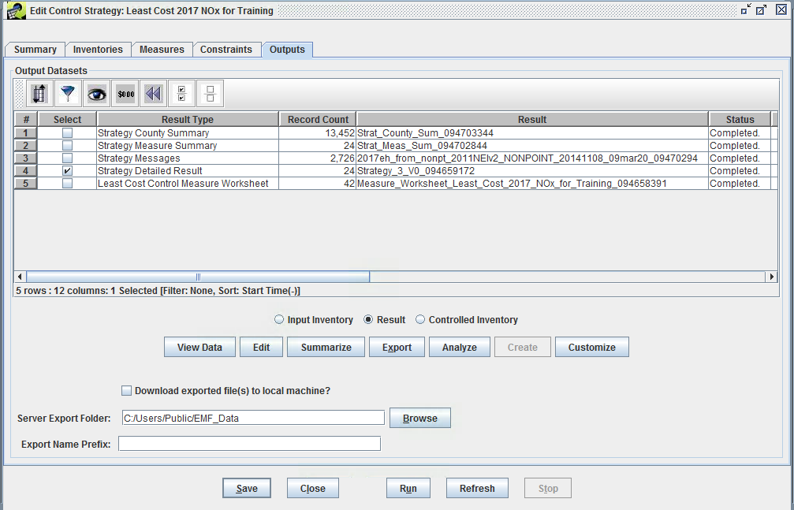

Outputs Tab of Edit Control Strategy Window for Least Cost Strategy

**Figure 4-18. Edit Control Strategy Outputs Window.**

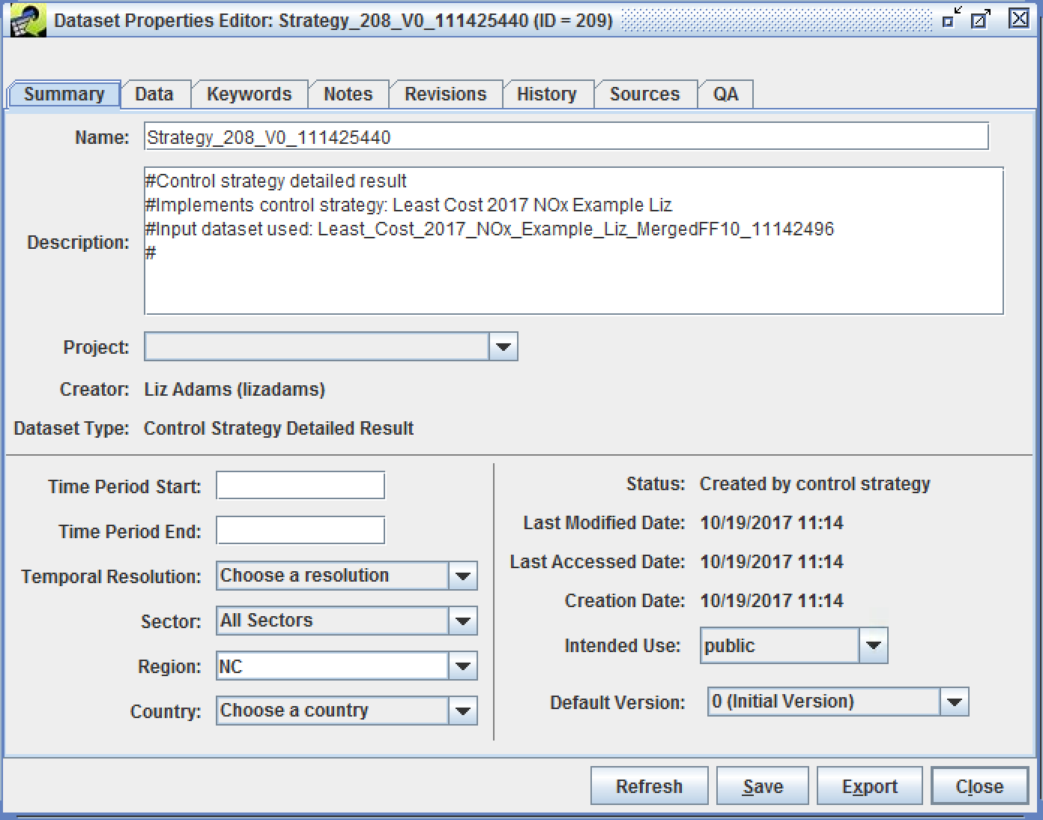

Sample Outputs Tab for a Least Cost Curve Strategy

**Figure 4-19. Dataset Properties Editor for Strategy Detailed Result.**

### Viewing and Editing Properties of the Strategy Outputs

It is possible to perform a number of operations on the strategy outputs. These operations are described in this and the following subsections.

**Step 5-4: View Control Strategy Run Outputs.** The most basic operation is to view the data of the output dataset using the **Data Viewer**. To do this, select one of the outputs on the **Outputs** tab, such as the **Strategy Detailed Result**, and then click View Data. (Note that the Strategy Detailed Result is the main output on which the Strategy County Summary and Strategy Measure Summary are based.) This will bring up the Data Viewer showing the contents of the Strategy Detailed Result (Figure 4-20).

The **Strategy Detailed Result** shows the abbreviation of the measure matched to each of the sources for all of the controlled sources, along with columns that identify each controlled source, information about the cost of applying the measures to the sources and the emissions reductions that resulted. The information computed includes the cost of application and the emissions reduced as a result. Enter a sort order (e.g., annual_cost desc) to have the rows sorted in a particular way.

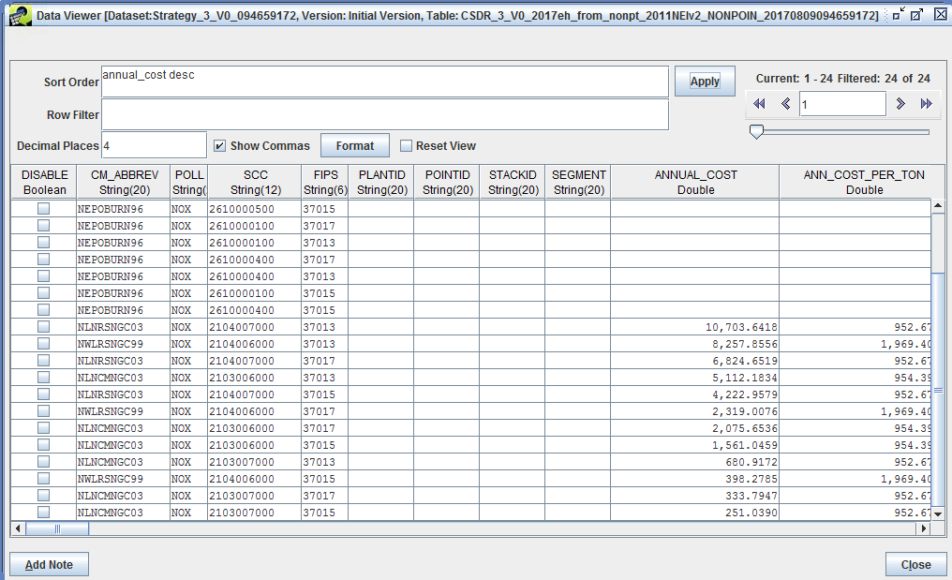

View Data for Strategy Detailed Result

**Figure 4-20. Strategy Detailed Result Outputs.**

Clear the entries in the Sort Order and Row Filter fields on the **Data Viewer** and click Apply, all of the data records will be presented in the order in which they appear in the database. More information about the columns included in the detailed result is given in Table 4-9, which is discussed later in the Strategy Detailed Result Section.

Click Close to exit from the **Data Viewer** when you are finished reviewing the **Strategy Detailed Result**.

**Step 5-5: View Control Strategy Run Output Properties.** From the View/Edit Control Strategy **Outputs** tab, access the properties (metadata) of an output dataset (as opposed to the actual data contained in the output), by selecting an output (for this exercise, select the **Strategy Detailed Result**) on the **Outputs** tab of the **Edit Control Strategy** window and clicking the Edit button. This will bring up the**Dataset Properties Editor** for the output dataset (Figure 4-21).

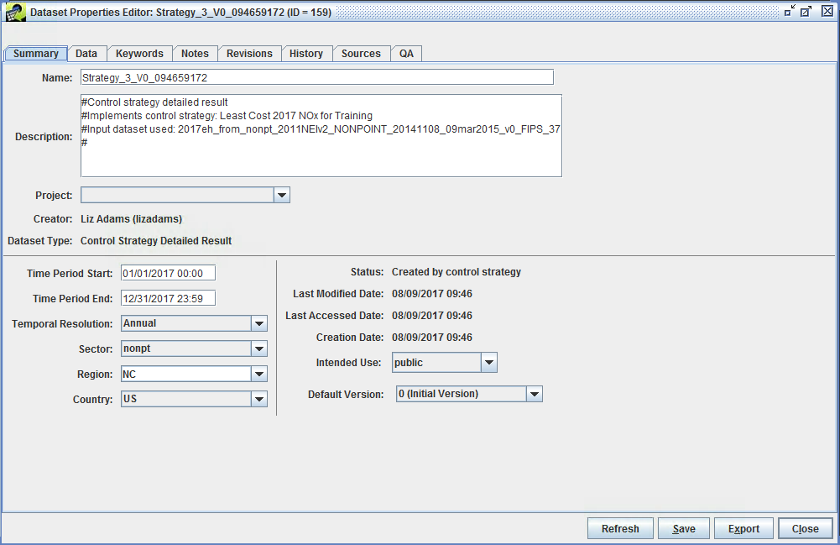

Summary Tab of Dataset Properties Editor

**Figure 4-21. Output Dataset Properties Window.**

Notice that the tabs on the **Dataset Properties Editor** are the same as those on the **Dataset Properties Viewer** shown in Figure 4-8. Editor mode allows many of the fields to be changed, where they could not be changed directly from in the Viewer mode. For example, change the name of the output by replacing the automatically generated name with a more meaningful one (e.g., **Least Cost 2017 VOC for Training Result**) and then click Save. Notice that unsaved edites are denoted with an asterisk in the title bar of the window.

Examine the other tabs of the **Dataset Properties Editor** for the **Strategy Detailed Result** output. In particular see the **Keywords** tab, an example of which is shown in Figure 4-22. For the **Strategy Detailed Result**, there are a number of keywords set in the Keywords Specific to Dataset section (in the lower part of window). These keywords correspond to the major parameters of the control strategy, such as the COST_YEAR and the STRATEGY_TYPE as shown in Figure 4-22). There are also keywords for the UNCONTROLLED_EMISSIONS, the TOTAL_EMISSION_REDUCTION, and the ACTUAL_PERCENT_REDUCTION.

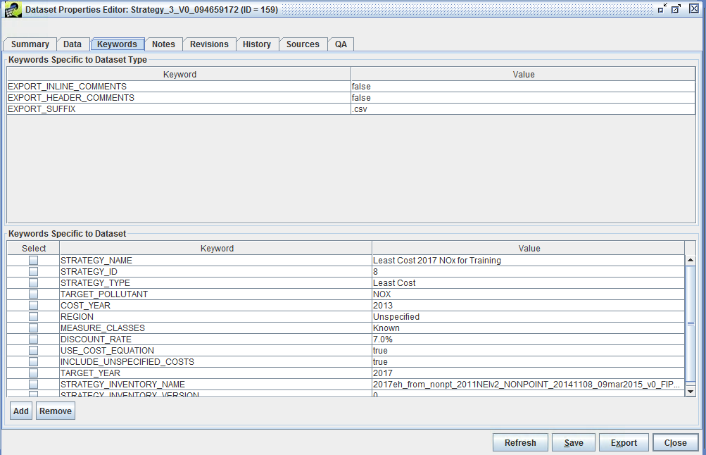

Keywords Tab of Dataset Properties Editor

**Figure 4-22. Output Dataset Properties Keywords Tab.**

The keywords in the Keywords Specific to Dataset Type section (the upper part of window in Figure 4-22) typically contain directives on how to export the data or other data values that are the same for all datasets of the same type. Typically FF10 or ORL inventories will have some of these keywords.

*Note that when the Dataset Properties Editor is open for a dataset no other users can edit that dataset.* Similarly, if a control strategy or control measure is open for *editing*, no other users can edit those items. Users will be able to view these items of the access permissions are set appropriately (see Intended Use setting on the **Summary** tab).

After examining the other Dataset Properties tabs, close the **Dataset Properties Editor** by clicking Save to save the changes, or Close to close without saving changes. For the example exercise, click Close and do not save any changes.

## Summarizing the Strategy Outputs

Strategy outputs, particularly **Strategy Detailed Results**, but also the input emissions inventories, can be summarized in many different ways. The ability to prepare summaries is helpful because in many cases there could be thousands of records in a single **Strategy Detailed Result** or emissions inventory. Thus, when the results of a strategy are analyzed or presented to others, it is useful to show the impact of the strategy in a summarized fashion. Frequently, it is helpful to summarize a strategy for each county, state, SCC, and/or control technology. The summaries are prepared using the EMF subsystem that was originally designed to support quality assurance (QA) of emissions inventories and related datasets, for which summaries are also needed. Thus, each summary is stored as the result of a “QA Step” that is created by having CoST run a SQL query. There are many predefined queries stored in the EMF as ‘templates’, circumventing the need for a user of the system to know SQL to create a summary. Summaries can be added from the QA tab of the **Dataset Properties Editor**, although there is a shortcut available on the **Outputs** tab. Summaries are discussed in more detail in Section 7.

**Step 5-6: Selecting Control Strategy Summaries.** Select **Strategy Detailed Result** on the **Outputs** tab of the **Edit Control Strategy** window and then click Summarize to open the **QA** tab of the **Dataset Properties Editor**.

To add a new summary from the list of predefined summary templates, click the Add from Template button to see a list of predefined QA Steps (Figure 4-23). To create summaries of interest, click the mouse button on the summaries to create. For this example, select **Summarize by Control Technology and Pollutant**, **Summarize by County and Pollutant**, **Summarize by Pollutant**. Select multiple summaries (as is illustrated in the figure) using Control-Click. Click OK after selecting the summaries and the selected QA templates will be added to the table on the QA tab (Figure 4-24).

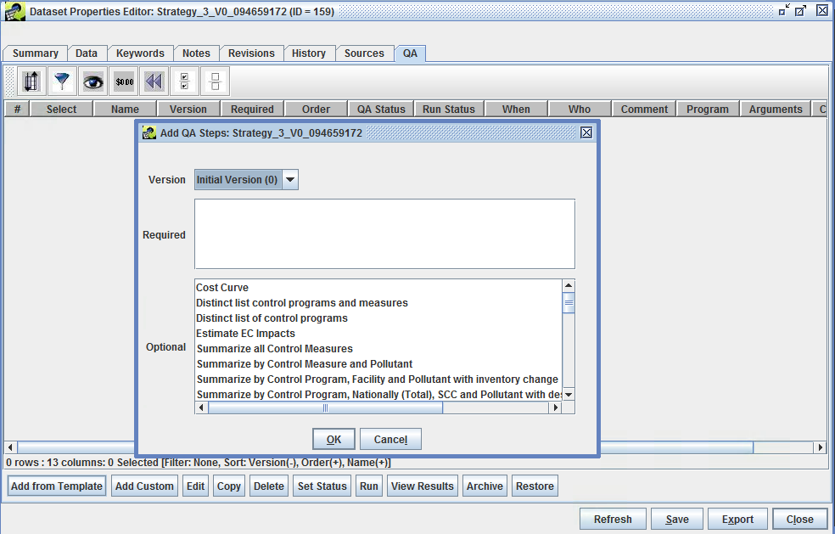

Summarizing a Strategy Detailed Result

**Figure 4-23. Add Predefined QA Steps Window.**

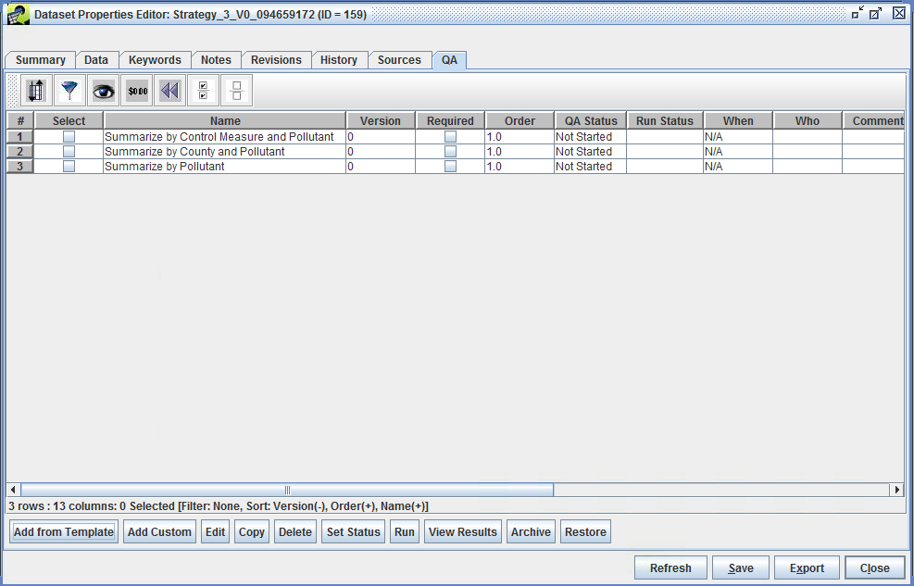

Available QA Summaries for a Strategy Detailed Result

**Figure 4-24. Selected QA Summaries.**

**Step 5-7: Running Control Strategy Summaries.** To run the QA summaries that are listed on the QA tab, first select the summaries of interest and then click Edit. The **Edit QA Step** window will appear (Figure 4-25). Do not edit anything in this window, just view the properties of the QA summary. Click Run at the bottom of the window to start the QA summary processing.

Monitor the progress of the QA step in the **Status** window at the bottom of the EMF main window. Once the run is complete, click the Refresh button to populate the Output Name, Run Status, and Run Date fields in the **Edit QA Step** window. *Note: as an alternative to clicking Run on several different windows, you can instead select a few summaries and click Run on the QA tab.*

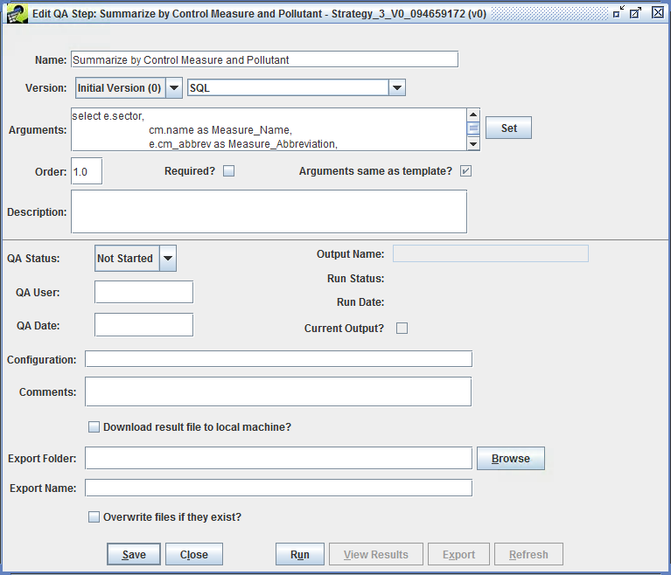

Edit QA Step Window to Create a Summary

**Figure 4-25. Edit QA Step Window.**

**Step 5-8: Viewing Control Strategy Summaries.** To see summarized control strategy output, select a checkbox next to the summary of interest on the **QA** tab and click View Results to bring up the **View QA Step Results** window (Figure 4-26). Sort and filter the results in this window in the same way as the **Control Measure Manager** and **Control Strategy Manager**. For example, click on the **avg_cost_per_ton** column header to sort on the cost per ton. You can also show the Top n or Bottom n rows using the second and third from the left toolbar buttons. The colorful toolbar buttons on the right support computing statistics, creating plots (if you have the R software package installed on your client machine), and saving the table and plot configurations.

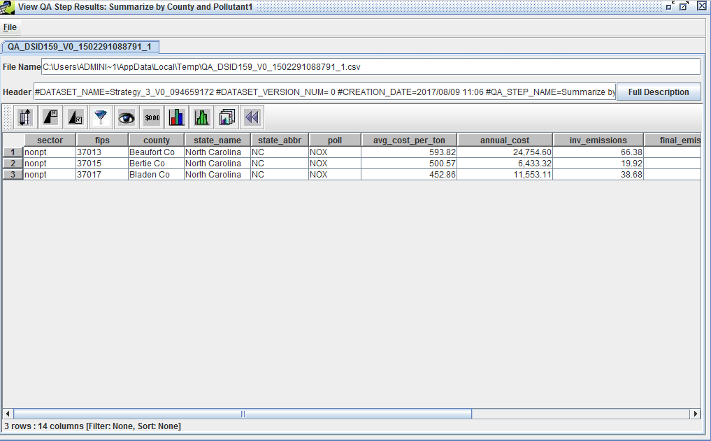

View QA Step Results Window

**Figure 4-26. View QA Step Results Window.**

**Step 5-9: Export Control Strategy Summary to Google Earth (KMZ).** If the summary has longitude and latitude information (e.g., a plant, state, or county summary), the EMF has an interface to create Google Earth-compatible Keyhole Markup Language Zipped (.kmz) files by choosing **Google Earth** from the File menu of the **View QA Step Results** window. The interface to create these files is shown in Figure 4-27. Note that the following detailed result summaries have longitude and latitude:

* Summarize by U.S. County and Pollutant
* Summarize by U.S. State and Pollutant
* Summarize by Plant and Pollutant

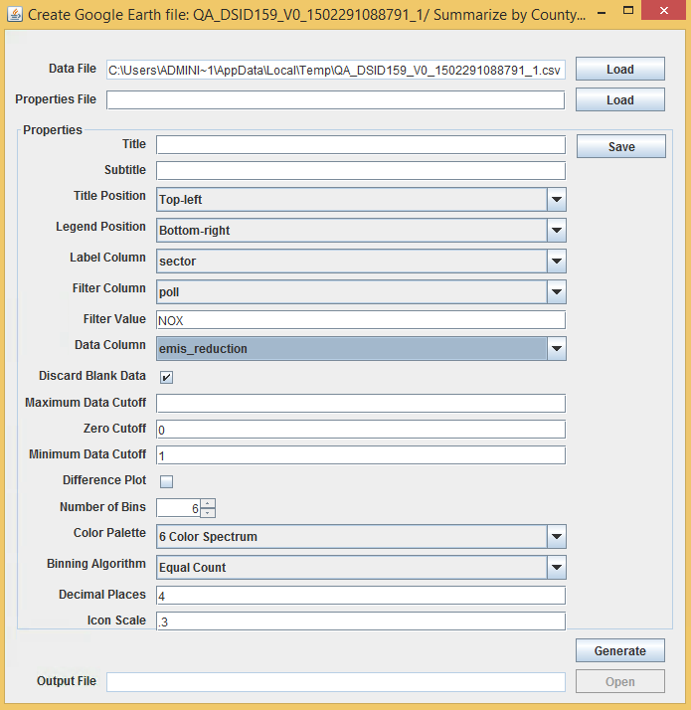

KMZ File Generator

**Figure 4-27. Google Earth KMZ file Generator.**

In the **Create Google Earth file** window, select a Label Column that will be used to label the points in the .kmz file. This label will appear when hovering over a point in the Goggle Earth map. For a plant summary this would typically be plant_name, for a county summary this would be county, for a state summary, this would be state_name.

Select a Data Column to show the value of a point in the .kmz file. This value will appear when hovering over a point in the Goggle Earth map. (e.g., total_emissions_reduction, total_annual_cost, or avg_cost_per_ton). The mouse over information will have the form:

*value from Label column : value from Data Column*.

For a summary that includes multiple pollutants, specify a filter so that data for only one pollutant is included in the .kmz file. Set the Filter Column to poll (e.g., pollutant), and then specify a Filter Value for a specific inventory pollutant (e.g., NOX).

Use Minimum Data Cutoff to limit the points shown in the .kmz file to include only those that reach a certain size threshold (e.g., do not show small sources or sources with a small amount of reduction). Points will only be created for rows in the summary for which the value in the data column exceeds the value given set by Minimum Data Cutoff. For example, if the **Data Column** is set to total_emissions_reduction, you might enter *1.0* as the Minimum Data Cutoff to show only plants with at least 1 ton of reduction.

Use **Icon Scale** to control the size of the points displayed in the Google Earth map. The setting of **Icon Scale** is a real number between 0 and 1. Smaller values produce smaller circles and larger values produce larger circles.

Mouse over the fields in this window to see tooltips with information about the field. After specifying the settings (aside from the Properties file) click Generate to create the .kmz file using default file name. The name and location of the output file are set by the Output File field.

Click Save to save the settings of the Google Earth file Properties to a file. Load a saved set of properties using the Load button in the **Create Google Earth file** window.

Close the **Create Google Earth file** window by clicking the X at the top right corner.

**Step 5-10: Export Control Strategy Summaries to CSV.** From the **Edit QA Step** window (Figure 4-25) select a folder to export the results to by either typing a directory path in the Export Folder field, or by using the Browse button to select an output directory. Click the Export button and the **Export QA Step Result** will be written to the selected folder on the EMF server.

### Exporting the Strategy Outputs

Return to the **Outputs** tab of the **Edit Control Strategy window** (Figure 4-18).

**Step 5-11: Export Control Strategy Outputs.** To export the strategy output datasets to the EMF server, enter a folder/directory name into the Server Export Folder field on the **Outputs** tab. Use the checkboxes to select one or more results to export from the Output Datasets table and click Export. The files will be written as ASCII files to the Server Export Folder. The resulting CSV files can be imported into a spreadsheet or other database software for analysis. *Note that the dataset must be exported to a location where the EMF application user has read/write access to the folder (e.g., the same directory as specified in the environment variable, EMF_DATA_DIRECTORY, in the EMF installation batch file).*

### Analyzing the Strategy Outputs

It is possible to view the strategy results directly from the **Outputs** tab in a sortable, filterable table, similar to the table used by the View QA Step Results window (Figure 4-26).

**Step 5-12: Analyze Control Strategy Outputs in CoST.** Use the checkboxes to select one or more results to analyze from the Output Datasets table and click **Analyze** to show the **Analyze Control Strategy** window for the selected outputs. An example of a Strategy County Summary analysis is shown in Figure 4-28. The results in this window can be sorted, filtered, plotted, and summarized with statistics. An example of a Least Cost Curve Summary is shown in Figure 4-29. Exit from the **Analyze Control Strategy** window using the X at the top of the window.

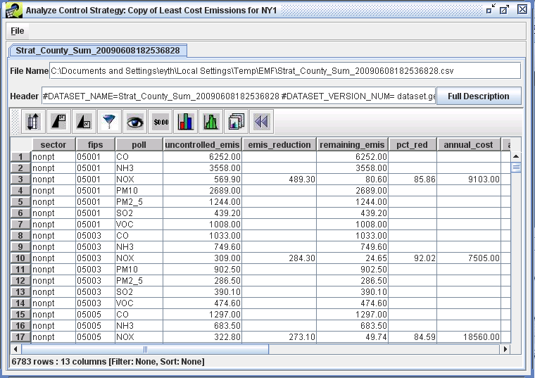

Analyze Control Strategy Window

**Figure 4-28. Control Strategy Analysis Window.**

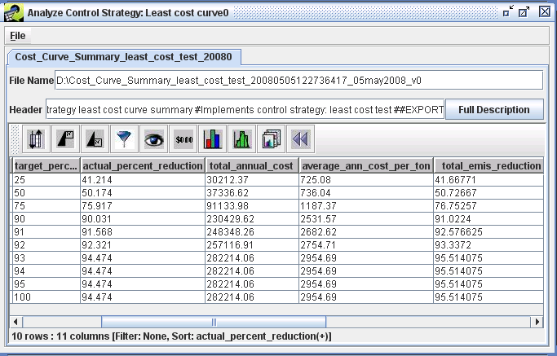

Analyzing a Least Cost Curve Output

**Figure 4-29. Least Cost Curve Strategy Summary.**

## Creating a Controlled Emissions Inventory

CoST can create a controlled emissions inventory that reflects the effects of the strategy by merging the detailed result with the original emissions inventory. Details on controlled inventories are discussed further in the Controlled Emissions Inventory Section.

**Step 5-13: Creating a Controlled Inventory.** To create a controlled inventory, click the Controlled Inventory radio button on the **Outputs** tab of the **Edit Control Strategy** window (Figure 4-18) and select the **Strategy Detailed Result** in the Output Datasets table to enable the Create button. *Note that only creators of a strategy or the Administrator can create inventories from a strategy result.*

Click Create to receive a prompt to **Enter a name prefix for the controlled inventories**; for this exercise, enter **training** and click the OK button. Cancelling this prompt will result in a controlled inventory with no name prefix. The status of the inventory creation will be shown in the Status window. Once the controlled inventory has been successfully created, for all but the Least Cost strategy types the name of the inventory will appear at the far right of the Output Datasets table in the row corresponding to the Strategy Detailed Result. For Least Cost strategy types, the controlled inventory will show up as rows in the Output Datasets table a “Controlled Inventory” **Result Type**. Figure 4-30 shows an example of where the controlled inventory name is located for a Maximum Emissions Reduction example strategy. Figure 4-31 shows an example of where the controlled inventories are located for a Least Cost example strategy.

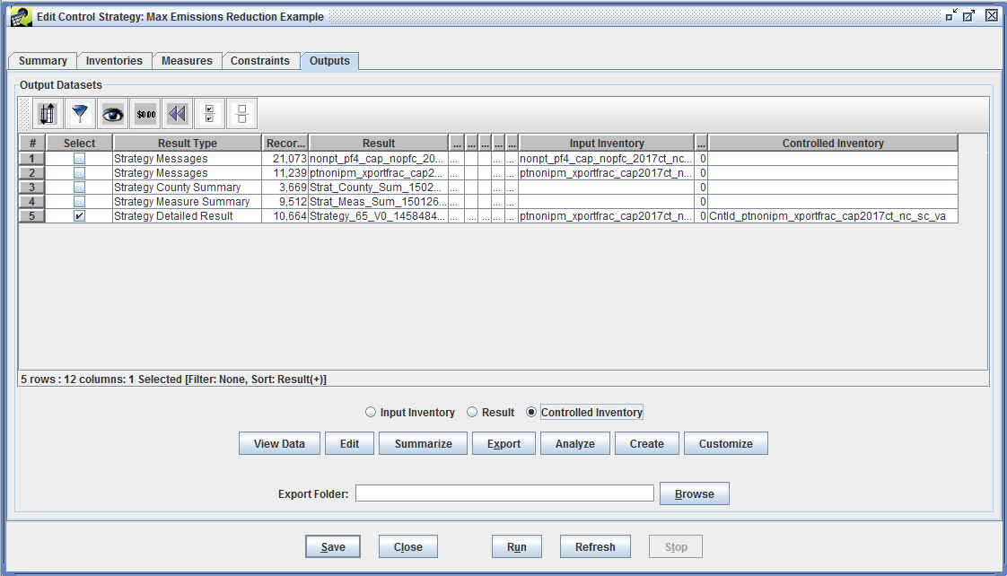

Controlled Inventory for Maximum Emissions Reduction Example

**Figure 4-30. Maximum Emissions Reduction Controlled Inventory Entry.**

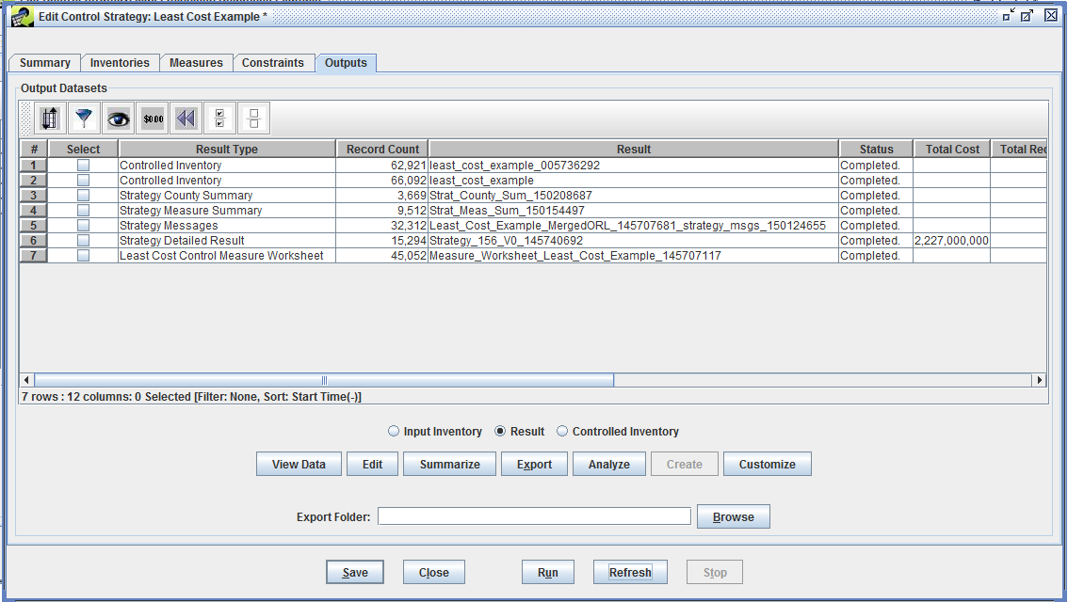

Controlled Inventory for Least Cost Curve Example

**Figure 4-31. Least Cost Curve Controlled Inventory Entry.**

**Step 5-14: Viewing a Controlled Inventory.** To view the data for a controlled inventory generated from all but the Least Cost strategy types, select the Controlled Inventory radio button and click View Data (Figure 4-30). For Least Cost strategy types use the checkbox in the **Select** column of the Output Datasets table to select a controlled inventory, select the Result radio button, and click View Data (Figure 4-31). The data for the controlled inventory dataset will appear in the **Data Viewer**.

To view the data for the input inventory that was merged with the **Strategy Detailed Result** to create the controlled inventory, select the Input Inventory radio button and click View Data.

### Creating Custom Strategy Outputs

The Customize button on the **Outputs** tab is not frequently used, but can generate special types of outputs related to analyses with a Response Surface Model (RSM). These custom outputs are not discussed here.

The remainder of this chapter provides reference documentation on the outputs of strategies and summaries that can be created with CoST. Additional advanced exercises and examples are available in [Chapter 5](./ch5_control_strategy_exercises.md).

## Outputs of Control Strategies

This section provides details on the contents of each type of CoST output.

### Strategy Detailed Result

As noted earlier, the Strategy Detailed Result is the primary output from running a control strategy. It is a table of emission source-control measure pairings, each of which contains information about the costs and emission reduction achieved for measures after they are applied to the sources. The contents of this table are described later in this subsection. When generating the Strategy Detailed Result table, some data are needed for CoST to calculate the values of some columns related to costs, such as:

* Stack Flow Rate (cfs): from the emissions inventory
* Capital Annual Ratio: from the control measure efficiency record
* Discount Rate (%): from the control measure efficiency record
* Equipment Life (yrs): from the control measure efficiency record
* Boiler Capacity (MW): from the design capacity column of the inventory; units are obtained from the design_capacity_unit_numerator and design_capacity_unit_denominator columns from the inventory. Note that boiler capacity is often blank in inventories, so special steps may need to be taken to fill in this information.

The stack flow rate provides information on the volume of effluent that requires treatment by the control device. The capital annual ratio is used to calculate the capital costs of a control device from an available O&M cost estimate for that device. The capital costs are the one-time costs to purchase and install the device, while the operating and maintenance (O&M) costs are those required to operate and maintain the device for each year. The discount rate and equipment life are used to compute the annualized capital costs for the device. The discount rate can be considered an annual interest rate used to calculate the cost of borrowing money to purchase and install the control device. The annualized capital cost is computed based on the discount rate, and the costs are spread over the life of the equipment. The algorithms to compute these cost breakdowns vary based on whether the input data required to utilize a cost equation are available. This topic is described in further detail in Table 4-9, which is given after an introductory discussion of cost concepts, below. The columns of the Strategy Detailed Result are also given in Table 4-9.

When cost data are provided for the control measures, the resulting costs are also specified in terms of a particular year. To compute the cost results for a control strategy, it is necessary to escalate or de-escalate the costs to the same year in order to adjust for inflation and to allow for consistency in comparing control strategy results. This is done with the following formula:

Cost (\$) for a year of interest = (Cost for original cost year x GDP IPD for year of interest) / GDP IPD for original cost year  
  
where the GDP IPD is the Gross Domestic Product.

Implicit Price Deflator (IPD) available from the United States Department of Commerce Bureau of Economic Analysis [Table 1.1.9. Implicit Price Deflators for Gross Domestic Product](http://bea.gov/iTable/iTable.cfm?reqid=9&step=3&isuri=1&903=13#reqid=9&step=3&isuri=1&904=2013&903=13&906=a&905=2015&910=x&911=1). The current version used is dated November 24, 2015. An excerpt of this version is shown in Table 4-8.

**Table 4-8. Excerpt from the gdplev Table Used to Convert Data between Cost Years**

|  |  |  |  |  |  |  |  |  |  |  |
| --- | --- | --- | --- | --- | --- | --- | --- | --- | --- | --- |
| Year | GDP IPD |  | Year | GDP IPD |  | Year | GDP IPD |  | Year | GDP IPD |
| 1980 | 44.377 |  | 1990 | 66.773 |  | 2000 | 81.887 |  | 2010 | 101.221 |
| 1981 | 48.520 |  | 1991 | 68.996 |  | 2001 | 83.754 |  | 2011 | 103.311 |
| 1982 | 51.530 |  | 1992 | 70.569 |  | 2002 | 85.039 |  | 2012 | 105.214 |
| 1983 | 53.565 |  | 1993 | 72.248 |  | 2003 | 86.735 |  | 2013 | 106.929 |
| 1984 | 55.466 |  | 1994 | 73.785 |  | 2004 | 89.120 |  | 2014 | 108.686 |
| 1985 | 57.240 |  | 1995 | 75.324 |  | 2005 | 91.988 |  |
| 1986 | 58.395 |  | 1996 | 76.699 |  | 2006 | 94.814 |  |
| 1987 | 59.885 |  | 1997 | 78.012 |  | 2007 | 97.337 |  |
| 1988 | 61.982 |  | 1998 | 78.859 |  | 2008 | 99.246 |  |
| 1989 | 64.392 |  | 1999 | 80.065 |  | 2009 | 100 |  |

To facilitate the comparison of the costs of control measures with one another, a normalized version of the control measure cost per ton is stored within the control measures database. These costs have all been converted to a consistent “reference year” using the above formula, so that the cost of any measure can be compared with any other even if their cost years differ. Currently, the reference year is 2013. In addition, during the course of the strategy run, the costs are converted (using the above formula) from the reference year to the cost year that was specified as an input to the strategy. The results of the strategy are therefore presented in terms of the specified cost year.

As indicated above, Table 4-9 provides details on the columns of the Strategy Detailed Result.

**Table 4-9. Columns in the Strategy Detailed Result**

|  |  |
| --- | --- |
| Column | Description |
| DISABLE | A true-false value that determines whether to disable the control represented on this line during the creation of a controlled inventory. |
| CM_ABBREV | The abbreviation for the control measure that was applied to the source. |
| POLL | The pollutant for the source, found in the inventory. |
| SCC | The SCC for the source, found in the inventory. |
| FIPS | The state and county FIPS code for the source, found in the inventory. |
| PLANTID | For point sources, the plant ID for the source from the inventory. |
| POINTID | For point sources, the point ID for the source from the inventory. |
| STACKID | For point sources, the stack ID for the source from the inventory. |
| SEGMENT | For point sources, the segment for the source from the inventory. |
| ANNUAL_COST ($) | The total annual cost (including both capital and O&M) required to keep the measure on the source for a year.*a. Default Approach (used when there is no cost equation, or when inputs to cost equation are not available):*Annual Cost = Emission Reduction (tons) x Reference Yr Cost Per Ton ($/tons in 2013 Dollars) x Cost Yr GDP IPD / Reference Yr GDP IPD*b. Approach when Using Type 8 Cost Equation:*If Stack Flow Rate >= 5.0 cfm ThenAnnual Cost = (Annualized Capital Cost + 0.04 x Capital Cost + O&M Cost)ElseAnnual Cost = Default Annualized Cost Per Ton Factor x Emission Reduction (tons) x Cost Yr GDP IPD / Reference Yr GDP IPD |
| ANN_COST_PER_TON ($/ton) | The annual cost (both capital and O&M) to reduce one ton of the pollutant.Ann_Cost_Per_Ton = Annual Cost ($) / Emis Reduction (tons) |
| ANNUAL_OPER_MAINT_COST ($) | The annual cost to operate and maintain the measure once it has been installed on the source.*a. Default Approach (used when there is no cost equation, or inputs to cost equation are not available):*= (Annual Cost - Annualized Capital Cost)Note: if the capital recovery factor was not specified for the measure, it would not be possible to compute Annualized Capital Cost or Annual O&M Costs*b. Approach when Using Type 8 Cost Equation:*If Stack Flow Rate >= 5.0 cfm Then= O&M Control Cost Factor x Stack Flow Rate (cfm) x Cost Yr GDP IPD / Reference Yr GDP IPDElse= Default O&M Cost Per Ton Factor x Emission Reduction (tons) x Cost Yr GDP IPD / Reference Yr GDP IPD |
| ANNUAL_VARIABLE_OPER_MAINT_COST ($) | The annual variable cost to operate and maintain the measure once it has been installed on the source.*a. Default Approach (used when there is no cost equation, or inputs to cost equation are not available):*= blank (not calculated, no default approach available)*b. Approach when Using Type 10 Cost Equation:*= variable_operation_maintenance_cost_multiplier x design_capacity x 0.85 x annual_avg_hours_per_year x Cost Yr GDP IPD / Reference Yr GDP IPD |
| ANNUAL_FIXED_OPER_MAINT_COST ($) | The annual fixed cost to operate and maintain the measure once it has been installed on the source.*a. Default Approach (used when there is no cost equation, or inputs to cost equation are not available):*= blank (not calculated, no default approach available)*b. Approach when Using Type 10 Cost Equation:*= design_capacity x 1000 x fixed_operation_maintenance_cost_multiplier x (250 / design_capacity) ^ fixed_operation_maintenance_cost_exponent x Cost Yr GDP IPD / Reference Yr GDP IPD |
| ANNUALIZED_CAPITAL_COST ($) | The annualized cost of installing the measure on the source assuming a particular discount rate and equipment life.Annualized_Capital_Cost = Total Capital Cost x Capital Recovery Factor (CRF)Note: if the CRF is not available for the measure, it is not possible to compute the ACC or the breakdown of costs between capital and O&M costs.CRF = (Discount Rate x (1 + Discount Rate)^Equipment Life) / ((Discount Rate + 1) ^Equipment Life - 1) |
| TOTAL_CAPITAL_COST ($) | The total cost to install a measure on a source.*a. Default Approach (used when there is no cost equation or cost equation inputs are not available):*TCC = Emission Reduction (tons) x Reference Yr Cost Per Ton ($/tons in 2013 Dollars) x Capital Annualized Ratio x Cost Yr GDP IPD / Reference Yr GDP IPD*b. Approach when Using Type 8 Cost Equation:*If Stack Flow Rate >= 5.0 cfm ThenTCC = Capital Control Cost Factor x Stack Flow Rate (cfm) x Cost Yr GDP IPD / Reference Yr GDP IPDElseTCC = Default Capital Cost Per Ton Factor x Emission Reduction (tons) x Cost Yr GDP IPD / Reference Yr GDP IPD |
| CONTROL_EFF (%) | The control efficiency of the measure being applied, stored in the measure efficiency record. |
| RULE_PEN (%) | The rule penetration of the measure being applied, stored in the measure efficiency record, but could be overridden as a strategy setting (see the Section on the Inputs to the Meaures Tab). |
| RULE_EFF (%) | The rule effectiveness of the measure being applied, stored in the measure efficiency record, but could be overridden as a strategy setting (see the Section on the Inputs to the Meaures Tab). |
| PERCENT_REDUCTION (%) | The percent by which the emissions from the source are reduced after the control measure has been applied.Percent reduction = Control Efficiency (%) x Rule Penetration (%) / 100 x Rule Effectiveness (%) / 100 |
| ADJ_FACTOR | The factor that was applied by a control program to adjust the emissions to the target year. |
| INV_CTRL_EFF (%) | The control efficiency for the existing measure on the source, found in the inventory. |
| INV_RULE_PEN (%) | The rule penetration for the existing measure on the source, found in the inventory. |
| INV_RULE_EFF (%) | The rule effectiveness for the existing measure on the source, found in the inventory. |
| FINAL_EMISSIONS (tons) | The final emission that results from the source being controlled.= Annual Emission (tons) - Emission Reduction (tons) |
| EMIS_REDUCTION (tons) | The emissions reduced (in tons) as a result of applying the control measure to the source.Emissions reduction = Annual Emission (tons) x Percent Reduction (%) / 100 |
| INV_EMISSIONS (tons) | The annual emissions, found in the inventory. Note that if the starting inventory had average-day emissions, the average-day value is annualized and the resulting value is shown here. This is necessary to properly compute the costs of the measure. |
| APPLY_ORDER | If multiple measures are applied to the same source, this is a numeric value noting the order of application for this specific control measure. The first control to be applied will have a value of 1 for this field, the second will have a value of 2, and so on. |
| INPUT_EMIS (tons) | The emissions that still exist for the source after prior control measures have been applied. Usually this is the same as INV_EMISSIONS (see above), but for the “Apply Measures In Series” strategy type, in which multiple measures are applied to the same source, this is the emissions that are still available for the source after all prior control measures have been applied. |
| OUTPUT_EMIS (tons) | The emissions that still exist for the source after the current and all prior control measures have been applied. Usually this is the same as FINAL_EMISSIONS (see above), but for the “Apply Measures In Series” strategy type, in which multiple measures are applied to the same source, this is the emissions that are still available for the source after the current and all prior control measures have been applied. |
| FIPSST | The two-digit FIPS state code. |
| FIPSCTY | The three-digit FIPS county code. |
| SIC | The SIC code for the source from the inventory. |
| NAICS | The NAICS code for the source from the inventory. |
| SOURCE_ID | The record number from the input inventory for this source. |
| INPUT_DS_ID | The numeric ID of the input inventory dataset (for bookkeeping purposes). If multiple inventories were merged to create the inventory (as can be done for Least Cost strategies), this ID is that of the merged inventory. |
| CS_ID | The numeric ID of the control strategy. |
| CM_ID | The numeric ID of the control measure. |
| EQUATION TYPE | The control measure equation that was used during the cost calculations. |
| ORIGINAL_DATASET_ID | The numeric ID of the original input inventory dataset, even if a merged inventory was used for the computation of the strategy, as can be done for Least Cost strategies. |
| SECTOR | The emissions sector specified for the input inventory (text, not an ID number; e.g., ptnonipm for the point non-IPM sector) |
| CONTROL_PROGRAM | The control program that was applied to produce this record. |
| XLOC | The longitude for the source, found in the inventory for point sources; for nonpoint inventories the county centroid is used. This is useful for mapping purposes. |
| YLOC | The latitude for the source, found in the inventory for point sources; for nonpoint inventories the county centroid is used. This is useful for mapping purposes. |
| PLANT | The plant name from the inventory (or county name for nonpoint sources). |
| REPLACEMENT_ADDON | Indicates whether the measure was a replacement or an add-on control.A = Add-On ControlR = Replacement Control |
| EXISTING_MEASURE_ABBREVIATION | This column is used when an Add-On Control was applied to a source; it indicates the existing control measure abbreviation that was on the source. |
| EXISTING_PRIMARY_DEVICE_TYPE_CODE | This column is used when an Add-On Control was applied to a source; it indicates the existing control measure primary device type code that was on the source. |
| STRATEGY_NAME | The name of the control strategy that produced the detailed result. |
| CONTROL_TECHNOLOGY | Indicates the control technology of the control measure. |
| SOURCE_GROUP | Indicates the source group of the control measure. |
| COMMENT | Information about this record and how it was produced; this information is either created automatically by the system or entered by the user. |
| RECORD_IDVERSIONDELETE_VERSIONS | System specific columns used for tracking primary key and versioning of data |

### Strategy Measure Summary

The Strategy Measure Summary output dataset is a table of emission reduction and cost values aggregated by the emissions sector (i.e., an EMF Sector), state/county FIPS code, SCC, pollutant, and control measure. This table contains information only for sources that were controlled during the strategy run. It is generated by running a SQL statement that aggregates the data from the Strategy Detailed Result according to the five categories just listed. The annual cost and emission reduction are calculated by summing all costs and emission reductions for the specified grouping (sector, FIPS, SCC, pollutant, and control measure). The average annual cost per ton is calculated by dividing the total annual costs by the total emission reduction for each measure. The columns contained in this summary and the formulas used to compute their values are shown in Table 4-10. An example Strategy Measure Summary is shown in Table 4-14.

**Table 4-10. Columns in the Strategy Measure Summary**

|  |  |
| --- | --- |
| Column | Description |
| SECTOR | The sector for the source (e.g., ptnonipm for the point non-IPM sector) |
| FIPS | The state and county FIPS code for the source |
| SCC | The SCC for the source |
| POLL | The pollutant for the source |
| CONTROL_MEASURE_ABBREV | The control measure abbreviation |
| CONTROL_MEASURE | The control measure name |
| CONTROL_TECHNOLOGY | The control technology that is used for the measure (e.g., Low NO~x burner, Onroad Retrofit). |
| SOURCE_GROUP | The group of sources to which the measure applies (e.g., Fabricated Metal Products - Welding). |
| ANNUAL_COST | The total annual cost for all sources that use this measure. This is calculated by summing all source annual costs that use this measure= sum(annual_cost) |
| AVG_ANN_COST_PER_TON | The average annual cost per ton ($/ton). This is calculated by dividing the total annual cost by the total emission reduction for all sources for this measure= sum(annual_cost) / sum(emis_reduction) |
| INPUT_EMIS | The total of emissions from all sources entering the control measure. This is calculated by summing the input emissions for all sources that were controlled by this measure= sum(input_emis) |
| EMIS_REDUCTION | The total reduction in emission in tons for all sources for this control measure |
| PCT_RED | The percent reduction (%) for all sources controlled by this measure. This is calculated by dividing the total emissions reduction by the total input emissions.= [sum(emis_reduction) / sum(input_emis)] x 100 |
| RECORD_IDVERSIONDELETE_VERSIONS | System specific columns used for tracking primary key and versioning of data |

### Strategy County Summary

The Strategy County Summary output dataset is a table of emission reduction and cost values aggregated by emissions sector, county, and pollutant. This dataset includes all of the inventory sources regardless of whether they were controlled. If there is more than one inventory included in the strategy inputs, then all inventories and their associated Strategy Detailed Results are merged and aggregated in this summary. The columns that compose this summary are shown in Table 4-11. An example Strategy County Summary is shown in Table 4-15.

**Table 4-11. Columns in the Strategy County Summary**

|  |  |
| --- | --- |
| Column | Description |
| SECTOR | The emissions sector for the source (i.e., ptnonipm for the point non-IPM emissions sector) |
| FIPS | The state and county FIPS code for the source |
| POLL | The pollutant for the source |
| UNCONTROLLED_EMIS | The original inventory emission for the county (in tons) |
| EMIS_REDUCTION | The total emission reduction for the county (in tons) |
| REMAINING_EMIS | The remaining emissions after being controlled (in tons) |
| PCT_RED | The percent reduction for the pollutant |
| ANNUAL_COST | The total annual cost for the county. This is calculated by summing the annual costs for the county= sum(annual_cost) |
| ANNUAL_OPER_MAINT_COST | The total annual O&M costs for the county. This is calculated by summing the annual O&M costs for the county= sum(annual_oper_maint_cost) |
| ANNUALIZED_CAPITAL_COST | The total annualized capital costs for the county. This is calculated by summing the annualized capital costs for the county= sum(annualized_capital_cost) |
| TOTAL_CAPITAL_COST | The total capital costs for the county. This is calculated by summing the total capital costs for the county= sum(total_capital_cost) |
| AVG_ANN_COST_PER_TON | The average annual cost per ton ($/ton). This is calculated by dividing the total annual cost by the total emission reduction for the county.= sum(annual_cost) / sum(emis_reduction) |
| RECORD_IDVERSIONDELETE_VERSIONS | System specific columns used for tracking primary key and versioning of data |

### Controlled Emissions Inventory

Another output that can be created is a controlled emissions inventory (introduced earlier in the Creating a Controlled Emissions Inventory Section). This dataset is not automatically created during a strategy run; instead, a user can choose to create it after the strategy run has completed successfully. When CoST creates a controlled inventory, comments are placed at the top of the inventory file that indicate the strategy that produced it and the high-level settings for that strategy. For the sources that were controlled, CoST fills in the CEFF (control efficiency), REFF (rule effectiveness), and RPEN (rule penetration) columns based on the control measures applied to the sources. It also populates several additional columns toward the end of the ORL inventory rows that specify information about measures that it has applied. These columns are:

* CONTROL MEASURES: An ampersand (&)-separated list of control measure abbreviations that correspond to the control measures that have been applied to the given source.
* PCT REDUCTION: An ampersand-separated list of percent reductions that have been applied to the source, where percent reduction = CEFF x REFF x RPEN.
* CURRENT COST: The annualized cost for that source for the most recent control strategy that was applied to the source.
* TOTAL COST: The total cost for the source across all measures that have been applied to the source.

In this way, the controlled inventories created by CoST always specify the relevant information about the measures that have been applied as a result of a CoST control strategy.

### Strategy Messages

The Strategy Messages output provides information gathered while the strategy is running that is helpful to the user. The Strategy Messages output is currently created by the following strategy types:

* Project Future Year Inventory
* Max Emission Reduction
* Least Cost (but not Least Cost Curve)

The columns of the Strategy Messages output are described in Table 4-12. An example Strategy Messages output is shown in Table 4-13.

**Table 4-12. Columns in the Strategy Messages Output**

|  |  |
| --- | --- |
| Column | Description |
| FIPS | The state and county FIPS code for the source, found in the inventory |
| SCC | The SCC code for the source, found in the inventory |
| PLANTID | For point sources, the plant ID for the source from the inventory. |
| POINTID | For point sources, the point ID for the source from the inventory. |
| STACKID | For point sources, the stack ID for the source from the inventory. |
| SEGMENT | For point sources, the segment for the source from the inventory. |
| POLL | The pollutant for the source, found in the inventory |
| STATUS | The status type of the message. The possible values:Warning - a possible issue has been detected, but processing did not stop.Error - a problem occurred that caused the processing to stop.Informational - it was desirable to communicate information to the user. |
| CONTROL_PROGRAM | The control program for the strategy run; this is populated only when using the “Project Future Year Inventory” strategy type. |
| MESSAGE | Text describing the strategy issue. |
| MESSAGE_TYPEINVENTORY PACKET_FIPSPACKET_SCCPACKET_PLANTIDPACKET_POINTIDPACKET_STACKIDPACKET_SEGMENTPACKET_POLLPACKET_SICPACKET_MACTPACKET_NAICSPACKET_COMPLIANCE_DATE | Reserved columns used for another strategy type that was not part of this training exercise. |
| RECORD_IDVERSIONDELETE_VERSIONS | System specific columns used for tracking primary key and versioning of data |

**Table 4-13. Example of Strategy Messages Output**

|  |  |  |  |  |  |  |  |  |  |
| --- | --- | --- | --- | --- | --- | --- | --- | --- | --- |
| fips | scc | plantid | pointid | stackid | segment | poll | status | control_program | message |
| 42049 | 30900201 | 420490009 | 942 | S942 | 1 | PM2_5 | Warning |  | Negative emission reduction (-1693.9) |

**Table 4-14. Example of Strategy Measure Summary Data**

|  |  |  |  |  |  |  |  |  |  |  |
| --- | --- | --- | --- | --- | --- | --- | --- | --- | --- | --- |
| SECTOR | FIPS | SCC | POLL | CONTROL_MEASURE_ABBREV | CONTROL_MEASURE | CONTROL_TECHNOLOGY | SOURCE_GROUP | ANNUAL_COST | AVG_ANN_COST_PER_TON | EMIS_REDUCTION |
| ptnonipm | 37001 | 10200906 | PM10 | PFFPJIBWD | Fabric Filter (Pulse Jet Type);(PM10) Industrial Boilers - Wood | Fabric Filter (Pulse Jet Type) | Industrial Boilers - Wood | $419,294 | $12,862 | 32.6007 |
| ptnonipm | 37001 | 10200906 | PM2_5 | PFFPJIBWD | Fabric Filter (Pulse Jet Type);(PM10) Industrial Boilers - Wood | Fabric Filter (Pulse Jet Type) | Industrial Boilers - Wood |  |  | 19.5426 |
| ptnonipm | 37001 | 30500311 | PM10 | PFFPJMIOR | Fabric Filter (Pulse Jet Type);(PM10) Mineral Products - Other | Fabric Filter (Pulse Jet Type) | Mineral Products - Other | $446,026 | $83,379 | 5.3494 |
| ptnonipm | 37001 | 30500311 | PM2_5 | PFFPJMIOR | Fabric Filter (Pulse Jet Type);(PM10) Mineral Products - Other | Fabric Filter (Pulse Jet Type) | Mineral Products - Other |  |  | 2.0939 |
| ptnonipm | 37001 | 30501110 | PM10 | PFFPJMIOR | Fabric Filter (Pulse Jet Type);(PM10) Mineral Products - Other | Fabric Filter (Pulse Jet Type) | Mineral Products - Other | $110 | $147 | 0.7498 |
| ptnonipm | 37001 | 30501110 | PM2_5 | PFFPJMIOR | Fabric Filter (Pulse Jet Type);(PM10) Mineral Products - Other | Fabric Filter (Pulse Jet Type) | Mineral Products - Other |  |  | 0.2605 |

**Table 4-15. Example of Strategy County Summary Data**

|  |  |  |  |  |  |  |  |  |  |  |  |
| --- | --- | --- | --- | --- | --- | --- | --- | --- | --- | --- | --- |
| SECTOR | FIPS | POLL | INPUT_EMIS | EMIS_REDUCTION | REMAINING_EMIS | PCT_RED | ANNUAL_COST | ANNUAL_OPER_MAINT_COST | ANNUALIZED_CAPITAL_COST | TOTAL_CAPITAL_COST | AVG_ANN_COST_PER_TON |
| ptnonipm | 37001 | VOC | 313.8724 |  | 313.8724 |  |  |  |  |  |  |
| ptnonipm | 37001 | PM2_5 | 33.4717 | 33.2505 | 0.2212 | 99.3391 |  |  |  |  |  |
| ptnonipm | 37001 | NH3 | 6.9128 |  | 6.9128 |  |  |  |  |  |  |
| ptnonipm | 37001 | NOX | 146.2904 |  | 146.2904 |  |  |  |  |  |  |
| ptnonipm | 37001 | PM10 | 51.0928 | 50.7019 | 0.3909 | 99.2349 | $865,430 | $746,831 | $83,300 | $882,489 | $22,363 |
| ptnonipm | 37001 | SO2 | 54.3864 |  | 54.3864 |  |  |  |  |  |  |

## Summaries of Strategy Inputs and Outputs

The EMF/CoST system can prepare summaries of the datasets that are loaded into the system, including both the emissions inventory datasets and the Strategy Detailed Result outputs. The ability to prepare summaries is helpful because in many cases there could be thousands of records in a single Strategy Detailed Result. Thus, when the results of a strategy are analyzed or presented to others, it is useful to show the impact of the strategy in a summarized fashion. Frequently, it is helpful to summarize a strategy for each county, state, SCC, or control technology. The power of the PostgreSQL relational database that contains the system data is used to develop these summaries. Currently, they are prepared using the EMF subsystem that was designed to support quality assurance (QA) of emissions inventories and related datasets. Recall that the creation of summaries for strategy outputs was discussed in the Summarizing Strategy Outputs Section.

Each summary is stored as the result of a “QA Step” that is created by asking CoST to run a SQL query. Summaries can be added to inventory or Strategy Detailed Result datasets by editing the dataset properties, going to the QA tab, and using the available buttons to add and edit QA steps. For more details on how to create summaries, see Summarizing Strategy Outputs Section. Examples of the types of summary templates available for Point Inventories (the type with the most templates due to the larger number of columns in that inventory type) are:

* “Summarize by Pollutant with Descriptions”
* “Summarize by Pollutant”
* “Summarize by SCC and Pollutant with Descriptions”
* “Summarize by SCC and Pollutant”
* “Summarize by U.S. State and Pollutant with Descriptions”
* “Summarize by U.S. State and Pollutant”
* “Summarize by U.S. County and Pollutant with Descriptions”
* “Summarize by MACT Code, U.S. State and Pollutant with Descriptions”
* “Summarize by Data Source Code, U.S. State and Pollutant with Descriptions”
* “Summarize by U.S. State, SCC and Pollutant with Descriptions”
* “Compare CoST to NEI measures”
* “Roll Up CoST and NEI measures”
* “Summarize by Plant and Pollutant”

Note that the summaries “with Descriptions” have more information than the ones without. For example, the “Summarize by SCC and Pollutant with Descriptions” summary includes the SCC description in addition to the pollutant description. The disadvantage to include the descriptions is that they are a bit slower to generate because information has to be brought in from additional tables than the table being summarized.

Each of the summaries is created using a customized SQL syntax that is very similar to standard SQL, except that it includes some EMF-specific concepts that allow the queries to be defined generally and then applied to specific datasets as needed. An example of the customized syntax for the “Summarize by SCC and Pollutant” query is:

select SCC, POLL, sum(ann_emis) as ann_emis from $TABLE[1] e group by SCC, POLL order by SCC, POLL

Notice that the only difference between this and standard SQL is the use of the $TABLE[1] syntax. When this query is run, the $TABLE[1] portion of the query is replaced with the table name used to contain the data in the EMF. Note that most datasets have their own tables in the EMF schema, so you do not normally need to worry about selecting only the records for the specific dataset of interest. The customized syntax also has extensions to refer to another dataset and to refer to specific versions of other datasets using tokens other than $TABLE. For the purposes of this discussion, it is sufficient to note that these other extensions exist.

Some of the summaries are constructed using more complex queries that join information from other tables, such as the SCC descriptions, the pollutant descriptions (which are particularly useful for HAPs), and to account for any missing descriptions. For example, the syntax for the “Summarize by SCC and Pollutant with Descriptions” query is:

select e.SCC, coalesce(s.scc_description,'AN UNSPECIFIED DESCRIPTION')::character varying(248) as scc_description, e.POLL, coalesce(p.descrptn,'AN UNSPECIFIED DESCRIPTION')::character varying(11) as pollutant_code_desc, coalesce(p.name,'AN UNSPECIFIED SMOKE NAME')::character varying(11) as smoke_name,p.factor, p.voctog, p.species, coalesce(sum(ann_emis), 0) as ann_emis, coalesce(sum(avd_emis), 0) as avd_emis from $TABLE[1] e left outer join reference.invtable p on e.POLL=p.cas left outer join reference.scc s on e.SCC=s.scc group by e.SCC,e.POLL,p.descrptn,s.scc_description, p.name, p.factor,p.voctog, p.species order by e.SCC, p.name

This query is quite a bit more complex, but is still supported by the EMF QA step processing system. In addition to summaries of the inventories, there are many summaries available for the Strategy Detailed Results output by control strategy runs and for some of the other CoST-related dataset types. Some of the summaries available for Strategy Detailed Results are as follows:

* “Summarize by Pollutant”
* “Summarize by County and Pollutant”
* “Summarize by SCC and Pollutant”
* “Summarize by Control Technology and Pollutant”
* “Summarize by Control Measure and Pollutant”
* “Summarize by Source Group and Pollutant”
* “Summarize by U.S. State and Pollutant”
* “Summarize by State, SCC, and Control Technology”
* “Summarize by Control Technology, FIPS, and SCC”
* “Summarize by Control Program, U.S. State and Pollutant”
* “Summarize by Plant and Pollutant”
* “Summarize all Control Measures”
* “Summarize by Sector and Pollutant with Descriptions”
* “Summarize by Sector, U.S. State, and Pollutant”
* “Summarize by U.S. State and SMOKE Pollutant Name”
* “Cost Curve”

A plot created based the output of a Summarize by Control Technology and Pollutant summary is shown in Figure 4-32.

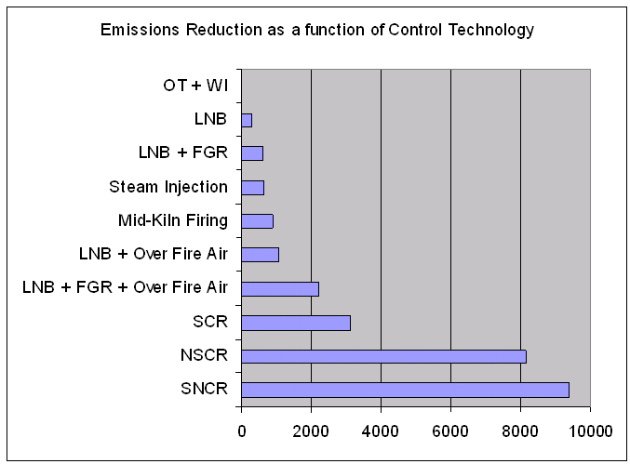

Control Technologies used within a Least Cost Analysis

**Figure 4-32. Control Technologies used within a Least Cost Analysis.**

When multiple datasets need to be considered in a summary (e.g., to compare two inventories), the EMF “QA Program” mechanism is used. The QA programs each have customized user interfaces that allow users to select the datasets to be used in the query. Some of the following QA programs may prove useful to CoST users:

* Multi-inventory sum: takes multiple inventories as input and reports the sum of emissions from all inventories
* Multi-inventory column report: takes multiple inventories as input and shows the emissions from each inventory in separate columns
* Multi-inventory difference report: takes two sets of inventories as input, sums each inventory, and then computes the difference between the two sums
* Compare Control Strategies: compares the data available in the Strategy Detailed Result datasets output from two control strategies

Summaries can be mapped with geographic information systems (GIS), mapping tools, and Google Earth. To facilitate this mapping, many of the summaries that have “with Descriptions” in their names include latitude and longitude information. For plant-level summaries, the latitude and longitude provided are the average of all the values given for the specific combination of FIPS and PLANT_ID. For county- and state-level summaries, the latitude and longitude are the centroid of the county or state specified in the “fips” table of the EMF reference schema.

It is useful to note that after the summaries have been created, they can be exported to CSV files. By clicking View Results, the summary results can be viewed in a table called the Analysis Engine that does sorting, filtering, and plotting. From the File menu of the Analysis Engine window, a compressed .kmz file can be created and subsequently loaded into Google Earth. Note that each KMZ file is currently provided with a single latitude and longitude coordinate representing its centroid, even for geographic shapes like counties.

Recall that in addition to the datasets output for control strategies, many types of summaries of these datasets can be created in CoST. Figure 4-30 shows a plot summarizing a Least Cost Strategy Detailed Result using the “Summarize by Control Technology and Pollutant” query. Some of the technologies used in this run were Low NOx burners (LNB), Low NOx burners with Flue Gas Recovery (LNB + FGD), Non-Selective Catalytic Reduction (NSCR), and Selective Non-catalytic Reduction (SNCR). Note that Figure 4-30 was generated by plotting data output from CoST with spreadsheet software, and not by CoST itself. CoST does have some plotting capabilities, but they are not discussed in this document.

# Advanced Control Strategy Exercises

This chapter includes advanced exercises for learning how to use different features of CoST. Users should complete the exercises in [Chapter 3](./ch3_control_measure_manager.md) and [Chapter 4](ch4_control_strategy_manager.md) before attempting the exercises in this chapter.

## Exercise 1. Importing an Emissions Inventory (or County List File)

1. Choose Datasets from the **Manage** menu of the main EMF window.

In many cases, it will be necessary to import an emissions inventory into the EMF for use with CoST. Before it can be imported, the inventory must be in one of these FF10 or ORL formats: Point, Onroad, Nonroad, or Nonpoint. For more information on these formats, see <https://www.cmascenter.org/smoke/documentation/4.5/html/ch08s02.html#sect_input_inventory_format>. Try importing an inventory using the following steps:

1. Select an inventory format from Show Datasets of Type menu to the type that represents the inventory to import (e.g., FF10 Nonpoint Inventory).
2. Click the Import button to show the **Import Datasets** window.

(Import Dataset Window Figure).

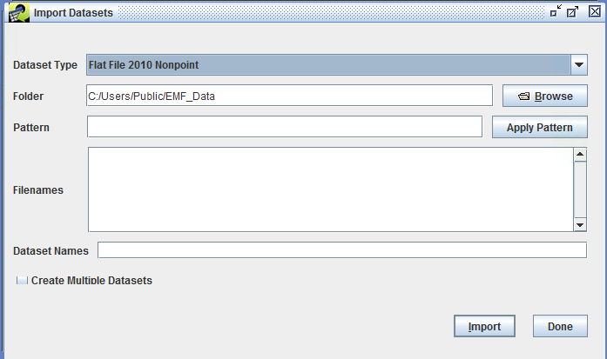

Import Dataset Window

1. Click the Browse button and browse to the location of the inventory to import on the EMF server computer (e.g., C:\Users\Public\EMF_Data\inventories).

(Browse Datasets Window Figure).

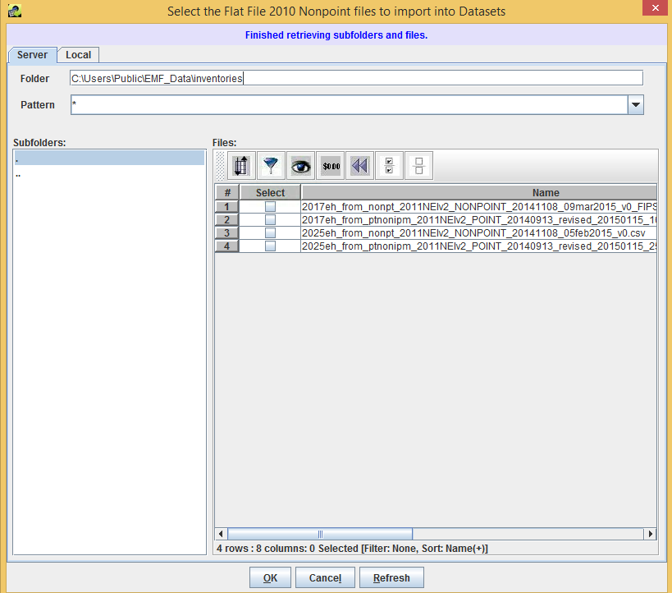

Import Browse Window

1. Select the checkbox that corresponds to the inventory (e.g., 2017eh_from_nonpt_2011NEIv2_NONPOINT_20141108_09mar2015_v0_FIPS_37.csv) and then click OK.
2. Specify a unique, descriptive name for the new dataset in the Dataset Name dialog box.
3. Click the Import button. Monitor the **Status** window for the status of the import.
4. Click Done on the Import Datasets window.
5. After the Status window messages indicates that the import has completed, click Refresh on the **Dataset Manager** and to see the newly imported inventory dataset. The dataset could now be used as an input to a control strategy.
6. To import a list of counties to limit the counties used for a strategy analysis, set the Show Datasets of Type menu to **List of Counties** and then import the file following steps 3 through 9 above. Be sure that the list of counties file has at least two columns, with one of them labeled ‘FIPS’.

The Dataset Manager includes the following controls:

* View opens the Dataset Properties Viewer
* Edit Properties opens the Dataset Properties Editor
* Edit Data creates new versions of the dataset
* Remove removes the dataset
* Import imports new datasets
* Export exports the data to a file on the EMF server
* Purge purges datasets that were removed from the system
* Close closes the **Dataset Manager Window**

(Export Dataset Window Figure).

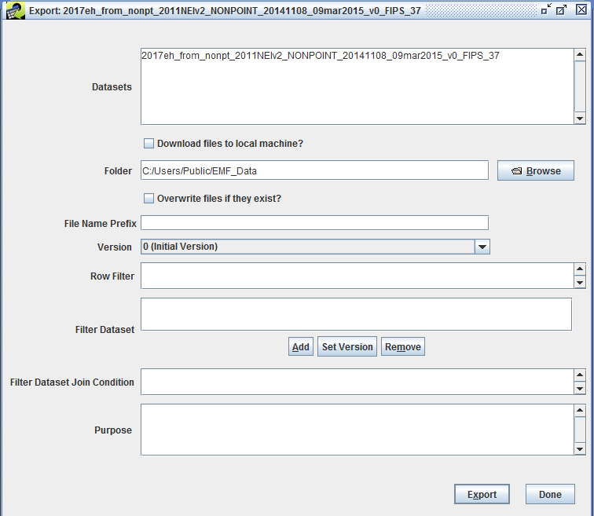

Export Window

## Exercise 2. Running a Maximum Emissions Reduction Strategy

For this exercise, an existing Least Cost Strategy will be modified to create a Maximum Emissions Reductions strategy.

1. From the Control Strategy Manager Copy the least cost strategy created in Chapter 4 to a new strategy.
2. Edit the strategy and set the Type of Analysis to **Max Emissions Reduction**.
3. Run the new strategy and answer the following questions once it completes.

* Did the Maximum Emissions Reduction strategy run slower or faster than the Least Cost?
* How much more emissions reduction was achieved over the 50% level of reduction set in the Least Cost run in Chapter 4?
* How do the Average Cost per Ton and Total Cost differ between the 50% Least Cost reduction strategy and the Maximum Emissions Reduction available?
* *Hint: use the following columns of the* ***Control Strategy Manager*** *to answer this question.*
* **Least Cost Strategy Total Cost:** **Least Cost Strategy Average CPT:**
* **Max. Emissions Red Total Cost:** **Max. Emissions Red Average CPT:**
* What are some of the SCCs for sources that had control measures applied in the result, but had a control efficiency of less than 90%? [It is important to note these because they may provide opportunities for controls…] *Hint: Examine the Strategy Detailed Result and apply a filter for CONTROL_EFF<90 to find the applicable rows:*
* **SCCs with CE < 90%:**

## Exercise 3. Running a Strategy with a Hypothetical Measure

For this exercise, create a new control measure and then see what impact it has on the strategy results.

1. From the **Control Strategy Manager** create a New control measure. Set the Major Pollutant to **NOX** and set the Class to **Hypothetical**.
2. For the new measure enter an Efficiency record for **NOX** with a control efficiency of **95%**, a Cost per Ton of **3000**, and a Cost Year of **2006**.
3. For your new measure, add all SCCs **starting with 102** (there should be about 78 of these). *Hint: you do not have to click 78 checkboxes to do this - remember to filter and Select All.*
4. Copy the Maximum Emissions Reduction strategy from the previous exercise to a new strategy.
5. Set the new strategy to include **Hypothetical** measures in addition to **Known**.
6. Run the new strategy.

Based on the results of this strategy, **how much additional emissions reduction** were realized over the previous maximum reduction result if there was a control measure with a 95% CE available for sources with SCCs starting with 102?

## Exercise 4. Examining Co-benefits of a Control Strategy

For this exercise, run a control strategy that produces co-benefits for multiple pollutants.

1. Set up a new control strategy.
2. Set the Target Year to **2020** and the Strategy Type to **Maximum Emissions Reduction**.
3. Set the inventory to use to be the **Nonpoint** inventory imported in Exercise 1.
4. Set the Target Pollutant to **PM2_5**, then Run the strategy.
5. Once the run completes, summarize the **Strategy Detailed Result** by **Control Technology and Pollutant**.
6. Once the summary has completed running, View the **Strategy Detailed Result**

* Does this result show more than one pollutant?
* What is the typical cost per ton for the strategy?

1. Try setting a **Maximum Cost per Ton** constraint less than the typical cost per ton in the result just generated and rerun the strategy. How does the constraint impact the results?
2. Use the Cost Control Summary Function in the Control Strategy Manager Window to create a local spreadsheet summarizing the selected control strategies, including name, strategy type, and constraints, emission reductions and strategy costs.

(Cobenefit Strategy Summary with Constraint Figure).

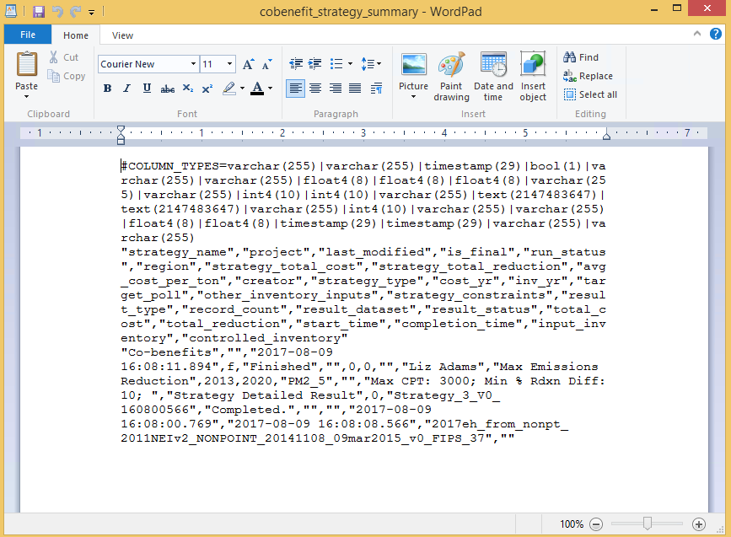

Summary Spreadsheet

(Cobenefit Strategy Summary with No Constraints Figure).

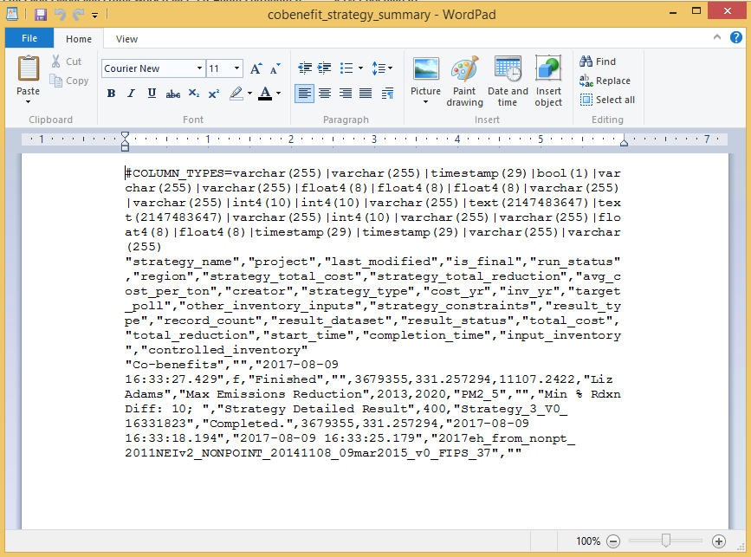

Summary Spreadsheet No Constraints

1. Note that the summary spreadsheet with constraints was for a cost per ton value of 3000. The result was that no controls were applied, as they all cost more than that. For the summary spreadsheet with no constraints, the cost of the controls is listed after the status (Completed), for a total value of $3,679,355 and a total emission reduction of 331.2 tons of PM2.5.

# Example SQL Statements for Creating Row Filters

Table 6-1 provides some examples of row filters that can be applied to inventory filters to target specific sources for use during strategy analyses.

**Table 6-1. Examples of Row Filters (Data Viewer window) and Inventory Filters (Inventories tab of the Edit Control Strategy window**

|  |  |
| --- | --- |
| Filter Purpose | SQL Where Clause |
| Filter on a particular set of SCCs | scc like '101%' or scc like '102%' |
| Filter on a particular set of pollutants | poll in ('PM10', 'PM2\_5')*or*POLL = 'PM10' or POLL = 'PM2\_5' |
| Filter sources only in NC (State FIPS = 37), SC (45), and VA (51);note that FIPS column format is State + County FIPS code (e.g., 37001) | substring(FIPS,1,2) in ('37', '45', '51') |
| Filter sources only in CA (06) and include only NO~x and VOC pollutants | substring(fips,1,2) = '06' and poll in ('NOX', 'VOC')*or*fips like '06%' and (poll = 'NOX' or poll = 'VOC') |

# References

Eyth, A.M., D. Del Vecchio, D. Yang, D. Misenheimer, D. Weatherhead, L. Sorrels, “Recent Applications of the Control Strategy Tool (CoST) within the Emissions Modeling Framework”, 17th Annual Emissions inventory Conference, Portland, OR, 2008.

Houyoux, M.R., M. Strum, R. Mason, A. Eyth, A. Zubrow, C. Allen, “Using SMOKE from the Emissions Modeling Framework”, 17th Annual Emissions inventory Conference, Portland, OR, 2008.

Misenheimer, D.C., “A New Tool for Integrated Emissions and Controls Strategies Analysis”, 16th Annual Emissions inventory Conference, Raleigh, NC, 2007.

Title: Acronyms Author: C. Seppanen, UNC CSS: base.css

# Acronyms [acronyms_chapter]

-|- AQM|Air Quality Model CE|Control Efficiency CMAQ|Community Multiscale Air Quality model CMAS|Community Modeling and Analysis System CoST|Control Strategy Tool CPT|Cost per Ton CRF|Capital Recovery Factor CSV|Comma-separated values DBF|D-base Format EC|Elemental Carbon EMF|Emissions Modeling Framework EPA|Environmental Protection Agency ESRI|Environmental Systems Research Institute (creators of ArcGIS software) FGD|Flue Gas Desulfurization FGR|Flue gas recirculation FIPS|Federal Information Processing Standards GDP|Gross Domestic Product GIS|Geographic information system GUI|Graphical User Interface HEID|Health and Environmental Impacts Division (of EPA) IE|Institute for the Environment (University of North Carolina) IPD|Implicit Price Deflator LNB|Low NO~x Burner NAICS|North American Industry Classification System NEI|National Emissions Inventory NSCR|Non-Selective Catalytic Reduction OC|Organic Carbon O&M|Operating and Maintenance ORL|One record per line PM10|Particulate matter with a diameter of 10 micrometers or less PM2_5|Particulate matter with a diameter of 2.5 micrometers or less PR|Percent Reduction RE|Rule Effectiveness RP|Rule Penetration SCC|Source Classification Code SCR|Selective Catalytic Reduction SIC|Standard Industrial Classification SNCR|Selective Noncatalytic Reduction SQL|Structured Query Language SMOKE|Sparse Matrix Operator Kernel Emissions modeling system tpy|Tons per year UNC|University of North Carolina